**Parent-Student**

**Handbook and Calendar**

**2022-2023**

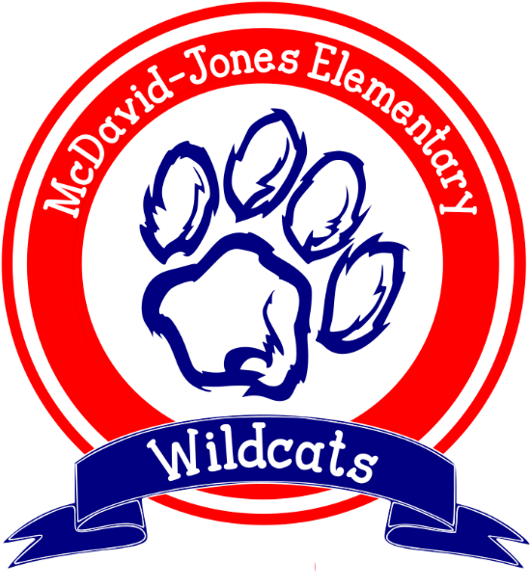

**McDavid-Jones Elementary School**

**16250 Highway 45 South**

**Citronelle, AL 36522**

**Telephone (251) 221-1510**

**Fax (251) 221-1513**

**Principal**

Susan Jill Dickinson

[sdickinson@mcpss.com](mailto:sdickinson@mcpss.com)

**Assistant Principal**

Kristy Davis

[Kdavis4@mcpss.com](mailto:Kdavis4@mcpss.com)

**Mobile County Public School System**

**District Website**

[www.mcpss.com](http://www.mcpss.com)

**McDavid-Jones Elementary Website**

[**https://mcdavidelemmcpssal.schoolinsites.com/**](https://mcdavidelemmcpssal.schoolinsites.com/)

****

**A Message from the Principal**

Welcome back students and parents to the 2022-2023 school year. I hope that everyone had an EXTRA special summer and is ready to come back to school and make **this year** the best one ever. McDavid-Jones is focused on making sure that all students are treated fairly, are respected, and achieve to their fullest potential in a safe and positive environment.

We look forward to the opportunity to work with your children this year and thank you in advance for the support that I know you will provide in this journey. If at any time you should need to contact us for any reason, please do not hesitate to do so. We are always here for you.

Our handbook has been updated to provide you with the most current information that you will need throughout the year. Additional information and dates will be posted on the school Facebook page or on DOJO.

**McDavid-Jones Vision**

The purpose of McDavid-Jones is to be a school that builds the foundation where students exhibit abilities and talents that will lead them to be college and career ready graduates.

**McDavid-Jones Mission**

The mission of McDavid-Jones is to provide students a safe environment where they are challenged to become prepared and productive citizens.

**McDavid-Jones Motto**

We are lifelong learners…learning as we grow!

****



President Jerome Williams

Vice-President Skyla Gaw

Secretary

Treasurer Kerry Williams

Volunteers Michelle Lucas

Fundraising/

Activities Ashley Newton



October Fall Fundraiser

November 10 Fall Festival

December Santa Shop

February Pageant



****



**Bell Schedule**

**7:15 Breakfast**

**7:30 School starts**

**7:40 Announcements**

**2:00 No dismissals after 2:00**

**2:30 Car Rider dismissal**

**Students must arrive BEFORE 7:30 to eat Breakfast.**

**Students that arrive after 7:40 A.M. are tardy.**



**Accelerated Reader and myON**

AR and myON are both district initiatives, and all students are required to participate. Students have a book to read every night that is on their reading level. K-2 students should reread their books before testing. 3-5 students reading chapter books should test at least twice weekly or once weekly when reading thicker books. All students should reach their goal each quarter since all goals are based on the student’s ability.

**Attendance**

Attendance is **critical** for student success. It is the responsibility of the **parent/guardian** to make sure that children are at school on time every day. Excessive absences are handled by the attendance officer for the Mobile County Public School System. **Students with more than 9 absences will not be eligible for National Elementary Honor Society**. Please make every effort to develop good attendance habits for your child. If your child is absent, please send a note within three days of the absence. Without a note, the absence will be marked unexcused. **Truancy** **Court papers are sent from Central Office on the third unexcused absence.** Students are allowed 8 parent notes per year for excused absences as noted in the MCPSS Code of Conduct. If the absence is due to a doctor’s appointment, please send a doctor’s excuse. For further information, you may contact Connie or Denise at 221-1510 or Student Services at 221-4245.

**The research says** that students who attend school regularly learn more and are more successful in school than students who do not. Parents who make regular school attendance a priority are also helping their children learn to accept responsibility and that is an important lesson for a successful life.



**Before and After School Care**

We are excited to offer before and after school care again this year. Students will participate in homework, computer, and P.E. Registration fees are $25 per family and the weekly cost is $15 for mornings, $50 for afternoons, and $55 for both. Additional children are ½ price. Students can be dropped off after 6:00 AM and must be picked up by 6:00 PM. Please see your registration information for additional information.

**Booster Club**

Our school Booster Club supports our students and teachers by purchasing equipment, providing incentives, coordinating our Pageant and Fall Festival, handling our snacks every day, and many other activities. In the past their projects have provided for covered walkways, playground equipment, media equipment, computers, other instructional items, and our digital school sign. Please participate in the enrollment period by sending in your $5 **family** membership and participate in our fundraisers by selling at least 5 items per child. If you have any questions about Booster Club or Parent Activities, please call Ms. Mason or Mrs. McDaniel at 221-1510.

**Bullying**

Bullying continues to be a huge problem nation-wide, therefore, all acts of bullying are taken seriously and warrant immediate action. Repeated offenses merit notification to any one of the county child service organizations. **“It is the policy of the Mobile County Board of School Commissioners that all students have an educational setting that is safe, secure and free from harassment and bullying of any kind. The board will not tolerate bullying and harassment of any type.”**

“A person is bullied when he or she is exposed, repeatedly and over time, to negative actions on the part of one or more other persons, and he or she has difficulty defending himself or herself and is fearful of the other person.”

What is Bullying? What is NOT Bullying?

1. Deliberate 1- Teasing and no one gets hurt
2. Repeated 2- Disagreements
3. Power Imbalanced 3- When there is a possible solution
4. Physical Bullying 4- Everyone is having fun
5. Verbal Bullying 5- There is an equal balance of power
6. Cyberbullying 6- It is an isolated event

For more information: **The Jamari Terell Williams Student Bullying Prevention Act, No. 2018-472**

MCFD02177_0000%5b1%5d

**Cafeteria**

Breakfast and lunch are served daily. Breakfast and lunch are both free of charge to students. Students may bring lunch from home if you prefer. **Soft drinks are not allowed for lunch or snack**. Parents are invited to eat with us for Thanksgiving and Christmas lunch. We will notify parents which building will have Thanksgiving Dinner and which one will have Christmas Dinner. Only 2 parents per student are allowed and COVID guidelines could apply.

**Carline Rules**

1. Move to the front of the line.
2. Do not leave gaps in the line.
3. Do not get on the grass if there is space available on the driveway.
4. No Cell Phones and while students are loading/unloading.
5. Unless you are picking up a Pre-K student do not leave your car. park in the first lane.

Hold up your grade level color coded sign and stay at your car.

1. Be PATIENT and keep a positive attitude!

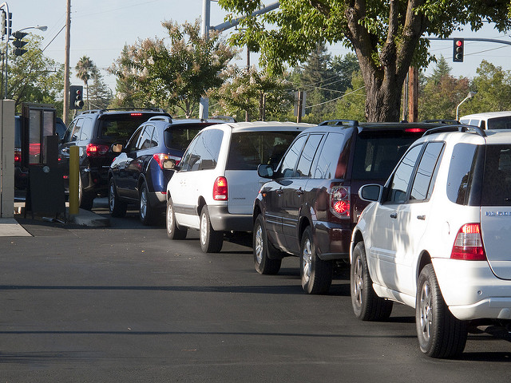

**Checks**

Most school related business is cash only. When we do accept checks we must have the following information: **parent name, student name, physical address, what it is for and two phone numbers written on the check.**

You may also use e-funds to pay for after school care, field trips, year books, etc. Call the school or check the website for more information. 221-1510 <https://payments.efundsforschools.com/v3/districts/56043>

**Classrooms**

Your child’s classroom is their learning spot! When visitors come to the room, students are distracted and learning stops. Please understand that we try our best to make sure that every minute of the school day is used to help your child achieve to their fullest potential. Privacy rights and safety concerns are also considerations as to why we do not allow you to observe in classrooms. Please understand our concerns.

**Classroom DOJO**

You will be given an invitation to DOJO during the first week of school. This invitation will have a specific code for you to use. DOJO gives you and your child’s teacher a quick communication tool and lets you see how your child is doing during the day when the teacher gives or takes away points for behavior and work. Office staff also use DOJO to quickly release valuable information. Please check DOJO often throughout the day.

**Conferences**

Conferences are scheduled before school, after school, or during the teacher’s planning time. Conferences will not be held in the carline or during instructional time. System guidelines require that teachers hold three parent conferences yearly. Please make every effort to come and discuss your child’s progress when the teacher requests these conferences. You may also call the school office and request a conference to discuss your child’s progress.

**Curriculum**

You will find a variety of information to help your child on the MCPSS website. Testing information, homework information, and pacing guides are available. The website address is [www.mcpss.com](http://www.mcpss.com). If you need further information, please call 221-4141.



**Discipline**

The Mobile County Code of Conduct is posted on the MCPSS website. When a student’s behavior warrants corrective action, the parent will be notified. Students who are a disruption to the school’s instructional program will be disciplined according to system guidelines. All discipline matters are taken seriously and warrant immediate action. Repeated offenses merit notification to any one of the county child service organizations. **Unsatisfactory conduct will keep a child off Honor Roll, out of the National Elementary Honor Society, and they will not participate in field trips**. All students are expected to follow our school rules and to conduct themselves as respectable and responsible citizens. **Please note that the Mobile County District Attorney’s Office stands firm that discipline is the responsibility of the parent.**

**Early Dismissal/Tardy**

Students coming in late and leaving early are an interruption to classroom instruction. If possible, please try to make doctor’s appointments after school. If you need to sign your child out early, please do so **before 2:00**, as there are no early dismissals after this time. **Only those people listed on your Enrollment Information will be allowed to sign your child out of school.** No one under 18 or not on the contact list is allowed to sign out a child. Students are marked absent if they are not present at school until 11:00 a.m. Please do not call and request to have your child meet you in the office, as we cannot call for students until you have come into the office and signed them out. **Students with more than 9 tardies or early dismissals will not be eligible for National Elementary Honor Society.** Students with excessive early dismissals and students who are habitually tardy will be reported to the Attendance Officer for Mobile County Public Schools. **A valid Photo ID is REQUIRED for ANYONE signing a student out of school.**

**Emergency Closing of School**

During emergency situations, the school must be able to contact a child’s parent/guardian. It is necessary that each child have up-to-date Enrollment Information (**address and phone number**) in case of an emergency closing of school (severe weather, snow, etc.). Extended Day Tutoring, Clubs, and the Before and After School program will be closed during emergency closings of school.

**Expectations during Programs**

Students and parents alike are expected to follow common courtesy during all programs at school. That includes, no talking during the program, no getting up and blocking someone else’s view, and not allowing smaller children to play on the floor or run around. We will send out more information prior to each program notifying you whether tickets are sold in a limited number, who can attend, and other important information.

**Extended Day (Tutoring) Program**

The Extended Day Program offers after-school tutoring based on grade level achievement and State test scores. On days specified by the MCPSS as holidays, the Extended Day Program will not be in session. For further information, contact Mrs. Kristy Davis at the school.

**Field Trips**

Field trips are an extension of classroom instruction. All students are encouraged to attend, and permission slips must be turned in in a timely manner. Parent participation depends on many factors, and you will be notified if chaperones are needed. Uniforms are required dress for field trips unless otherwise notified in writing, on Facebook, DOJO or over the SCHOOL MESSENGER. **The school reserves the right to not allow students to participate in a fieldtrip if they have unsatisfactory conduct or have been suspended**. Any special arrangements for medication, dismissal, or meals must be made prior to the trip. Adults that attend a field trip must adhere to the following rules:

* **NO SMOKING of any type**

**MC900060306[1]**

* **APPROPRIATE DRESS**
* **PROPER CONDUCT TOWARDS ALL STUDENTS AND FACULTY**
* **NO OTHER SCHOOL AGE STUDENTS or YOUNGER CHILDREN ARE ALLOWED**

**Homework**

All students will have homework each night. K-2 students need to read their library book for 20 minutes and practice addition and subtraction facts. 3-5 students need to read for 30 minutes and practice their multiplication and division facts. Students who do not complete classroom assignments will have those assignments as additional homework if the teacher allows.

**Incentives**

Throughout the year, we will have incentives for testing, attendance, achievement, behavior, etc. Our incentives are fun and we encourage everyone to participate, but these are not required.

**Medication**

**The school is not allowed to give medication of any kind (including aspirin, cough medicine, ointment, toothache medicine, etc.) unless the parent has signed the required MCPSS forms, and the medication is in a bottle labeled with the child’s name.** The medication must have the physician’s name, as well as the directions for administering. Forms are available in the office. When possible, please give your child medication at home. Students are not allowed to have medication at school even if they are delivering it from home to school. The parent/guardian should deliver medication to the school, and it should be given directly to the school nurse. A brochure with additional information is available in the office. For further information, contact either Nurse Henderson (3rd-5th) or Nurse Hopkins (PreK-2nd) at 221-1510.

**Money**

For any reason that money needs to be brought to school, it should be placed in an envelope with the child’s name, teacher’s name, amount, and purpose written plainly on the outside of the envelope.

**National Elementary Honor Society**

During the third quarter, students in third and fourth grade will be screened for eligibility for NEHS. Students must maintain high academic standards, above average attendance, and must be role models for other students by not having any discipline incidents. Students must have no more than 9 absences, early dismissals and tardies. In addition, the child’s current and past teachers will submit recommendations for induction. Once inducted into NEHS, students must continue to meet the standards as described in our Charter.

**Parent-Teacher Relations**

To ensure that your child has a successful year, please stay in contact with his/her teacher. Teachers are available for conferences during planning times and will often grant before or after- school conferences. If there is a problem of any sort, please discuss it with the teacher before bringing it to the administration.  **Please do not speak negatively about the teacher or the school in front of your child.** Our goal is to have a great home-school partnership that will help each child achieve to their fullest potential.

**Partners in Education**

Thanks to our wonderful Partners in Education, ARKEMA for a fabulous 33 years of supporting our students and teachers! Also, thanks to Connie Hudson, Andrews Hardware, and the many faith-based organizations for the support they give to our school. Without their help, we would be *just another school*.

**Physical Education**

Physical Education is required for all elementary students. If your child needs to be excused from P.E. for an extended period, you **must** send a doctor’s note. Students will not participate in outdoor activities when the temperatures are below 40 degrees or above 90 degrees.



**Pictures**

Pictures are taken twice during the school year. Students will be notified in a timely manner concerning date, cost, and type of clothing to be worn. Our school Yearbook will also be available for purchase, and you are encouraged to put your order in early as we do not order extra.

**Registration**

All students must register on-line before the end of the current school year. The username will be the parent’s email address and the password is the oldest sibling’s birthdate using the 8 digit birthdate with no spaces or slashes. Please make sure that you list anyone you want to pick up your child with updated phone numbers in case of an emergency. Pay close attention to the questions about whether your child is allowed to be photographed for school activity posts in the paper, on social media, displayed within the school and even to be included in the yearbook.

**Report Cards**

**Honor Roll and Perfect Attendance**

A-Honor Roll: all A’s in all subjects; S in PE

A/B-Honor Roll: all A’s and B’s in all subjects; S in PE

Perfect Attendance: zero absences

Conduct (K-5) or Conduct and Work Study (3-5) are subject areas and count towards Honor Roll.

Report cards are available in Schoology. Should you have any questions or concerns, please do not hesitate to call the teacher or administrator.

**School in Sites**

You can access the school website by logging on to <https://mcdavidelemmcpssal.schoolinsites.com/> You will find current information for uniform policy, attendance policy, our Continuous Improvement Plan, current events, as well as a variety of pictures of our fabulous faculty, staff, and students.



**School Messenger**

Please make sure that we have your most current phone number listed first when you register. This is the number we will use to send important reminders and school closing information to you. A cell phone number is advised so you can be reached when you are away from home as this is extremely important in the event of an emergency. **Please listen to the messages and don’t just hang up!**

**School Rules** 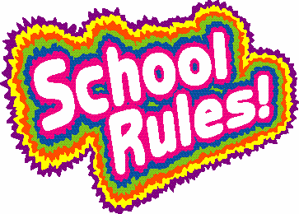

We want our school to be a safe place for all students. In order to achieve this goal we have established the following school-wide rules:

**1. Be Responsible**- be safe, be on time, acknowledge your actions, and complete your assignments…

1. **Be Respectful**- speak and act with kindness, keep our school clean, represent your family well…
2. **Be Ready to Learn**- have your supplies, study at home, get enough rest each night, and use your time wisely.

Please review these rules with your child and impress upon them the importance of following them. The District Attorney’s Office is clear that student discipline is the responsibility of the parent.

**Snack**

A variety of snacks are available each day for your child to purchase. All snacks are 50¢. Students are requested to bring the correct change. If you are sending snack money for the week, please put it in an envelope and write your child’s name and teacher’s name on the front. Students **are not allowed** to bring soft drinks to school for snack or lunch.

**State-Wide Parenting Day**

Mobile County Public Schools will participate in the State-Wide Parenting Day during the month of October. We will notify you of the date when it is set by the district. Please make plans to attend this informative event at McDavid-Jones.

**Student Dismissal**

You will be required to complete a Student Dismissal Form for your child. This will inform the teacher of your dismissal preference of car rider or bus rider.



**Student Health/First Aid Room**

The health and well-being of your child is important to us. To provide your child with most prompt and effective assistance, please follow these procedures:

\*Provide working contact numbers. If at any time you need to update phone numbers, please send these in

writing.

\*List at least two other individuals, that are over the age of 18 and have a valid driver’s license, that we can

contact in the event you cannot be reached.

\*Appropriate agencies will be notified under warranted circumstances.

Students who are vomiting, have a temperature above 101 degrees, pink eye, diarrhea, etc. must be picked up from school. **Students should be free from symptoms for 24 hours before returning to school.** Students with live head bugs or nits (lice) have up to three days to treat heads. Students may not return to class or ride the bus until they have been cleared through the office. It is extremely important that we have current phone numbers to reach you in case of an emergency.

**Telephone**

Please let your child know before they leave for school as to money, transportation, after school plans, etc. so they don’t have to call you from school. Students may have their cellular devices but may not use them during school hours without teacher permission. Students taking pictures, recording others, posting on FACEBOOK, or any other social media, will be subject to disciplinary action following the MCPSS Student Code of Conduct.

**Transportation**  

**All bus transportation changes must be approved through the transportation department.** If you have any transportation changes or questions, please contact Transportation at 221-5260.

**Uniform Policy**

All students are required to wear a uniform to school. Uniforms are required for field trips unless otherwise notified in writing or over the SCHOOL MESSENGER. Our complete uniform policy is posted on the school website at <http://mcdavidjones.mce.schoolinsites.com>.

\*Pants- khaki or navy

\*Skorts/Capris for girls-khaki or navy

\*Shirts- red or navy polo style, School Spirit shirts

\*Jumpers/Dresses for girls-red, khaki or navy with white blouse underneath.

\*Dresses that are made to be sleeveless are fine as long as they are not revealing.

\*Shoes- athletic shoes

\*Belts- black or brown (Not required for PreK-2nd grade.)

**Visitors**

All visitors to the school must report to the office to sign-in and receive a visitor’s pass. This is a system-wide policy and must be followed in order to insure the safety of students, teachers, and staff**. Please do not enter the building or playground area without coming to the office first.**  Teachers are required to report any visitor that is on our campus without a pass. Passes must be visible while at school.

**Miscellaneous**



\*Assemblies and Off Campus Activities: These are an extension of the regular school program and all MCPSS policies and procedures will apply. Appropriate actions will be taken against violations to these policies and procedures for both students and adults.

\*Birthdays – Students may not have parties at school; however, parents may send healthy snacks as a special treat. Balloons are not allowed.

\*Class Assignments – Please notify your teacher know if your child will be absent for more than three days so assignments can be left in the office. You may pick them up after 12:00 noon.

\*Classroom Parties – There are two approved parties per year-- one in December for Christmas and one at the end of the school year.

\*Complaints- Please let me know if there is a situation that is causing stress to you or your child. I cannot help resolve the issue if I don’t know about it.

\*Parental Rights – Any court documents relating to child custody must be on file in the office. Unless otherwise stated in these documents, **both** parents are allowed access to the child’s school information.

**McDavid-Jones Elementary**

**2022-2023 School Year**

**August:**

**4th- First Day of School**

**25th- 4H Volunteer Training**

**September:**

**5th- Labor Day Holiday**

**12th-15th – Forest in the Classroom PreK-4th**

**October:**

**7th – Blood Drive**

**10th- Teacher Work Day**

**21st- First Quarter Awards Day**

**24th-28th – Classroom in the Forest PreK-4th**

**27th- Fall Pictures, Out of Uniform**

**November:**

**10th- Fall Festival**

**11th- Veteran’s Day Holiday**

**16th -Thanksgiving Dinner for 3-5 guests**

**17th- 5th grade Forest in the Classroom**

**21st -25th -Thanksgiving Holidays**

**December**

**6th- Make Up Picture Day**

**14th - Christmas Dinner for PK-2 guests**

**16th- 8:00 Christmas Parties**

**19th -31st -Christmas Holidays**

**January**

**1st-4th Holidays**

**5th- Back to School**

**16th- MLK Jr. Holiday**

**20th- 2nd Quarter Awards Day**

**27th - Blood Drive**

**February**

**20th-24th- Mardi Gras Holiday**

**March-ACAP Testing this month**

**9th-10- Fifth Grade Classroom in the Forest**

**20th- Teacher Work Day**

**21st - Spring Pictures…Out of Uniform; First Day of Testing**

**April-ACAP Testing this month**

**7th – 3rd Quarter Awards Day/Blood Drive**

**17th-21st Spring Break**

**28th – Last Day of Testing**

**May**

**16th – Fifth Grade Day**

**17th - 1st-4th Grade Year End Awards Program**

**18th - Pre-K & Kindergarten Day**

**19th- 12:30-1:30 K-5 End of Year Parties**

**25th- Last Day of School**

**June- Literacy and Math Camp**

**July- 5th Quarter Summer School**

**Dates are subject to change**