**Jakob Hohm Off-Road Adventures**

**In Memory of**

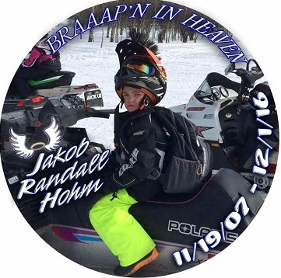

**Jakob was a boy that loved to experience the thrill of adventure. He loved all aspects of the outdoors, particularly riding his Polaris RZR and Snowmobile. Jakob thought all kids should be able to ride and asked many of his friends to ride with him. Jakob’s earthly life ended at the young age of 9, but he will “Forever Ride With Us Together” in the Heavens above.**

**The Jakob Hohm Off-Road Adventures Foundation was created in his memory and to keep his dream of allowing others to experience an outdoor adventure.**

**Jakob Hohm Off-Road Adventures will award two $1000 scholarships, to be received after the completion of one semester of college or tech school.**

**Jakob Hohm Off-Road Adventures Mission Statement**

Keeping Jakob’s dream alive by lifting the spirits of today’s youth through his love for off-road adventures.



**Scholarship Application**

**\*\*\*MUST BE TYPED\*\*\***

**Name:**

**Address:**

**Phone Number:**

**Email Address:**

**High School: Graduation Date:**

**Anticipated Tech School, College, or University:**

**Major:**

**Please name 3 quality characteristics about you and explain why:**

**1)**

**2)**

**3)**

**How would you introduce another young person to snowmobiling or riding ATV’s? Why would that be important to you? (use as much space as you need to explain)**

**Application is due April 4th, 2025 (Must be received no later than 5:00 pm 4/4/25)**

**Please email scholarship application to:**

**17jhora@gmail.com**