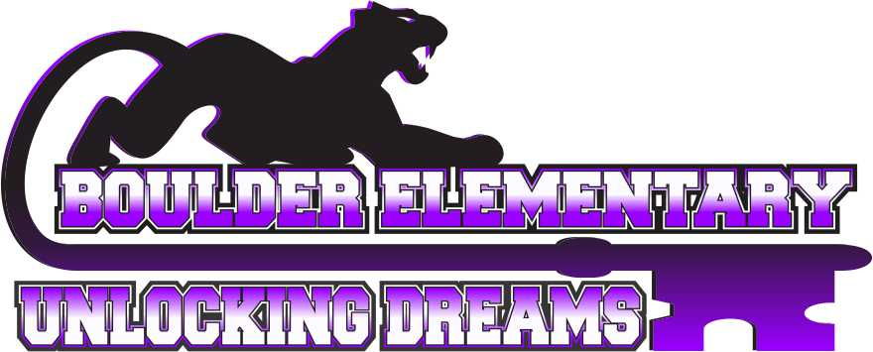
Vision Statement: Committed to pursuing a community of excellence.

Mission: Here at Boulder Elementary School, we are committed to pursuing a community of excellence by engaging students in a positive environment that supports all they do.

AGENDA
BOULDER ELEMENTARY BOARD OF TRUSTEES MEETING
SPECIAL MEETING MONDAY APRIL 27, 2026 3:30 PM
BOULDER ELEMENTARY SCHOOL – CLASSROOM #109

A. Call to order –
- Pledge of Allegiance

B. PUBLIC COMMENT
THE BOARD WELCOMES AND ENCOURAGES PUBLIC COMMENT. ANYONE WISHING TO ADDRESS THE BOARD IS ENCOURAGED TO DO SO WITH THESE STIPULATIONS:
The Board may limit the amount of time for comment if they become extensive. If the speaker begins to infringe on the right to privacy of another, the Board may interrupt and end the comments on that issue. Even if the comments are entirely appropriate, the Board will take no action on them at this meeting. To ensure that others who want to address the same issue have the opportunity to do so, the item may be placed on the agenda for a later meeting.

C. NEW BUSINESS
- Superintendent Interviews – (Possible Executive Session after Interviews) - action item

D. ADJOURNMENT

