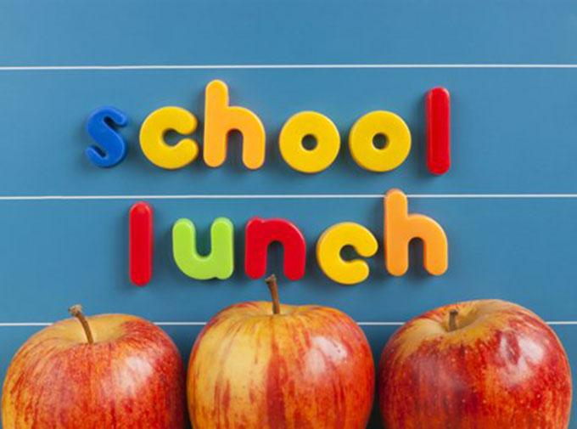

This Photo by Unknown Author is licensed under CC BY-SA-NC
Mon – Thurs: 11:52- 12:47
Friday: 11:40 -12:40

Week 1 | Monday | Tuesday | Wednesday | Thursday | Friday
MENU | BBQ Meatballs  (4) per child  W/  Mashed Potatoes | Nachos | Corn Dogs | Chicken and Yellow Rice | Cheese Pizza
GRAIN | Rolls (1) per child | Tortilla Chips | N/A | Rolls (1) per child | N/A
FRUIT | Pears | Mandarin Oranges | Pineapples | Peaches | Pears
VEGETABLES | Green Beans | Lettuce  &  Black Beans | Baked Beans | Steamed Carrots | Salad
OTHER FOODS/  CONDIMENTS | N/A | Taco Sauce | Ketchup | N/A | Ranch
Milk is offered with every meal
- Fat – Free Flavored and Unflavored Milks
- Low Fat (1%) unflavored choices
- Lactose Intolerant Milks will be provided for those in need

This Photo by Unknown Author is licensed under CC BY-SA-NC
Mon – Thurs: 11:52- 12:47
Friday: 11:40 -12:40

Week 2 | Monday | Tuesday | Wednesday | Thursday | Friday
MEAL | Pulled BBQ Chicken | Cheeseburger Mac | Chicken Patty Sandwich | Baked Ziti | Cheese Pizza
GRAIN | Whole Wheat Grain Bun | Whole Wheat Grain roll  &  Pasta | Whole Wheat Grain Bread | Whole Wheat Grain Pasta | Whole Wheat Grain Crust
FRUIT | Pears | Pineapples | Mandarin Oranges | Pears | Pineapples
VEGETABLES | Baked Beans | Corn | Steamed Carrots | Green Beans | Salad
OTHER FOODS/  CONDIMENTS | N/A | N/A | Ketchup | N/A | Ranch
Milk is offered with every meal
- Fat – Free Flavored and Unflavored Milks
- Low Fat (1%) unflavored choices
- Lactose Intolerant Milks will be provided for those in need

This Photo by Unknown Author is licensed under CC BY-SA-NC

Lunch / Recess
11:52-12:20pm (B)
12:20-12:47 (G)

Week 3 | Monday | Tuesday | Wednesday | Thursday | Friday
MEAL | Chicken Alfredo w/ Penne Pasta | Chicken w. Yellow Rice | Sloppy Joe’s | Grilled Cheese Sandwich | Cheese Pizza
GRAIN | Whole Wheat Grain Roll (1) per child | Rice | Whole Wheat Grain Bun | Whole Wheat Grain Bread | Whole Wheat Grain Crust
FRUIT | Pineapples | Pears | Mandarin Oranges | Peaches | Pineapple
VEGETABLES | Carrots | Black Beans | Corn | Mixed Veggies | Salad
OTHER FOODS/  CONDIMENTS | N/A | N/A | N/A | N/A | Ranch
Milk is offered with every meal
- Fat – Free Flavored and Unflavored Milks
- Low Fat (1%) unflavored choices
- Lactose Intolerant Milks will be provided for those in need

This Photo by Unknown Author is licensed under CC BY-SA-NC

Lunch / Recess
Mon – Thurs: 11:52- 12:47
Friday: 11:40 -12:40

Week 4 | Monday | Tuesday | Wednesday | Thursday | Friday
MEAL | Bean and Cheese Burrito | Chicken Teriyaki | Shepard’s Pie w. Mashed Potatoes | Rotini | Cheese Pizza
GRAIN | Whole Wheat Grain Bun (1) per child | Rice | Whole Wheat Grain Rolls (1) per child | Whole Wheat Grain Bun (1) per child | Whole Wheat Grain Crust
FRUIT | Pineapple | Mandarin Oranges | Peaches | Pears | Pineapples
VEGETABLES | Baked Beans | Mixed Veggies | Green Bean’s | Steamed Carrots | Salad
OTHER FOODS/  CONDIMENTS | Taco Sauce | N/A | N/A | N/A | Ranch
Milk is offered with every meal
- Fat – Free Flavored and Unflavored Milks
- Low Fat (1%) unflavored choices
- Lactose Intolerant Milks will be provided for those in need

This Photo by Unknown Author is licensed under CC BY-SA-NC

Lunch / Recess
Mon – Thurs: 11:52- 12:47
Friday: 11:40 -12:40

Week 5 | Monday | Tuesday | Wednesday | Thursday | Friday
MEAL | Cheeseburger  Mac and Cheese | Chicken w. Gravy & Mashed Potatoes | Nachos | Corn Dog | Cheese Pizza
GRAIN | Pasta | Whole Wheat Grain Roll | Tortilla Chips | Whole Wheat Grain Bread (1) per child | Whole Wheat Grain Crust
FRUIT | Pears | Mandarin Oranges | Pineapples | Peaches | Pears
VEGETABLES | Mixed Veggies | Steamed Carrots | Black Beans | Baked Beans | Salad
OTHER FOODS/  CONDIMENTS | N/A | N/A | Taco Sauce | N/A | Ranch
Milk is offered with every meal
- Fat – Free Flavored and Unflavored Milks
- Low Fat (1%) unflavored choices
- Lactose Intolerant Milks will be provided for those in need

This Photo by Unknown Author is licensed under CC BY-SA-NC

Lunch / Recess
M-T (11:52- 12:47pm)
Friday (11:40-12:40pm)

Week 6 | Monday | Tuesday | Wednesday | Thursday | Friday
MEAL | Turkey Meatball (4) Subs | Soft Tacos | Spaghetti | Pulled BBQ Chicken | Cheese Pizza
GRAIN | Sub Buns | Tortilla | Whole Wheat Grain Pasta | Whole Wheat Grain Bun (1) per child | Whole Wheat Grain Crust
FRUIT | Pineapple | Pears | Mandarin Oranges | Pineapples | Tropical Fruit
VEGETABLES | Green Beans | Lettuce  &  Black Beans | Steamed Carrots | Corn | Salad
OTHER FOODS/  CONDIMENTS | N/A | Taco Sauce | N/A | N/A | Ranch
Milk is offered with every meal
- Fat – Free Flavored and Unflavored Milks
- Low Fat (1%) unflavored choices
- Lactose Intolerant Milks will be provided for those in need

