
Sterling Rock Falls Gobblers
National Wild Turkey Federation’s
Academic Scholarship Program

Instructions
1. Read the applicant information sheet carefully to
determine eligibility before completing application.
2. Include your full name on the upper left corner of all pages, including attachments.
3. Make sure all portions of the application are complete and include all requested enclosures. Incomplete applications will not be considered.

4. Applicant and school guidance counselor/principal must sign application.
5. Return this application to your local NWTF chapter no later than February 4, 2026.

Return application no later than February 1, 2025, to:

Chapter Name: Sterling Rock Falls Gobblers

Contact Name: Heath Jordan

Mailing Address: 2756 School Rd

City: Chadwick State: Illinois Zip: 61014

Contact Number: (815) 441-4222

PART I: Applicant Information
Please type or print.

Today’s Date:

Name:

Permanent Address:

City: State: Zip Code:

Telephone No. ( ) E-mail address:

Date of Birth:

Name of Parent/Guardian with whom you reside:

PART II: Extracurricular Activities
Securely attach additional sheets if necessary.

List membership in school-related organizations (i.e., Honor Society, FFA, Beta Club, Science Club, Ecology Club, Student Council, etc.):

List any activity that demonstrates community leadership and /or involvement (i.e., Scouts, 4-H, civic group or club, volunteer work, etc.):

List any awards received for school or community involvement:

List job experience (i.e., after school, summer, etc.):

How did you learn about the Sterling Rock Falls Gobblers NWTF Academic Scholarship Program?

PART III: School Information

High School: Expected Graduation Date:

College Preference:

Major Study Area:

PART IV: Essay
Write a brief essay describing your commitment to conservation and preserving our hunting heritage. Essay must be typewritten, double-spaced and should not exceed three pages. Essay must include:
• Why you will be a good investment if you are awarded this conservation scholarship
• Any experiences and background that demonstrate your dedication to conservation and the preservation of our hunting heritage
• Why hunting is important to you and your family

PART V: Letters of Reference
Include two letters of reference from teachers, counselors, community leaders or clergy (do not include relatives).

PART VI: Required Enclosures
Complete applications must include:
• Official, sealed transcripts
• Photo (minimum wallet size suitable for publication).

PART VII: Counselor or Principal Signature and Stats
To be completed by counselor or principal

Current Cumulative Grade Point Average (unweighted)

*If your school does not use a 4.0 scale, please calculate, and convert GPA to a 4.0 scale. Applicant’s rank in graduation class: out of (total number in class)
*Official, sealed transcripts are required.

Signature of Guidance Counselor or Principal Date

PART VIII: Signature
By signing this form, I hereby grant the National Wild Turkey Federation the unconditional right to use my name, photograph, and essay in connection with press releases and/or publications. I also certify that I have read and meet the eligibility requirements for the NWTF scholarship.

Signature of Applicant Date

Applicant Name

Before mailing this application, please check for the following:

0 I have completed the APPLICANT INFORMATION section
page 4 Academic Scholarship Program

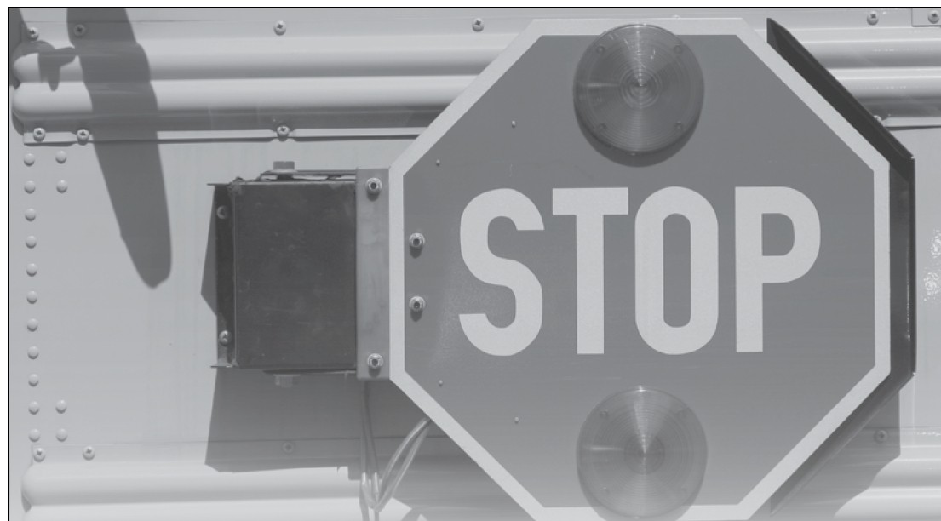
0 I have completed the EXTRACURRICULAR ACTIVITIES section

0 I have completed the SCHOOL INFORMATION section and acquired the signature of my guidance counselor or principal

0 I have enclosed my ESSAY

0 I have enclosed two LETTERS OF REFERENCE

0 I have enclosed OFFICIAL, SEALED TRANSCRIPTS

0 I have enclosed a PHOTO of myself suitable for publication

0 I have SIGNED MY APPLICATION

0 I have read the APPLICANT/SCHOOL INFORMATION SHEET

0 Return this application to your LOCAL CHAPTER no later than February 4, 2026.

National Wild Turkey Federation Scholarship Program

Applicant/School Instruction Sheet

Eligibility:
1. Students should be graduating seniors with a 3.0 on 4.0 scale or equivalent grade point average. (If transcript indicates a scale other than 4.0, student should have a minimum of 3.50 on a 5.0 scale, 4.5/6.0 scale, 5.25/7.0 scale, 6.0/8.0 scale, 6.75/9.0 scale or a
7.5/10.0 scale).
2. Students must be pursuing a degree at an accredited institution of higher education (i.e., Junior College, Community College, Technical College, College or University).
3. Students must support the preservation of the hunting tradition and actively participate in hunting sports.
4. Students must demonstrate ability as a leader among his or her peers.
5. Students must demonstrate community leadership and/or involvement (i.e., Scouting, 4-H, civic group or club, volunteer work).
6. Students must submit an essay exhibiting dedication to conservation (see application).
7. Two letters of recommendation must be attached to the application (i.e., teacher, counselor, community leader).
8. High schools/students must submit complete applications to the local chapter by February 4, 2026. The local chapter president’s name and address should appear on the application in the box provided.

Selection Process:
1. High schools/students will submit applicant names and qualifications on an official NWTF scholarship application, along with required attachments, to the local chapter by February 4, 2026.
5. Winners will be notified by February 15, 2026.
6. The winner(s) will be invited to attend the Local Banquet held on March 7, 2026.

Scholarship Level:
Most Local Scholarship Winners will receive a minimum of $250.

Disbursement of Funds:
Students may use their scholarship at any accredited institution of higher education (i.e., Junior College, Community College, Technical College, College or University). The money must be used for tuition, books, fees, and housing. The NWTF chapter will work with the student and the college financial aid officer in determining the payee when the check is issued. This will ensure the greatest benefit to the recipient and avoid violation of eligibility requirements. This is a one-time award for one year.

