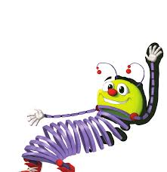
Nov. 27-Dec. 1, 2023
Open Court First Grade Reading Series Unit 4 Light and Sound 4.3
Foundational Skills: Phonemic Awareness and Phonological Awareness: /v/ spelled: v (initial position/beginning sound), -ve (ending position) /y/ spelled y (initial position/beginning sound as in yak)
Fluency Decodables: Beth’s Yak, Seven Pals
New Red Words for this week: were, give.
Read the Words and Sentences (minor reading grade) Nov. 30th Grammar: Sentences, Correct Spelling, Capitalization, and Punctuation
*Dictation & Spelling Assessment (minor language arts grade) Dec. 1st
Chapter Book Read Aloud: Junie B. Jones Jingle Bells
Nonfiction read alouds: Christmas Around the World
envision Math: Topic: Subtraction Facts to 20: Use Strategies
Monday: 4-5: Use Addition to Subtract
Tuesday: 4-6: Continue to Use Addition to Subtract
Wednesday: 4-7: Explain Subtraction Strategies (minor math grade 4-7)
Thursday: 4-8: Solve Word Problems with Facts to 20
Friday: 4-9: Reasoning

Science: Sound How do you experience light and sound? (cross-curricular with reading selections: “Listen”, “The Tale of Lightning and Thunder”

Social Studies: Christmas Around the World

Leader in Me: Habit #7 Sharpen the Saw means keeping your body, brain, heart, and soul “sharp.” Eating right is one way to sharpen the body. It gives you energy and helps you stay healthy.

