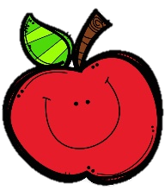
Mrs. Burns’ Messages
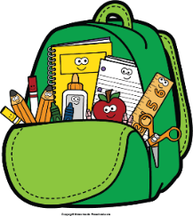
October 31 - November 4, 2022
Reading Assessments
Wednesday Quizzes: Phonics, Cause and Effect, Adjectives, Vocabulary
Thursday Assessments: Reading Skills Test, Grammar Test, Spelling Test
Thursday, November 3: Vaccinations for
those Signed Up
Friday, November 11: Veterans Day (NO SCHOOL)
Friday, November 18: Spirit Day; Special Snack;
Santa Pictures
November 21-25: Thanksgiving Break (NO SCHOOL)
Wednesday, November 9: Progress Reports
Thursday, November 10: Parent Picnic
Reading Story and Skills:  Story:  All About Earthquakes  Phonics/Fluency:  /e/: e, e_e  long-vowel  review  Text-Based Comprehension:  Cause and Effect  Grammar/Language:  Adjectives |  | Vocabulary Words  - absorb – to soak up or take in  - boundaries – lines that form edges  - collide – to crash into each other  - energy – the power to use in action and work  - interact– to act on or influence each other  - plates – huge parts of Earth’s crust on which the  continents and oceans rest  - structures - things built
Math  Topic 5: Subtract Within 100 Using Strategies  Lesson 1: Subtract Tens and Ones on a Hundred Chart  Lesson 2: Count Back to Subtract on an Open Number Line  Lesson 3: Add Up to Subtract Using an Open Number Line  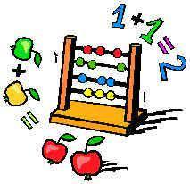  Lesson 4: Break Apart Numbers to Subtract  Lesson 5: Subtract Using Compensation |  |  |  |  | Social Studies/Science  We will continue our unit on Earth’s systems this week as we continue to look at examples of Earth events that happen over a short or long period of time. We will also discuss solutions that address changes caused by such events.
Spelling Words:
- label  - vine | - bonus  - wild |  | - begin  - these | - gate  - use |  | - meter  - spoke

