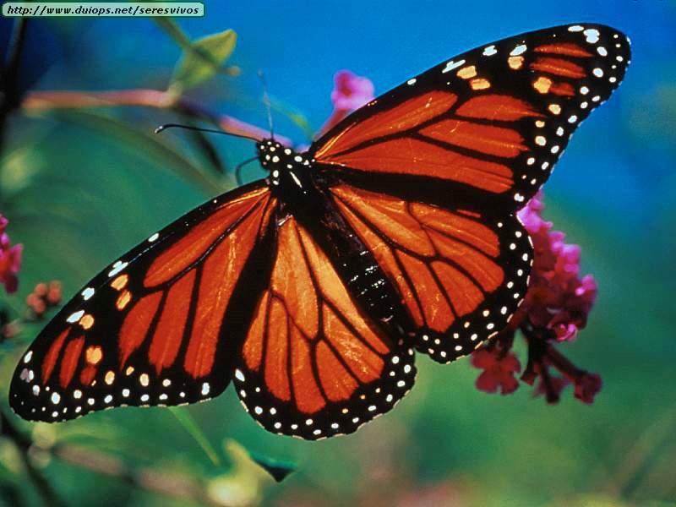

**Reading News**

**Mrs. Williams’ Second Grade**

**October 6, 2025**

**Reading:** Great Migration - Butterflies

**Word Study:** Vowel Diphthongs ou, ow

**Vocabulary:**

**migration** – a type of travel where animals move long distances to avoid winter weather

**generation** – a period of time between when parents are born and their children are born

**protection** – something that prevents harm or injury to something else

**transforming** – indicates a change that has happened in the past

**chemicals** – used to stop insects from eating plants people use for food