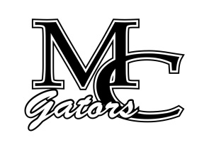School Council Agenda
October 18th, 2022

Chairperson – Andy Gentry Vice Chairperson- Patrick Chiappetta Secretary- Michelle Starley

Other Members: Sydney Howard, Jennifer Zoumberis, Marcell Ausborn, Suzanne Ganas, Carey Bassett

Student Council Members: Angelina Park, Miranda Aguilar, Zoey Cunningham

Welcome/ Introductions
Old Business – Elections August 2022
New Business
Elect Officers – Chairperson, Vice Chairperson, Secretary
Principal Report – Beginning of the year, SBRC, Athletics, MAP
Teacher Report
Counselor Report – SOS, new MFLC (Mrs. Andrews)
Student Report
Parent Report – Anything negative?

Next Meeting- December 8th, 2022

