Mrs. Bowles’ Newsletter
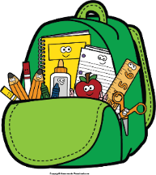
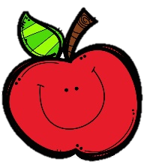
May 9-13, 2022
Grammar (commas in compound sentences) and

Reading Skills (facts and details) Tests: Thursday
Spelling (prefixes mis-, mid-) and Vocabulary Tests: Friday
Our Student of the Week (May 16-20): Amethyst
Monday, May 9: Field Trip
Tuesday, May 10: ACAP Reward Snack
Monday, May 16: Field Day
Friday, May 20: Awards Day (time TBD)
Thursday, May 26: Teacher In-Service
(NO SCHOOL)
Friday, May 27: Last Day of School

Reading Story and Skills:  Story:  Grace for President  by Kelly DiPucchio  Text-Based Comprehension:  facts and details;  predict and set purpose  Phonics/Fluency:  prefixes  mis-, mid-, micro-, non-  Grammar:  commas in  compound sentences |  | Vocabulary Words  (these words will be tested each week):  - assembly – a gathering of the students in a school for  a special purpose  - election – the act of voting for a person to hold a  position in a group  - microphone – a machine that makes the speaker sound  louder  - rallies – meeting that people go to in order to show  support  - slogan – a word or short sentence  used by a person or  business that tells an idea
Math  Topic 15: Graphs and Data  On Friday, we will take a weekly assessment. |  |  | Social Studies/Science  We are wrapping  things up this week!
Spelling Words: No bonus words this week.
1. midair  2. midway  3. midweek | 4. mismatch  5. misplace  6. misprint |  |  | 7. misbehave  8. misdeed  9. mislead | 10. midday  11. midyear  12. mistake

