Stidham Public School
Superintendent Danny Williams
Principal Angelia Yandell
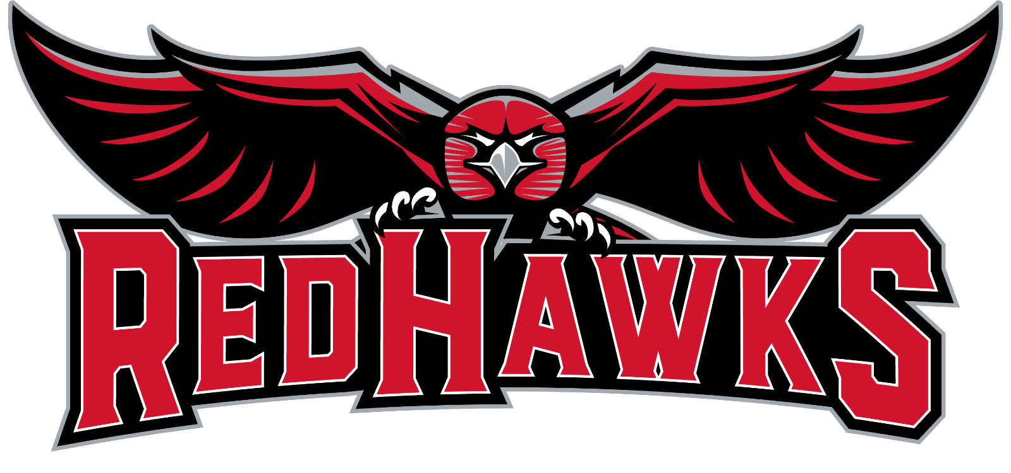

Stidham Public School
Return to Learn Plan
2021-2022
ESSER III

OUR MISSION

Stidham School District is extremely grateful to have the opportunity to educate and serve your child at our school. We are excited to start back the school year, however our mission is to make sure that we clarify and explain what our plans are in order for all students and staff to return to learn in a safe and healthy manner.

OPTIONS FOR SCHOOL LEARNING

We will be offering students and their families with 2 options for learning.
- Traditional Learning Student
- Virtual Learning Student

Option 1 Traditional Student | Option 2 Virtual Student
→All on Site Learning  →In person learning and interaction with peers  → Immediate access to teachers, libraries, computer labs, etc.  →Transportation to and from school for in district students  →Students offered free breakfast and lunch  →Students eligible to participate in extracurricular activities and sports  →Chromebook is provided for grades 3rd-8th. Tablets for grades PreK -2nd.  →Hotspots will be provided for students without Internet access  →Students will participate in virtual (distant learning) days throughout the school year to prepare for school closures, if needed.  Programs that will be utilized include but not limited to Reflex Math, IXL,  Google Classroom  **All students will be enrolled in this plan, unless a parent request is made.** | →Remain a Stidham School Student.  →Available for students PreK-8th grade  →Communication between teacher/parent with regular updates provided  →Students will be eligible to participate in extracurricular activities. Transportation will need to be provided  →Chromebook is provided for grades 3rd-8th. Tablets for grades PreK -2nd.  Paper/Pencil packets will be provided if requested  →Hotspots will be provided for students without Internet access  →Distant learning programs will be provided by Stidham School  Programs that will be utilized include but not limited to Reflex Math, IXL,  Google Classroom  **For enrollment into this option, please contact Stidham School by August 10th.  Stidham School 918.689.5241
Students will have until Sept. 1, 2021 to make changes to their learning preference, or at the end of each nine weeks. In certain circumstances, students may be moved to in-person learning if learning virtually is too cumbersome.

Students choosing to complete their learning virtually will need to contact the school by Aug. 10, 2021 and complete the distance learning plan information.

SCHOOL CALENDAR

Stidham School will have a blended calendar for the year 2021-2022. Students will receive in-person instruction on Monday - Thursday, and Fridays will be a virtual or distance learning day. These days will be used for students and parents to familiarize themselves with accessing programs and completing assignments in preparation for school closure, if needed. Students will use their Chromebook or tablet to complete their work.

Students' first day of school will be August 16th, 2021.

AFTER SCHOOL PROGRAM

Parents will have the opportunity to allow students to receive additional instruction and tutoring services daily from 3:30 - 5:30 p.m. each day school is in session.

CURRICULUM

Students will be utilizing textbooks and workbooks as well as using chromebooks/tablets to complete assignments. Instruction from textbooks will be the majority of students' curriculum for the school year, however teachers will have the ability to create assignments and review information utilizing students' chromebooks and devices.

COVID - 19 SCREENING

At this time, student temperatures will NOT BE taken daily before being allowed to get on the bus and at school each morning. We will rely on parents and students to practice a home-based screening approach. However, should an outbreak occur, the policy requiring temperature to be taken before loading the bus or at school each morning, can be reinstated.

Home-Based Symptom Screening
Caregivers: If your child has any of the following symptoms, they might have an illness they can spread to others.
- Temperature of 100.4 degrees Fahrenheit or higher
- Sore throat
- Cough (for students with chronic cough due to allergies or asthma, a change in their cough from usual)
- Difficulty breathing (for students with asthma, check for a change from their baseline breathing)
- Diarrhea or vomiting
- New onset of severe headache, especially with a fever
Check your child for these symptoms before they go to school. Check symptoms for changes from usual or baseline health.

If your child DOES have any of the symptoms above:
- Keep them home from school
- Get your child tested for COVID-19.
- Contact your child’s school and report that your child is sick. The school may ask some additional questions to help determine when it is safe for your child to return to school and about other people who may have been exposed.
- CDC has a Coronavirus Self Checker* available in its website, which may help you make decisions about seeking medical care for possible COVID-19.

If your child does NOT have any of the symptoms above:
- Consider whether your child needs to see a healthcare provider and be tested for COVID-19. Even if they don’t have symptoms, your child should be tested if they:
- have been in close contact with someone with COVID-19, or
- have taken part in activities that puts them at higher risk for COVID-19 because they cannot physically distance as needed, such as participating in contact sports, attending a gathering with other children or family, or
- were asked or referred to get testing by a state, tribal, local, and territorial health department or healthcare provider.
- For the purposes of these criteria, daycare and school settings that implement multiple prevention strategies, such as universal and correct use of masks and physical distancing to the greatest extent possible, are not considered higher risk settings.
- If they do not have symptoms and do not meet any of the criteria above, send them to school as usual.
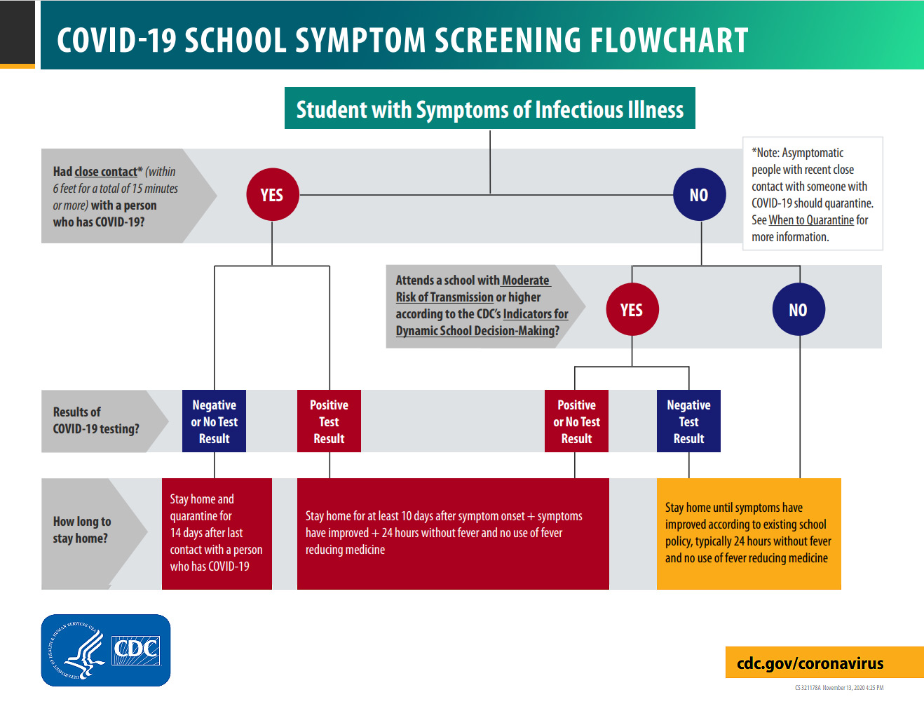
Stidham School will use the flow thru chart as needed

RECOMMENDATION FOR SCHOOL CLOSURE
Stidham School will communicate with the McIntosh Co. Health Dept. as well as the OSSBA Covd-19 Alert System to determine the safety of all students and staff. If a closure is needed, Stidham School will communicate with parents via text, facebook, letter, and the schools website.

POSITIVE COVID 19 CASE
If a student or staff member tests positive for Covid-19, all persons in contact with the infected person, including siblings and family members, will need to be quarantined for 10 days. Families will be notified and distant learning plans will begin. If the number of persons exposed to the virus are more than 35% of school enrollment, the entire school will close for 10 days. Students will all move to distant learning plans. All school facilities will be closed for disinfecting purposes.

MASK REQUIREMENT
At this time, wearing face masks will be optional and NOT required for students or staff. Students choosing to wear face masks, should wear a clean mask daily.
SANITATION AND DISINFECTING
Stidham School will continue to use an elecro-magnetic disinfecting device in the classroom, buildings, bussed, gym, cafeteria and playground area to ensure disinfecting. In addition, teachers will disinfect high contact areas throughout the day.

PARENTS/VISITORS AT SCHOOL
At this time, parents and visitors NOT will be allowed in the school buildings on a daily basis. Parents and visitors will be allowed in when special events or extra-curricular events occur.
Exceptions include:
- 1st day of school - Parents can walk with their children to their classroom.
- Classroom Parties

WATER FOUNTAINS:
Water - bottle fill stations have been installed throughout the building. Parents should provide a water bottle for their child to use daily. If needed, water bottles can be cleaned and sanitized in the school cafeteria.

CONTACT INFORMATION:
For further information concerning Stidham School’s Return to Learn Plan please contact:
Angelia Yandell, 918.689.6480, or by email at ayandell1@stidham.k12.ok.us

