North Middle School Mission
North Middle School, together with parents and community members, will provide a safe and caring environment that allows each student the opportunity to become a life-long learner through the development of his or her potential in academic, social, cultural, and physical endeavors.
I’m thrilled to be your math teacher and I look forward to working with each of you. I know we are going to have an exciting, interesting, and fulfilling year together. This is OUR classroom. We are a team. We must work together in order to achieve our goals. My goals are to teach you the standards set for 6th grade, provide a safe, nurturing, and interesting environment, and get you to LOVE MATH. Your goals should be to succeed in math, get along with your peers, and come to class with a positive attitude.
I have high expectations for all of you.
I KNOW we are going to have a fantastic year together!
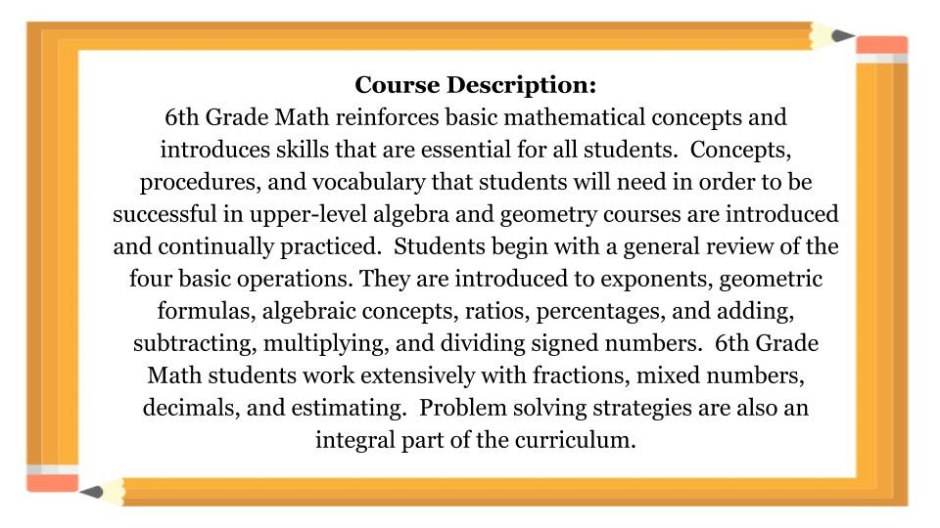

Classroom Rules
- Be on time, on task, and prepared to learn every day.
- Respect all property, classmates, and teachers at all times.
- Be responsible for you and your learning.
- Clean up after yourself.
- Follow all classroom procedures.

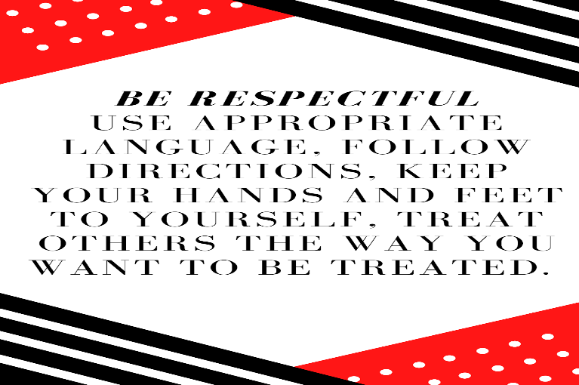
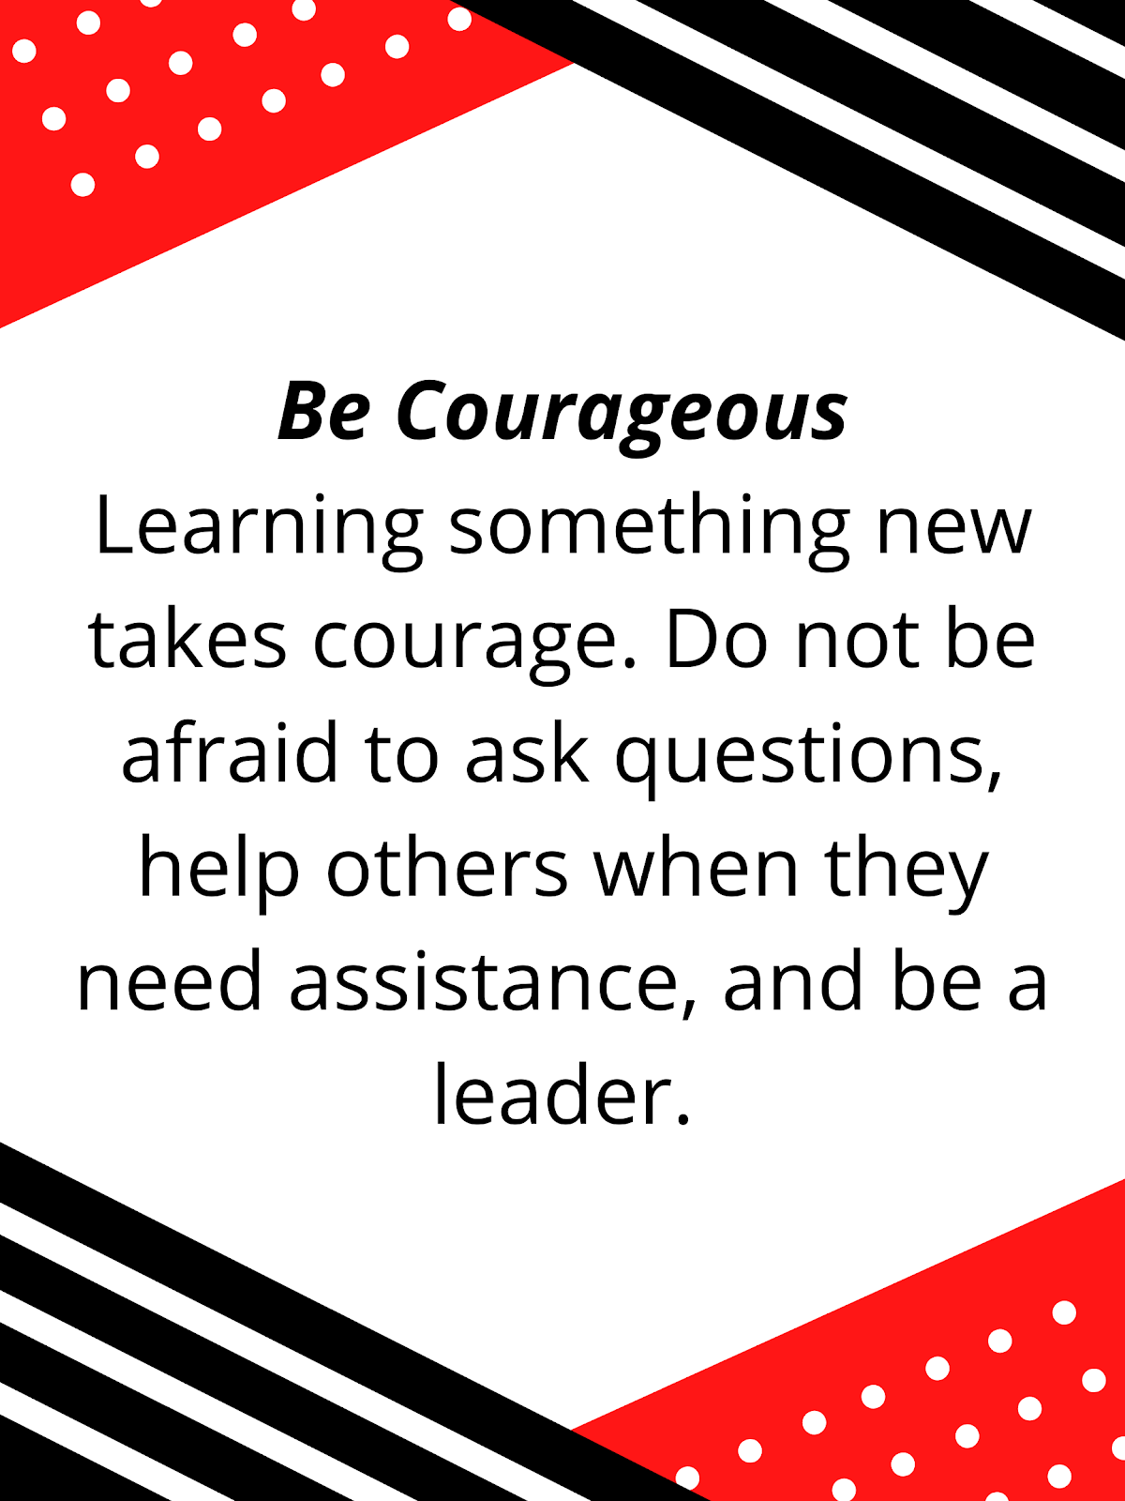
Classroom Procedures:
- When the bell rings, you are to be in your seat and working on that day's Bellringer. This is the way that every class will begin.
- Every time you turn in an assignment, you must have your name, date, and class period in the top right-hand corner and highlight it. You should do this for every assignment turned in.
- When turning in papers, place them in your period’s drawer.
- If you are turning in a paper late, you must write LATE on the top of the paper.
- If you want to ask a question or make a statement, simply raise your hand to be recognized.
- If you are absent, it is your responsibility to get your makeup work from the front board. You can find the assignments you missed in that day's folder or from the calendar on the side board. You can also check missed assignments on my website.
- Homework is due at the beginning of class! I will not accept homework any later.
- At the end of the class period, I (not the bell) will dismiss you.

Grades:
Each grading period there will be formal tests, quizzes (announced and unannounced), warm-up activities, class work, and homework assignments. There will also be other types of informal assessments to periodically check for understanding. Students will also be keeping a Math Notebook throughout the year.

All assignments will count as 100% of the student’s grade.
Test will be counted twice in the grade book.
A= 93-100 B= 85-92 C= 75-84 D= 70-74 F= 60-69

Absent Work:
If absent, students may find the missing assignments on the front board titled, “While you were out”. Please take the work for the date absent. Students will have 5 school days to complete make up work and turn in to Ms. Hayes.

Supply List:
Composition notebook, folder with brads, pencil, paper, a good attitude, earbuds, school agenda, and pencil pouch with supplies (scissors, glue, etc.).

Communication:
I feel that in order for a child to be successful, parent/teacher communication is a must. Please feel free to contact me via email akira.hayes@fcstn.net. You may call and leave a message with the school, but email is quicker.
You may also visit our Google Classroom or my teacher page for more class resources.

I have fully read this syllabus and understand what is expected to succeed this school year in Ms. Hayes’s math class.

Student Signature:__________________________________ Date:_____________

Parent Signature:___________________________________ Date:_____________

