Grant Union Prospectors
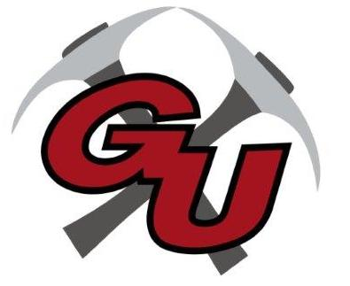
Wrestling 2022-23

DATE OPPONENT/SITE TIME DISMISS DEPART
12/1 Enterprise Dual 6:00 10:45 11:00am
12/2 Enterprise Kickoff 10:00am 12/9-10 Culver Invitational 2:00/10:00am 8:00am
12/16-17 Elgin Invitational 2:00/10:00am 8:30am
12/30 Woodfin Duals (Burns) 10:00am 5:45am
1/6-7 Jo-Hi Tournament (Joseph) TBD TBD
1/12 Madras Duals 5:00 12:45 1:00
1/13-14 Oregon Classic (Redmond-DCF) TBD
1/20 Grant Union Tournament Noon
1/25 Burns/Crane/GU Duals (Burns) 5:00 1:45 2:00
1/28 BEO Tournament (Heppner) 10:00am
1/28 Hood River (Girls) TBD
2/3-4 Girls Districts TBD TBD
2/4 Pine Eagle 10:00am TBD
2/10-11 Boys Districts (Crane) TBD TBD
2/23-25 State Wrestling TBD TBD

Head Coach:
Assist. Coaches:
Athletic Director: Andy Lusco
Principal: Karen Shelton
Superintendent: Louis Dix

