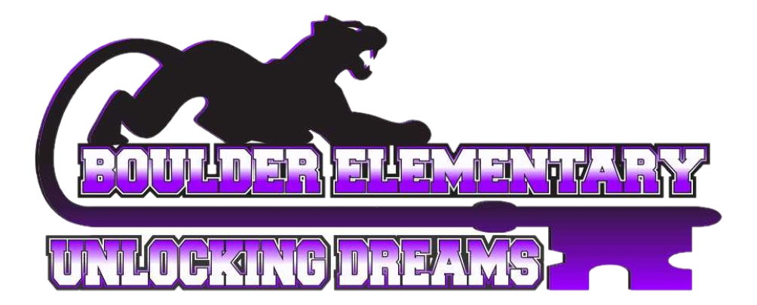Boulder Elementary School
2021-2022 School Supply List
Grade 7th – 8th Teacher: Mrs. Ottman
- 2 Spiral Bound notebooks (not composition notebooks)
- 1 Folder
- 2 Boxes of 24 Pencils (1 for the classroom)
- Note Cards
- 2 Boxes of Kleenex (200 count or greater)
- 2 Two Pocket Folders
- Dry Erase Markers
- Markers
- Highlighters
- Colored Pencils

