phan

Second Grade

* Each second-grade student will receive instruction in English Language Arts (ELA) and Math daily. The children will have social studies and science instruction, alternating every two weeks. Students will also participate in other classes each week: P.E. (5 days per week) and Music (1 day a week). We will have STEAM lessons throughout the school year which will focus on science, technology, engineering, arts, and math. Our children will also engage in counseling lessons once a month.
* Our 2nd Grade Course of Study goes beyond textbook teaching and is based on the Alabama State Standards. Our second-grade curriculum will cover Reading, Language Arts, Math, Science and Social Studies. Our reading resource is Open Court by McGraw Hill. Students will develop their reading skills, such as fluency and comprehension through increased word study. They will be exposed to more complex texts and a variety of genres. Envision Math by Savvas is our math resource. The children will work with the base ten number system, build fluency with addition and subtraction facts, learn units of measure, and identify shapes and their attributes. We also use other resources for math and reading, such as MyPath.

**Classroom Rules**

* Be a friend. Second grade should never be lonely!
* Use quiet voices. Communication is welcome, just at a low volume.
* Participate and stay on task. This will help you grow!
* Be cooperative. Always listen and respect other’s ideas.
* Keep all areas of the classroom tidy. It’s everyone’s responsibility.
* Always tell the truth, no matter if you will receive consequences.
* Always do your best, no matter how challenging the task.

We will use a clip chart system in our classroom. If children move their clips down for a poor choice in behavior, they will have the opportunity to move the clip back up the chart!

Children will have take-home binders so they can stay organized. The students will be responsible for bringing the binder home each day and having it for school each morning. Students are expected to clean out their binders with their parents each night.

**Components**

* **Behavior Chart** – This tool will communicate to parents how their children followed rules every day. The behavior chart will be coded with colors that will indicate the type of behavior the children displayed in the educational setting.

SNIPpETs

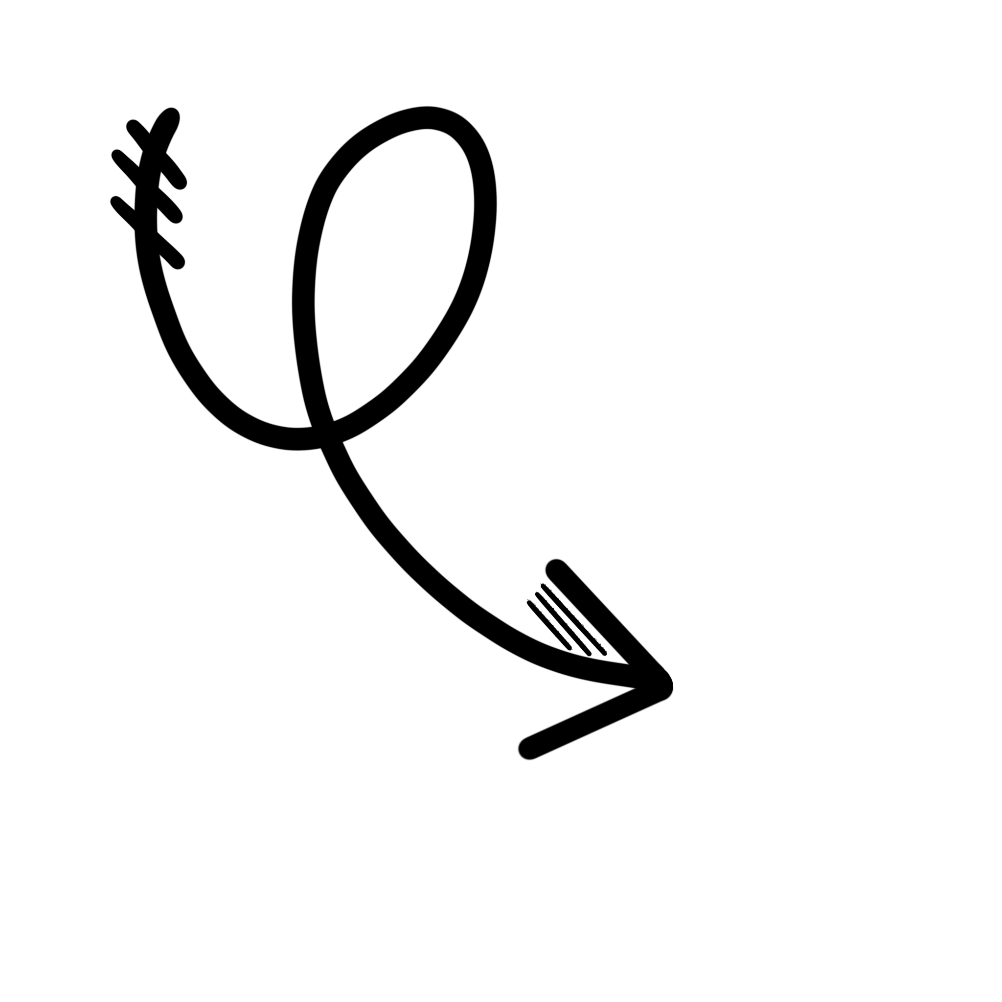

Introduction: Step into Second Grade

Rules: High Expectations

Classroom Binders: Keepin’ It Together!

* **Newsletter/Homework** – Students will receive a newsletter and homework sheet(s) each Monday. The newsletter will inform parents of concepts and skills we will be learning for the week, as well as, spelling and vocabulary lists, assessment dates, and all upcoming events. Homework needs to be worked on a little each night and completed by Thursday night. Homework must be turned in each Friday. (If your child forgets their homework every now and then, I promise it’s going to be ok!) Children needs to practice math facts (addition and subtraction) and read a text on their level each night with a parent.
* **Graded Papers** – Each Tuesday your child will receive graded papers. Please look over the papers and review them with your child. If you find a mistake that I have made or have a question about a test item, please do not hesitate to contact me. I will be glad to answer any questions you may have or correct any mistake that I make.
* **Classroom Work** – This pocket will be the papers your child completes in class. Please take these out each night.

**Major Grades**  
Major grades are derived from the Autauga County Adopted Core and Supplemental Programs.

|  |  |  |  |  |
| --- | --- | --- | --- | --- |
|  | **Quarter 1** | **Quarter 2** | **Quarter 3** | **Quarter 4** |
| **Reading** | OCR Comprehension and Vocabulary Tests | OCR Comprehension and Vocabulary Tests | OCR Comprehension and Vocabulary Tests | OCR Comprehension and Vocabulary Tests |
| **ELA** | Opinion Writing (2) | Informative Writing (2) | Narrative Writing (2) | Research Project (1) |
| **Math** | Topic Assessments | Topic Assessments | Topic Assessments | Topic Assessments |

**Minor Grades**Minor grades are derived from Weekly Lesson Tests (Reading/ELA), Skills Practice Pages (Reading/ELA), Spelling Tests (ELA), Math Practice Pages.

|  |  |  |  |  |
| --- | --- | --- | --- | --- |
| **A** | **B** | **C** | **D** | **F** |
| 100% - 90% | 89% - 80% | 79% - 70% | 69% - 60% | 59% - 0 |

Second grade will participate in the YMCA Water Safety Program and our social studies curriculum’s Citizen Program. These field trips will be for students only. We will have field trips this year where parents will be able to participate!

Email: [stephanie.rowell@acboe.net](mailto:stephanie.rowell@acboe.net)  
Parent Square Platform  
PLES Phone #: 334-358-2658

Assessments and Grading: A+ Work

Field Trips: Let’s Get Goin’

Communication: Teamwork Makes the Dream Work!