Moseley Athletics Hat Fundraiser
Hats will be 28$ apiece. Orders can be turned into Coach M or Coach J by Friday March 6th. All orders are pre-pay only.

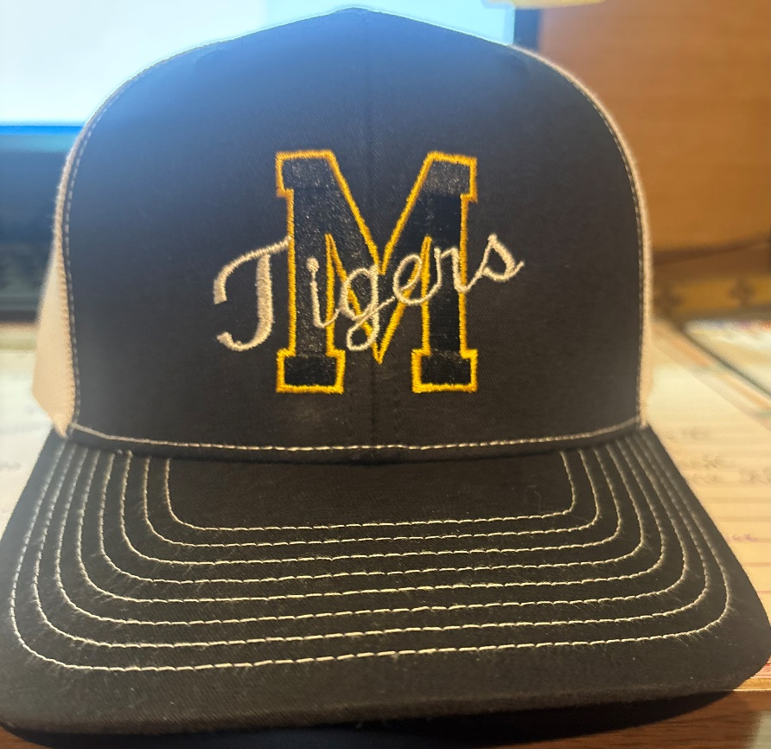

Name: _____________________________________________

Number of Items: _______________________

