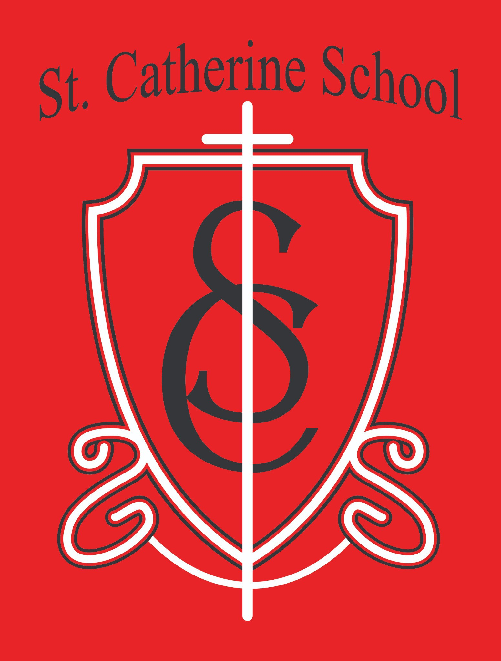

**St. Catherine School Weekly Newsletter Week of May 5-9** [**https://www.stcatherine.k12.nd.us/parents**](https://nam02.safelinks.protection.outlook.com/?url=https%3A%2F%2Fwww.stcatherine.k12.nd.us%2Fparents&amp;data=05%7C02%7CTerra.Giesen%40k12.nd.us%7C86f1efc608704052b4b608dd8f0cd85a%7Cdbbf782acef14af186c81f9201061db6%7C0%7C0%7C638824007554065610%7CUnknown%7CTWFpbGZsb3d8eyJFbXB0eU1hcGkiOnRydWUsIlYiOiIwLjAuMDAwMCIsIlAiOiJXaW4zMiIsIkFOIjoiTWFpbCIsIldUIjoyfQ%3D%3D%7C0%7C%7C%7C&amp;sdata=votXDUZwrtzoYwcrKgV42QDExaTUV%2BFWeYl9wLXJXGc%3D&amp;reserved=0)

# Principal's Message

This past week, the **school choice debate** once again reached the highest levels of our state government. **House Bill 1540**, a measure that would have expanded educational choice for North Dakota families, was **vetoed by Governor Armstrong**, just as a similar bill was vetoed by Governor Burgum in 2023.

While I am disappointed by this decision, I am encouraged by the growing number of citizens and leaders across North Dakota who are working to empower **parents to choose the educational environment that best supports their children**. This issue is about putting families first—and we will continue to advocate for that future.

Unfortunately, as this bill advanced, several **inaccuracies were shared publicly**. I want to take a moment to clarify a few key facts:

**HB 1540 did not take money from public schools.** It proposed a separate

**general fund allocation**, not a diversion of existing education funding.

**Private schools in North Dakota are held to strong accountability standards**. We submit annual reports to the state, our teachers must be **highly qualified**, and we **teach to the same academic content standards** as public schools.

## North Dakota is one of the most regulated states in the country for private school oversight.

Finally, the claim that private schools are inherently discriminatory is misleading. At **St. Catherine School**, we work incredibly hard to serve a wide range of students— including those with unique learning needs—and we do so with **little to no outside funding**, always placing the **dignity of the child** at the center of our decisions.

A **big thank you to the parents who helped advocate alongside us**—through testimony, calls, letters, and prayers. Although the outcome was not what we hoped for, I was **proud to represent our school in Bismarck** and to advocate for our **families and students**.

I will continue to do so—**each day and at every opportunity**.

Thank you for believing in our mission and for walking this journey with us.

# Reminders

## Field Day – Wednesday, May 14 (Afternoon)

☀

We’re excited for a fun-filled **Field Day next Wednesday afternoon**!

Please **pray for good weather**, and look out for more details coming early next week.

## Library Book Return – Due by May 20

📚

Please return **all library books** to the school by **Monday, May 20**.

**5th & 6th Grade States and Countries Presentations – Friday, May 16** Join us in the **gym at 1:00 PM** on Friday, May 16, as our **5th and 6th grade students present their States and Countries projects**.

🌍

All are welcome to attend—come support their hard work!

## 6th Grade Graduation Mass – Tuesday, May 20

Our **6th Grade Graduation Mass** will be held at **9:**🎓**30 AM** in the church.

All are welcome to attend this celebration of faith, growth, and community.

## Last Day of School – Wednesday, May 21

📅

St. Catherine School will follow **Valley City Public School's early dismissal**

schedule.

## Dismissal at 12:10 and 12:15 PM Buses will run

**Sack lunch will be served** before dismissal

## Childcare Center Updates – Progress, Enrollment & Hiring News

🏗

Renovations are moving along at **St. Catherine Little Saints Childcare**: Kitchen cabinetry is installed

Flooring work continues in the **infant room and kitchen Back bathrooms** are nearing completion

**Painting is underway**, transforming the space!

## ✅ Staffing Update:

Several **full-time and part-time staff** have been hired, in addition to **Director Beth Nadelin**

Still hiring for **Lead Teachers, Assistant Teachers, and Float Teachers**

📧 Contact: [beth.nadelin@k12.nd.us](mailto:beth.nadelin@k12.nd.us) | ☎ 701-845-1453

## 🍼 Crib Sponsorship – 1 Remaining!

A full sponsorship is **$250**

💛

Thank you to all who’ve supported this effort!

## 📢 Now Enrolling:

We accept **childcare assistance**

Serving up to **78 full-time spots** across age levels Follow us on social media or contact Beth directly Thank you to the families who have already enrolled!

## Big Ticket Raffle – Let’s Get Them Sold!

Help us meet our goal in this **critical fundra**🎟**iser**:

💰

## Only 300 tickets available

**$100 per ticket**

**$5,000 Grand Prize** + Five **$1,000 prizes**

About **190 tickets remain**

✅ Reach out to **family and friends**

✅ Consider buying an extra if you're able—**every ticket makes a difference**

# St. Catherine Spotlight

**What a joyful celebration we had at our Spring Music Program on Thursday, May 8!** The evening was a beautiful display of student **talent, creativity, and community spirit**. A packed house of parents, grandparents, parishioners, and friends filled the gym to cheer on our students—and it did not disappoint!

🎶 **Ms. Busch and Mr. Kjelland** did an outstanding job preparing our students.

The **band performance was excellent**—it was heartwarming to see students so engaged in music.

**Artwork and quilts** were beautifully displayed, thanks to Ms. Busch’s vision and extra effort, making the space come alive with color and creativity.

We also recognized two amazing groups for their contributions to our school:

## Business Friend of St. Catherine School – Ivy Real Estate Group

💼

Owned by **Loni Trapp and Alison Kasowski**, Ivy Real Estate Group has been a

## steadfast supporter.

Alison chairs our **Fall Auction** and serves as **President of our Board of Education**.

The Kasowski family includes one alum and two current students. We are so grateful for their leadership and support.

## Friend of St. Catherine School – St. Catherine Quilters

🧵

This generous group not only **sews and donates quilts** to service organizations but also teaches our **older students how to quilt**, living out our mission of **faith, learning, and service**.

Their patience and love have made a lasting impact on our students—and our students truly **love quilting**!

Summer Tutoring Program – Enroll Now! 📚✏

**St. Catherine School is now enrolling for our Summer Tutoring Program** for students entering **grades K–6** in the **2025–2026 school year**.

Open to **all families in the community** — students **do not need to be currently enrolled** at St. Catherine School. This program is designed to support both students who need extra help and those looking for enrichment.

*Tutoring Details:*

**Dates:** June through the first week of August **Days:** Tuesdays, Wednesdays, and Thursdays **Tutor:** *Ms. Halley Thoreson*

St. Catherine aide and VCSU elementary education major Experienced with reading and math interventions

*Two Format Options:*



Option A: Three 30-minute sessions/week → $150/month Option B: Three 1-hour sessions/week → $300/month **Rate:** $25/hour

**Billing:** Monthly through St. Catherine School

📌 **Note:**

No refunds for missed sessions (unless canceled by the school) **Minimum of 3 sessions per week** for effective intervention Planning meetings with each family will be held in May

We also have access to **Barton and SPIRE curricula** for students showing signs of dyslexia. Curriculum needs will be discussed at your family’s planning meeting.

## 👉 Enroll by May 15:

🔗 [Summer Tutoring Enrollment Form](https://nam02.safelinks.protection.outlook.com/?url=https%3A%2F%2Fforms.cloud.microsoft%2FPages%2FResponsePage.aspx%3Fid%3DKni_2_HO8UqGyB-SAQYdtuNWEWJUrb9IqWawNyzDkbpUNldVQktQTkE5RzU5VjhZSzMzU1pEMkY5Qy4u&amp;data=05%7C02%7CTerra.Giesen%40k12.nd.us%7C86f1efc608704052b4b608dd8f0cd85a%7Cdbbf782acef14af186c81f9201061db6%7C0%7C0%7C638824007554088552%7CUnknown%7CTWFpbGZsb3d8eyJFbXB0eU1hcGkiOnRydWUsIlYiOiIwLjAuMDAwMCIsIlAiOiJXaW4zMiIsIkFOIjoiTWFpbCIsIldUIjoyfQ%3D%3D%7C0%7C%7C%7C&amp;sdata=4g%2FLQk90kl70FYIjk4jc8csq6T6wweN87Wt3%2B9ZnaIc%3D&amp;reserved=0)

Questions? Email **Mr. Lee** at [nicholas.lee1@k12.nd.us](mailto:nicholas.lee1@k12.nd.us)

📧

Stay Connected with St. Catherine School

📍 **Address:** 540 3rd Ave. NE, Valley City, ND 58072

**Email:** [nicholas.lee1@k12.nd.us](mailto:nicholas.lee1@k12.nd.us)

📧

**Phone:** 1-701-845-1453

📞

**Website:** [www.stcatherine.k12.nd.us](https://nam02.safelinks.protection.outlook.com/?url=https%3A%2F%2Fwww.stcatherine.k12.nd.us%2F&amp;data=05%7C02%7CTerra.Giesen%40k12.nd.us%7C86f1efc608704052b4b608dd8f0cd85a%7Cdbbf782acef14af186c81f9201061db6%7C0%7C0%7C638824007554104599%7CUnknown%7CTWFpbGZsb3d8eyJFbXB0eU1hcGkiOnRydWUsIlYiOiIwLjAuMDAwMCIsIlAiOiJXaW4zMiIsIkFOIjoiTWFpbCIsIldUIjoyfQ%3D%3D%7C0%7C%7C%7C&amp;sdata=PhJpQy9rMAOcSC6dOUPTA%2F1QIrmJ6xLnvhsLsbrubDg%3D&amp;reserved=0)

🌐

📘 **Follow Us on Facebook:** [St. Catherine School on Facebook](https://nam02.safelinks.protection.outlook.com/?url=https%3A%2F%2Fwww.facebook.com%2Fst.catherineschoolvc%2F&amp;data=05%7C02%7CTerra.Giesen%40k12.nd.us%7C86f1efc608704052b4b608dd8f0cd85a%7Cdbbf782acef14af186c81f9201061db6%7C0%7C0%7C638824007554119666%7CUnknown%7CTWFpbGZsb3d8eyJFbXB0eU1hcGkiOnRydWUsIlYiOiIwLjAuMDAwMCIsIlAiOiJXaW4zMiIsIkFOIjoiTWFpbCIsIldUIjoyfQ%3D%3D%7C0%7C%7C%7C&amp;sdata=ItBTJsSkKmtORiROt%2B5aXkm6zSF0Mfo05j82uktmWEg%3D&amp;reserved=0)

*“Inspiring excellence through faith, learning, and service.”*