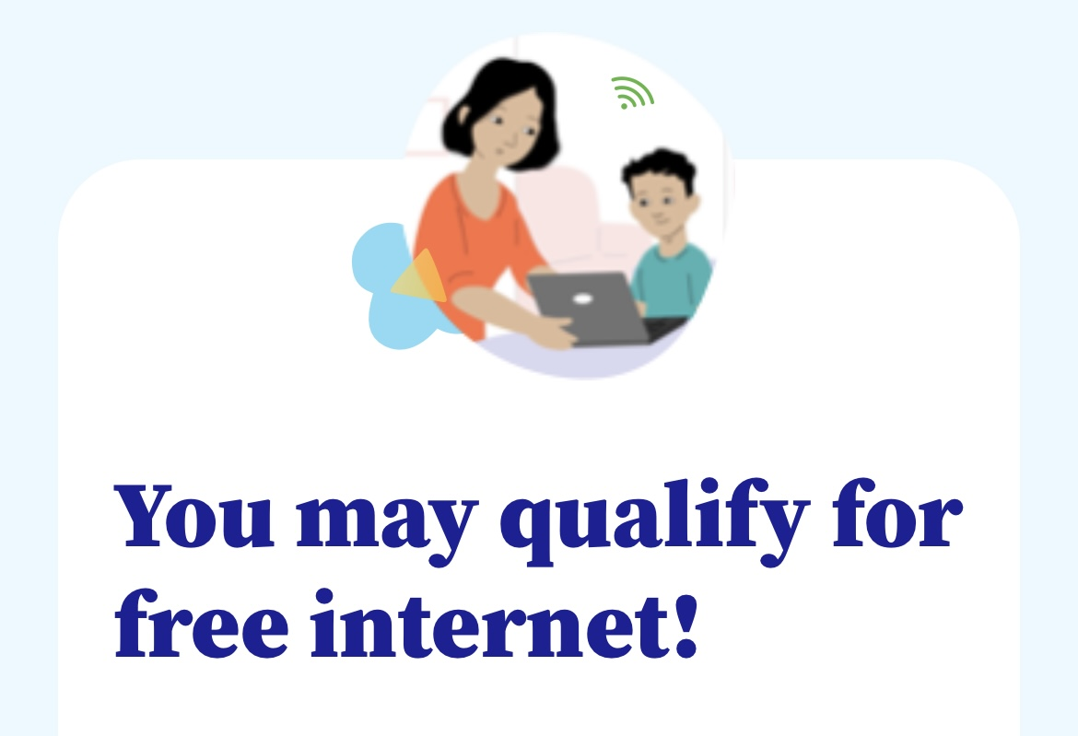
The Affordable Connectivity Program (ACP) is a new federal benefit that helps pay for internet service and devices. For more information, visit www.GetMyInternet.org

