CERTIFIED EVALUATION PLAN


PROFESSIONAL GROWTH & EVALUATION
OF CERTIFIED STAFF

2026-2027

PERRY COUNTY SCHOOLS
Kent Campbell, Superintendent

“WE EXPECT SUCCESS”

MISSION
The mission of Perry County Schools is to provide a safe and engaging school environment where students are not only supported, but also challenged.

VISION
The vision of Perry County Schools is to provide students with the tools to be post-secondary ready, community leaders, and innovative thinkers.

PURPOSE
The belief of Perry County Schools is to educate each student to their maximum potential using engaging instructional strategies. Each school will be a welcoming environment for every student and will assist in providing support to eliminate barriers to success.

NON-NEGOTIABLES

- All stakeholders will work together to create a supportive school environment which empowers students and staff to attain the highest levels of success.
- Staff will continually analyze data sources to make informed adjustments to instructional practices.
- Each member of our educational community will hold other members and themselves accountable and work to remove barriers to success.

Foreword

Kentucky law requires that each school district adopt board policies pertaining to staff evaluation and that a plan and procedures be submitted to the Kentucky Department of Education for approval.
The Perry County Board of Education recognizes that the evaluation of all certified staff members is essential to the achievement of the educational goals of the district. This policy and its accompanying procedures specify the rationale and methods for so doing. The purpose of this evaluation program is to promote professional excellence and improve the skills of teaching staff members, improve student learning and growth, and provide a basis for the review of staff performance.
In order to assure the greatest benefit to the district from this program of evaluation, the Board will provide skilled leadership, adequate resources for supervision, quality professional development, and time to conduct evaluations properly. These factors are intended to improve learning experiences of students.
The evaluation process is a valuable tool for the improvement of teaching and learning in Perry County Schools. This process has been developed to guarantee that our certified personnel are, and remain, professional, motivated, and highly skilled. With this in mind, Perry County Schools are involved in an evaluation process that we believe will provide positive benefits for personal growth and the improvement of education in our school district.

KENT CAMPBELL

Kent Campbell, Superintendent
Perry County Schools

INTRODUCTION

The evaluation of certified personnel is an important tool that our district utilizes to help assure the public, community, parents, and students that providing a quality education is foremost.

Evaluation is the process of assessing or determining the effectiveness of performances and products to:
- promote the continuation of professional competence
- identify areas for professional growth
- Assist in making personnel decisions

The purpose of evaluation is improving instruction, curriculum, assessment, and other professional responsibilities.

The principal is primarily responsible for evaluating teachers with the assistance of an assistant principal where appropriate. One-year summative cycle teachers will be evaluated yearly and five-year summative cycle teachers will be evaluated at least every five years following the requirement of the teacher/specialist framework system.

Administrators will be evaluated annually by the superintendent or by the superintendent’s designee following the requirements of the PGES system.

The Superintendent will be evaluated annually by the local school board.

The local school district shall designate a contact person responsible for monitoring evaluation training and implementation of the Professional Growth and Effectiveness System.

Perry County Schools
Certified Evaluation Plan
Table of Contents
Mission, Vision, Non-Negotiables………………………………………………………………………………………………………………….. 2
Foreword- Superintendent ……………………………………………………………………………………………………………………………… 3
Introduction ……………………………………………………………………………………………………………………………………………………. 4
Assurances ………………………………………………………………………………………………………………………………………………… … 6
Committees ………………………………………………………………………………………………………………………………………………… 7
Professional Growth and Effectiveness System- Role and Definitions............................................................ 8-10
The Kentucky Framework for Teaching/Specialist ………………………………………………………………………………………….11
Sources of Evidence/Framework for Teaching Alignment ………………………………………………………………………………12
Professional Practice Growth Planning and Self-Reflection ……………………………………………………………………..13-14
Timeline for PGP………………………………………………………………………………………………………………………………………… …..14
Observation- Model/Schedule ………………………………………………………………………………………………………………….15-16
Observation Timeline/Conferencing………………………………………………………………………………………………………… .17-20
Evaluation Procedures/Process…………………………………………………………………………………………………………….. 21-22
Observations ………………………………………………………………………………………………………………………………………………23-25
Products of Practice/Other Sources of Evidence……………………………………………………………………………………… 25-27
Determining the Overall Performance Category …………………………………………………………………………………………… 28
Principals and other Building Administrators-District Level Administrators Evaluation Process
Performance Measures and the Professional Standards for Educational Leader…………………………………………… 29 Professional Practice ……………………………………………………………………………………………………………………………………..29
Professional Growth Plan and Self Reflection …………………………………………………………………………………………..30-31
Products of Practice ………………………………………………………………………………………………………………………………………32
Determining the Overall Performance Category/ Rating Overall Professional Practice …………………………………32
Determining Source of Evidence Summative Rating ………………………………………………………………………………….33-36
Other District Certified Personnel……………………………………………………………………………………………………………...37-38
Appeals Process …………………………………………………………………………………………………………………………………………39-42
Appendix A- Pre-observation Information ……………………………………………………………………………………………………..43
Appendix B- Post Observation Document ……………………………………………………………………………………………………. 44
Appendix C- Individual Targeted Growth Plan……………………………………………………………………………………………45-46
Appendix D- Individual Corrective Action Plan…………………………………………………………………………………………..47-48
Appendix E- Individual Growth Plan…………………………………………………………………………………………………………..49-50
Appendix F- Summative Evaluation Report………………………………………………………………………………………………… 51
Appendix G- Summative Certified Teacher…………………………………………………………………………………………………52-53
Appendix H- Summative Library Media Specialist………………………………………………………………………………………54-55
Appendix I- School Psychologist………………………………………………………………………………………………………………… 56-57
Appendix J- Instructional Specialists………………………………………………………………………………………………………… 58-59
Appendix K- School Counselors/Social Workers…………………………………………………………………………………………60-61
Appendix L- Therapeutic Specialists……………………………………………………………………………………………………………62-63
Appendix M- Technology Personnel Evaluation…………………………………………………………………….……………………64-65
Appendix N- Individual Teacher PD Plan…………………………………………………………………………………………………………66
Appendix O- Kentucky Framework Criteria Crosswalk ……………………………………………………………………………………67
ASSURANCES CERTIFIED SCHOOL CERTIFIED EVALUATION PLAN
The Perry County Schools hereby assures the Commissioner of Education that:

This evaluation plan was developed by an evaluation committee composed of an equal number of teachers and administrators (KRS 156.557).
Name: Title:
Johnny Wooton Deputy Superintendent

The evaluation criteria and process used to evaluate certified school personnel shall be explained to and discussed with the evaluatee no later than the end of the evaluatee’s first thirty (30) calendar days of reporting for employment each school year. (704 KAR 3:370)

All certified school personnel who have not attained continuing service status shall receive an annual summative evaluation and shall incorporate the formative data collected during the Kentucky Teacher Internship Program (if funded). (KRS 156.557)

All certified school personnel who have attained continuing service status shall receive a summative evaluation at least once every five (5) years. (KRS 156.557)

Each evaluator will be trained, tested, and approved in the use of appropriate evaluation techniques (KRS 156.557).

This plan requires a summative evaluation of certified school personnel to be documented in writing and to be included in the evaluatee’s official personnel record. (704 KAR 3:370)

The local evaluation plan provides for the right to a hearing as to every appeal, an opportunity to review all documents presented to the evaluation appeals panel, and a right to presence of evaluatee’s chosen representative (KRS 156.557).

The evaluation plan process will not discriminate on the basis of age, race, color, national origin, religion, sex, disability, or any other protected characteristic, as required by all applicable federal, state, and local law.

The local board of education shall review, as needed, the district’s certified evaluation plan to ensure compliance with KRS 156.557 and this administrative regulation. If a source of evidence is added or removed from the certified evaluation plan or if a decision rule or calculation is changed in the summative rating formula, the revised certified evaluation plan shall be reviewed and approved by the local board of education. If the local board of education determines the changes do not meet the requirements of KRS 156.557, the certified evaluation plan shall be returned to the certified evaluation committee for revision.

The local board of education approved the evaluation plan as recorded in the minutes of the meeting held on . (704 KAR 3:370)

__________________________________________________ _______________________
Signature of District Superintendent Date

__________________________________________________ _______________________
Signature of Chairperson, Board of Education Date
Certified School Personnel Evaluation Plan
Perry County Schools
315 Park Avenue
Hazard, Kentucky 41701

Superintendent: Kent Campbell

Evaluation Contact Person: Johnny Wooton (606) 439-5813
Superintendent Designee for Evaluation of Administrators

Evaluation of Certified Personnel Committee: 50/50 Committee (Appointed by BOE)

Administrators:
- Johnny Wooton- Central Office
- Josh Baker- Central Office
- Emily Duke-Kemper- Principal/West Perry Elementary
- Jennifer Hickerson- Principal/East Perry Elementary
- Harvey Colwell- Central Office

Teachers
- Missi Daniels - West Perry Elementary
- Kathy McIntyre - Viper Elementary
- Tiffany Hall- East Perry Elementary
- Denise Colwell - Buckhorn Elementary
- Matt Robinson – Perry County Central High School

Certified Appeals Committee (3 Yr. Cycle: 26/27 – 28/29)

Administrator: Josh Baker Alternate: Harvey Colwell

Teachers (Popular Vote)
1. Daniel Combs
2. Devina Baker

Alternate(s)
1st Alternate: Jeremy Woolum
2nd Alternate: Donnie Paul Fugate

*Nomination and election will take place with schools beginning on the opening day of SY 26/27.

Perry County School District Professional Growth and Effectiveness Plan

Professional Growth and Effectiveness System – Certified Teacher
The vision for the Professional Growth and Effectiveness System (PGES) is to have every student taught by an effective teacher and every school led by an effective leader. The goal is to create a fair and equitable system to measure teacher and leader effectiveness and act as a catalyst for professional growth.

Roles and Definitions (These are from the 5.0 version along with Full and Mini observations defined)

- Roles and Definitions
- Artifact: A product of a certified school personnel’s work that demonstrates knowledge and skills.
- Assistant Principal: A certified school personnel who devotes the majority of employed time in the role of assistant principal, for which administrative certification is required by EPSB.
- Certified Administrator: A certified school personnel, other than principal or assistant principal, who devotes the majority of time in a position in a district for which certification is required by EPSB.
- Certified School Personnel: A certified employee, below the level of superintendent, who devotes the majority of time in a position in a district for which certification is required by EPSB.
- Conference: A meeting between the evaluator and the evaluatee for the purpose of providing feedback, analyzing the results of an observation or observations, reviewing other evidence to determine the evaluatee’s accomplishments and areas for growth, and leading to the establishment or revision of a professional growth plan.
- Evaluatee: A certified school personnel who is being evaluated.
- Evaluator: The primary evaluator as described in KRS 156.557(5)(c)2.
- Formative Evaluation: is defined by KRS 156.557(1)(a).
- Full Observation: An observation lasting from the beginning to the end of the lesson usually lasting around 60 minutes conducted by the certified evaluator who collects evidence based on the established framework for TPGES/OPGES. Pre-observation and post observation forms are required for mini observations.
- Improvement Plan: A plan for improvement up to twelve months in duration for:
  - Teachers and other professionals who are rated ineffective in professional practice and have a low overall student growth rating.
  - Principals who are rated ineffective in professional practice and have high, expected, or low overall student growth rating.
- Job Category: A group or class of certified school personnel positions with closely related functions.
- Mini Observation: An observation lasting 15-30 minutes, conducted by the certified evaluator who collects evidence based on the established framework. Observation will reflect components from domains 2 & 3 of the KyFft based on needs of the teacher. Pre-observation and post observation forms are required for mini observations.
- Observation: a data collection process conducted by a certified observer, in person or through video, for the purpose of evaluation, including notes, professional judgements, and examination of artifacts made during one (1) or more classroom or worksite visits of any duration.
- Other Professionals: Certified school personnel, except for teachers, administrators, assistant principals, or principals.
- Performance Criteria: The areas, skills, or outcomes on which certified school personnel are evaluated.
- Performance Rating: The summative descriptions of a teacher, other professional, principal, or assistant principal evaluatee’s performance, including the ratings listed in Section 7(8) of this administrative regulation.
- Principal: A certified school personnel who devotes the majority of employed time in the role of principal, for which administrative certification is required by the Education Professional Standards Board pursuant to 16 KAR 3:050.
- Professional Growth and Effectiveness System: An evaluation system to support and improve the performance of certified school personnel that meets the requirements of KRS 156.557(1) (c), (2), and (3) and that uses clear and timely feedback to guide professional development.
- Professional Growth Plan: An individualized plan for a certified personal that is focused on improving professional practice and leadership skills, aligned with performance standards and the specific goals and objectives of the school improvement plan or the district improvement plan, built using a variety of sources and types of data that reflect student needs and strengths, evaluatee data, and school and district data, produced in consultation with the evaluator as described in Section 9(1), (2), (3), and (4) and Section 12(1), (2), (3), and (4) of this administrative regulation, and includes: (a) Goals for enrichment and development that are established by the evaluatee in consultation with the evaluator; (b) Objectives or targets aligned to the goals; (c) An action plan for achieving the objectives or targets and a plan for monitoring progress; (d) A method for evaluating success; and (e) The identification, prioritization, and coordination of presently available school and district resources to accomplish the goals.
- Professional Practice: The demonstration, in the school environment, of the evaluatee’s professional knowledge and skills.
- Professional Practice Rating: The rating that is calculated for a teacher or other professional evaluatee pursuant to Section 7(8) of this administrative regulation and that is calculated for a principal or assistant principal evaluatee pursuant to the requirements of Section 10(7) of this administrative regulation.
- Self-Reflection: The process by which certified personnel assesses the effectiveness and adequacy of their knowledge and performance for the purpose of identifying areas for professional learning and growth.
- Sources of Evidence: The multiple measures listed in KRS 156.557(4) and in Section 7 and 10 of this administrative regulation.
- Summative Evaluation: is defined by KRS 156.557(1)(d).
- Teacher: A certified school personnel who has been assigned the lead responsibility for student learning in a classroom, grade level, subject, or course and holds a teaching certificate under 16 KAR 2:010 or 16 KAR 2:020.
- Walkthrough snapshot: A brief observation, 10-15 minutes, conducted by the evaluator. Snapshots do not require a pre or post observation conference or form. These observations provide quick feedback to the teacher based on the observed domain component of the Kentucky Framework for Teaching.

For Additional Definitions and Roles, please see 704KAR 3:370 Professional Growth and Effectiveness System.

The Kentucky Framework for Teaching with Specialist Frameworks for Other Professionals
The Kentucky Framework for Teaching is designed to support student achievement and professional practice through the domains of:

Framework for Teaching Specialist Framework for Other Professionals
Planning and Preparation Planning and Preparation
Classroom Environment Environment
Instruction Delivery of Service
Professional Responsibilities Professional Responsibilities

The Framework also includes themes such as equity, cultural competence, high expectations, developmental appropriateness, accommodating individual needs, effective technology integration, and student assumption of responsibility. They provide structure for feedback for continuous improvement through individual goals that target professional growth, thus supporting overall school improvement. Evidence documenting professional practice is situated within one or more of the four domains of the framework. Performance is rated for each component according to four performance levels: Ineffective, Developing, Accomplished, and Exemplary. The summative rating will be a holistic representation of performance, combining data from multiple sources of evidence across each domain.

The use of professional judgment based on multiple sources of evidence promotes a more holistic and comprehensive analysis of practice, rather than over-reliance on one individual data point or rote calculation of practice based on predetermined formulas. Evaluators will also take into account how educators respond to or apply additional supports and resources designed to promote student learning, as well as their own professional growth and development. Finally, professional judgment gives evaluators the flexibility to account for a wide variety of factors related to individual educator performance, such as: school-specific priorities that may drive practice in one domain, an educator’s number of goals, experience level and/or leadership opportunities, and contextual variables that may impact the learning environment, such as unanticipated outside events or traumas.

Evaluators must use the following categories of evidence in determining overall ratings:
Required for All Perry County teachers
  - Self-Reflection and Professional Growth Planning
  - Observation
- Other Measures of Student Learning
- Products of Practice
- Other Sources (e.g., surveys)

All components and sources of evidence related supporting an educator’s professional practice will be completed and documented to inform the Overall Performance Category, All Summative Ratings will be recorded in the department-approved technology platform.
SOURCES OF EVIDENCE/FRAMEWORK FOR TEACHING ALIGNMENT
FRAMEWORK for TEACHING (FfT) | Domain | Planning & Preparation |  |  |  |  |  | Classroom Environment |  |  |  |  | Instruction |  |  |  |  |  | Professional Responsibilities
FRAMEWORK for TEACHING (FfT) | Component | 1a -Knowledge of content/pedagogy | 1b-Demonstrate knowledge of students | 1c- Setting Instructional Outcomes | 1d-Demonstrates knowledge of resources | 1e-Designing Coherent Instruction | 1f- Designing Student Assessment | 2a-Creating Env. of Respect & Rapport | 2b-Establish Culture of Learning | 2c-Maintaining Classroom Procedures | 2d-Managing Student Behavior | 2e-Organizing Physical Space | 3a-Communicating with Students | 3b-Questioning & Discussion Techniques | 3c-Engaging Students in Learning | 3d-Using Assessment in Learning | 3e-Demonstrating Flexibility & Responsive | 4a-Reflecting On Teaching |  | 4b-Maintaining Accurate Records | 4c-Communicating With Families | 4d-Participating in Profess. Learning Comm. | 4e-Growing & Developing Professionally | 4f-Showing Professionalism
SOURCES OF EVIDENCE  To Inform Professional Practice | Supervisor Observation | Evidence  (pre conferences) |  |  |  |  |  | Observation |  |  |  |  |  |  |  |  |  |  | Evidence  (post conferences)
SOURCES OF EVIDENCE  To Inform Professional Practice | Professional Growth | Professional Growth Planning and Self Reflection
SOURCES OF EVIDENCE  To Inform Professional Practice | Self  Reflection
Professional Practice
Self-Reflection and Professional Growth Planning
Reflective practices and professional growth planning are iterative processes. The teacher (1) reflects on his or her current growth needs based on multiple sources of data and identifies an area or areas for focus; (2) collaborates with his or her administrator to develop a professional growth plan and action steps; (3) implements the plan; (4) regularly reflects on the progress and impact of the plan on his or her professional practice; (5) modifies the plan as appropriate; (6) continues implementation and ongoing reflection; (7) and, finally, conducts a summative conference with the evaluator to discuss goal attainment and the implications for next steps.

The Professional Growth Plan will address realistic, focused, and measurable professional goals. The plan will connect data from multiple sources including classroom observation feedback, data on student achievement, and professional growth needs identified through self-assessment and reflection. In collaboration with the administrators, teachers will identify explicit goals which will drive the focus of professional growth activities, support, and on-going reflection.

Required for all Perry County Teachers
- All Teachers and Other Professional specialists participate in self-reflection and professional growth planning each year.

- PROFESSIONAL GROWTH PLAN

As part of the formal evaluation process, all certified staff members below the level of superintendent shall develop an annual professional growth plan in collaboration with his/her immediate supervisor. The professional growth plan must be aligned with the specific goals and objectives of the school or district improvement plan and with findings of formative evaluations conducted by supervisor. Any personnel who receives an overall score of “Ineffective” shall develop goals on the professional growth plan that address the standard where that score has been assigned and directed by the evaluator. Growth plans are reviewed annually.

The professional growth plan will be reviewed and monitored by the immediate supervisor. For those personnel being evaluated during any given year, the growth plan shall become a part of the official summative evaluation documentation. Former Professional Growth Plan evidence can be used in the summative rating. (See Appendix D)

Conferences must be held to evaluate progress toward improvement plan goals. After two (2)
Conferences, if no progress is apparent, the principal shall involve the next level of supervision in the evaluation process. To ensure fairness to all personnel, no evaluator shall evaluate members
of his/her family. Family members shall be defined in the instance pursuant to Section 4 KRS
160.180. Evaluation in such a case shall be conducted by the next level of supervision. The
evaluation process developed for the superintendent by the local board of education shall
include provision for assistance for professional growth of the superintendent pursuant to KRS
156.111.
TIMELINE FOR SELF REFLECTION/PGP
September 15th* | Teachers and Other Professionals will reflect on his/her current growth and completes the Self Reflection using the Framework specific to their job description. Teacher will develop a Professional Growth Goal focused on an identified area based on information and data currently available. Administrator must approve the Professional Growth Plan.
January-April * | Modifies plan as appropriate and continues implementation and ongoing reflection.
April 15th* | Summative reflection on the degree of goal attainment and implications for next steps will be discussed between certified staff members and building level supervisor.
Documentation Process | Building level administrators will meet with certified staff either in a Professional Learning Community or hold individual conferences with staff to develop, approve, and monitor the completion of the Self Reflection and Professional Growth Plan requirements. Conferences will be held (2) two times throughout the year (fall and spring) to monitor all certified staff including other professionals’ progress and completion of goals. Documentation of Self Reflections and Professional Growth Plans will be recorded using district developed electronic documents or the state approved platform and will be kept on file at each school.
*Timeline will be tentative based on any adjustment of the calendar year

Observation

The observation process is one source of evidence to determine teacher effectiveness that includes supervisor observation for each certified teacher. The supervisor observation will provide documentation and feedback to measure the effectiveness of a teacher’s professional practice. The rationale for each type of observation is to encourage continued professional learning in teaching and learning through critical reflection.

Observation Model

The observation model must fulfill the following minimum criteria:

Required for all Perry County Teachers

- 5 (five) observations in the summative cycle for certified staff with continuing contracts.
  - 4 mini-observations (Instructional focus- Domain 2 & 3)
  - 1 Full observation (domains 1-4)
- Final observation is conducted by the supervisor and is a full observation.
- Address any differences for Other Professionals

Documentation of Evidence | Documentation of Evidence for Full & Mini will be maintained by using district developed electronic forms or other district/state approved electronic formats. Documentation will be based on the Framework specific to certified staff job description. Observations of Other Professionals will be conducted as site visits using the Specialty Framework and the approved observation forms. Documentation will be completed on district approved forms or state approved platform.

Observation Schedule

Required for All Perry County Teachers

- Observations may begin after the evaluation training takes place within 30 calendar days of reporting for employment each school year.

Scheduled Observations
The principal will conduct scheduled observation according to evaluation requirements in which the teacher is informed of the date and time. A Pre-Observation Form is to be presented to the evaluator by the teacher (at least one day in advance)

Unscheduled Observations
The principal can also conduct unscheduled observation during the evaluation year or cycle. Additional unannounced observations may be conducted if considered necessary.

Observation Resources

Bullseye for Schools (Classroom walkthrough)
Bullseye for Schools is an educator support and coaching platform designed to streamline goal setting, feedback, and instructional growth. It provides a centralized system for administrators and teachers to align professional growth goals with evaluation standards, track progress over time, and engage in reflective conversations about instruction. Bullseye allows users to input evidence from classroom walkthroughs directly into the platform, categorize observations by domain, and monitor trends across staff or individual educators.

Observation Timeline

STEPS | PROCESS | TIMELINE
Step 1 | ORIENTATION: The evaluation criteria and process used to evaluate certified school including other professionals shall be explained and discussed with certified school personnel no later than the end of the first thirty (30) calendar days of reporting for employment for the school year. | Within 30 calendar days of reporting for employment.
Step 2 | PRE-OBSERVATION (TEACHER): Principal holds a pre-observation conference with teacher to be evaluated during the year. | One-Three days prior to scheduled observation
Step 3-1 | FORMAL OBSERVATION: Conduct formal observation and collect formative data. (Intern Teacher and principal) (Post Observation Conference held within 5 days of the full observation).  - First Year Teacher | Observations will be Three Full Observations over the course of the interns first year.
Step 3-2 | Formal Observation: Conduct formal observation and collect formative data (One Year Summative Cycle Teachers including Other Professional/Specialist) (Post Observation Conference held within 5 days of the full observation). Post observation conferences for mini will also be conducted in a face-to-face meeting.  - Limited contracts  - Targeted Growth Plans  - Corrective Action Plans | Observations will be over a one-year cycle.  First Semester  - Supervisor Full Observation  Second Semester  - Full Observation Summative (April 15th)  Additional observations can be conducted if deemed necessary.
Step 3-3 | FORMAL OBSERVATION: Conduct formal observations and collect formative data. (Five Year Summative Cycle Teachers including Other Professionals) (Post Observation Conference held within 5 days of the full observation). Post observation conferences for mini and peer observations will also be conducted in a face-to-face meeting.  - Continuing Contracts | Observations will be over a five-year cycle with the summative in the final year of the cycle. Additional observations can be conducted if deemed necessary. Four mini observations from administrator.  Year One-Mini  Year Two- Mini  Year Three- Mini  Year Four- Mini  Year Five- Full Summative  Evaluation from Supervisor. All observations must be completed by April 15th.
Step 3-4 | FORMAL OBSERVATION: Conduct formal observation and collect other formative data (Administrators) (Post Observation Conferences held within 5 days of the full observation). Site Visits will utilize the Principal Performance Standards. | One required formal observation annually when results are satisfactory (More observations shall occur when results are considered Ineffective)
Step 5 | INDIVIDUAL GROWTH PLAN-An individual growth plan shall be developed jointly by evaluator and evaluatee. | Refer to above information on the development of an individual growth plan.
Step 6 | SUMMATIVE EVALUATION: Evaluator completes evaluation summary | April 15 *
Step 7 | SUPERINTENDENT RECOMMENDATION: Evaluator recommends re-employment/termination to superintendent for One Year Summative Cycle teachers. | April 20 *

*All dates are tentative based upon the adjustments of the calendar year.

Observation Conferencing
Observers will adhere to the following observation conferencing requirements for teachers and other professionals:

Required for all Perry County Teachers

- Conduct observation pre-conference 1-3 days prior to the observation.
- Conduct observation post conference within five working days following each observation.

PERRY COUNTY EVALUATION PROCEDURES

The immediate supervisor of the certified school employee shall be designated the primary evaluator. Additional trained administrative personnel may be used to observe and provide information to the primary evaluator. The monitoring or observing of performance of a certified employee shall be conducted openly and with the full knowledge of the teacher or administrator.

ONE YEAR SUMMATIVE CYCLE TEACHERS

Intern teachers shall follow all rules and regulations as set forth by the Beginning Teacher Internship Program 704 KAR 20:320 (KTIP) and when applicable the Evaluation Guidelines 704 KAR 3:345. A copy of the Internship Summary Form, which is submitted to the Division of Certification, shall be placed in the intern’s personnel file. All intern observations will follow the Teacher Internship Program guidelines.

Each one-year summative cycle teacher other than interns will have two formal observations completed during their one-year evaluation cycle. Evaluators will complete one full observation during the first semester followed by a full observation and summative conference during the second semester. These will be completed on a yearly basis until receiving a five-year summative cycle status. Multiple observations are required for one-year summative cycle certified personnel.

An individual growth plan will be developed annually. This plan may be an enrichment or improvement plan, based on the performance rating of the formal evaluation and/or formative data.

The summative evaluation will be completed by April 15th. This date will be tentative based on any adjustment to the school calendar.

A copy of the formative observations and the summative evaluation report will be given to the teacher.

The summative evaluation report will be placed in the teacher’s file in the Central Office. Evaluations completed by evaluators will be housed on district approved forms and/or the state approved platform. Evaluations will be documented on approved forms and become part of the official personnel files.

FIVE YEAR SUMMATIVE CYCLE TEACHERS- Continuing Contract

Five-year summative cycle teachers will be evaluated using the observation cycle outlined in the Certified Evaluation Plan.

Each five-year summative cycle teacher will have one full observation and four mini observations completed during their five-year summative cycle. Evaulators will complete one mini observation during each of the first four years of this summative cycle. A full observation will take place in the fifth and final year of the summative cycle along with a summative conference.

An individual growth plan shall be developed annually. This plan may be an enrichment or improvement plan, based on the performance rating of the formal evaluation and/or formative data and reflected in the school/district comprehensive improvement plan.

Multiple observations will be conducted with five-year summative cycle teachers when deemed necessary by the evaluator or the evaluatee.

The summative evaluation for five-year summative cycle personnel will be completed by April 15th. This date will be tentative based on any adjustments to the school calendar.
A copy of formal observations and evaluations will be given to the teacher. Opportunity for written response shall be included in the personnel record.

The summative evaluation report will be placed in the teacher’s file. Evaluations completed by the evaluators will be housed on district approved forms and/or the state approved platform. Evaluations will be documented on approved forms and become part of the official personnel file.

OTHER PROFESSIONALS/SPECIALISTS

Teachers who fall into the Other Professionals category such as counselors, psychologists, library media specialists, instructional specialists (curriculum coaches, math specialists, reading specialists), itinerant staff (vision, hearing, OT) and school speech therapists will be evaluated utilizing the Specialty Framework that is specific to their job description. Other professionals will be evaluated following the same protocol as a first-year summative cycle teacher or a five-year summative cycle teacher. Specialty participants will receive full and mini as part of the evaluation cycle. Observations will be conducted similar to site visits as much as possible when evaluations occur. Evaluations completed by the evaluators will be housed on district approved forms and/or the state approved platform. Evaluations will be documented on approved forms and become part of the official personnel file.

EVALUATION PROCESS

Evaluators

All evaluators shall be trained in accordance with the rules and regulations as set forth in KRS 156.101. All Perry County evaluators shall be certified in the state approved certification platform and have updated training sessions on procedures and instruments before the beginning of each school year.

All trainings shall be conducted by persons who have received training in evaluation and/or have conducted training in evaluation methods.

The following personnel are listed as evaluators:
- The Perry County Board of Education will evaluate the superintendent.
- The superintendent or designee will evaluate Central Office personnel and principals.
- Principals and assistant principals will evaluate all certified personnel assigned to their schools.
- Specialists will be evaluated by the principal and/or designee assigned by central office personnel.
- Itinerants will be evaluated by the principal at the home school and/or designee assigned by central office personnel in consultation will other building principals as needed.

DESCRIPTION OF THE EVALUATION PROCESS

The evaluation process consists of several basic steps. Each step is designed to provide both the teacher and evaluator an orderly process for collecting information about the strengths and weaknesses of the staff member. The direct but simple process encourages continuous professional development in the areas essential to the learning process.

The pre-evaluation, formative, summative, and growth plan monitoring is described as follows:

PRE-EVALUATION CONFERENCE

STEP 1
- The evaluator explains and discusses the evaluation process with all certified staff.
- The evaluator determines the members of the staff that are to participate in the evaluation process during the school year.
- The district’s “Teacher Evaluation Schedule” is to be prepared by the principal and one copy is forwarded to the Central Office by the end of the first month of school.
- One-year summative cycle teachers evaluated annually.
- Five-year summative cycle teachers evaluated over a five-year cycle.

STEP 2
- The evaluator informs all members of the staff, listed on the “Teacher Evaluation Schedule”, that they will be evaluated during the school year. A written notification/agenda and a conference/meeting shall be completed by the end of the first month of reporting for employment for each school year.
- The evaluator shall conduct a pre-evaluation conference with each teacher on the evaluation list by October 15th of the school year. The conference shall provide the teacher with detailed information about the evaluation procedures that include the following:
- data collection procedures (observation, conferences, review of lesson plans, records, etc.)
- form information (types, completion dates, use of information, etc.)
- evaluation criteria (copy of criteria)
- timetable of events
- types of evaluation
- growth and enrichment plans (writing and monitoring)
- summative evaluation procedures
- confidentiality of evaluation process
- use of evaluation reports
- roles and responsibilities of teacher and evaluator
- addresses differences in peer and full observations
- The evaluator may meet with the teachers as a group or individually. Regardless of the method used, all pertinent information is to be provided and time permitted for conversation and questions. Teachers may request additional time if special questions or situations warrant an individual conference.

FORMATIVE PROCESS

PRE-OBSERVATION Conferences (Full & Mini)

Pre-observations conferences will be required for both mini & full observations. Pre-observations must be conducted one-three days prior to the scheduled observation. Pre-observations can be conducted by electronic forms of communication.

The teacher is responsible for providing the observer with pertinent information of the lesson to be observed for scheduled observation and (summative).

A Pre-Observation Information Form (PIF), provided in the appendix, is to be completed by the teacher one-three days prior to the observation date. The form is to be completed only for scheduled observations. (Appendix A)

The purpose of the PIF is to provide the observer immediate knowledge of the lesson to be observed and to pinpoint the unique characteristics of the class. The form is to be used to set the stage for the observer so he/she can focus immediately on the teaching-learning process.

The PIF is attached to the Formative Observation Instrument and is to become a part of the observation data file. It is recommended that the teacher keep a copy of the form in his/her file. This document can also be uploaded as an artifact using district approved forms and/or the state approved platform

OBSERVATIONS

For teachers, the formative observations (minis) will usually cover about 15-30 minutes of the lesson/class period. The content and length of any observation will be determined by the evaluatee and evaluator in advance of the actual observation.

Data which describes the teaching/learning situation will be gathered and recorded on the observation form and recorded on district approved forms and/or the state approved platform.

The principal (evaluator) is to observe the teaching/learning process and provide feedback to the teacher according to timelines established within the Certified Evaluation Plan.

See timeline for one-year summative cycle teachers and five-year summative cycle observations.

Supporting Data and Input
- Informal, non-scheduled snapshots are part of the evaluation process.
- Data or anecdotal notes will be shared with the teacher/administrator in writing. (ie. Glow & Grows)
- Evaluators will keep files current.
- Work samples and data should be used for both formative and summative evaluation purposes. These include student grade reports, memoranda, lesson plans, and/or student work samples.
- Teachers will be encouraged to maintain a professional development portfolio (teacher data notebook) which may contain the following types of information, and which may be considered by the evaluator during the evaluation process:
- transcripts and certificates
- projects, units, lesson plans, etc.
- writings, self-assessments, surveys, etc.
- use of technology, special performances, recognitions, etc.
- formative observations and summative evaluation reports
- professional growth plans
- Other (any other supporting evidence teacher deems supports evaluation)

Post-Observation Conferences

Following the observation, the evaluator will analyze the data.

The principal will conduct a conference following each scheduled and non-scheduled observation for participants (full). Post observation conference should be conducted within five (5) working days of the observation. A post observation form is provided in the appendix and is to be completed during the post conference. (See Appendix B)

The post observation process for teachers and other professionals/specialties shall include a conference or conferences to discuss his/her strengths and weaknesses as determined by the specific data regarding the performance criteria.

At the conclusion of the formative and/or summative conferences, the teacher or administrator may file a written response within ten (10) working days. This response will be attached to the observation/evaluation report and included in the teacher/administrator’s file.

Conferences should be conducted for non-instructional standards after a review of records, teaching plans, and school related events in which documentation will be complied or collected.

Conferences may also be initiated by the teacher in order to receive clarification, explain circumstances, review plans, plan professional development, and to receive general guidance.

MONITORING OF NON-INSTRUTIONAL DUTIES:

Monitoring of Non-Instructional Duties are referred to as Domain 1-Planning and Preparation and Domain 4-Professional Responsibilities as the district’s standards as reflected in the Framework for Teaching. These standards are specific to teachers and are to be monitored consistently and do not require scheduled observations.

SUMMATIVE EVALUATION

The principal is to schedule a summative evaluation conference according to the district’s evaluation timetable. During the conference, the principal and teacher or other professional will review the previous observation reports, enrichment/growth plans, and other pertinent data compiled during the evaluation year or cycle. This conference shall include all applicable Professional Growth and Effectiveness data.

The principal is to respond to all areas on the summative evaluation form.

The principal will present the summative evaluation form to the teacher or other professional, discuss the rating, and both teacher and principal will sign all documents.

The following are suggested documents that may provide pertinent information in completing the Summative Evaluation Report:
- observation process
- teacher lesson plans
- student test data (district approved assessments)
- exit criteria data
- growth and/or enrichment plans
- teacher files and portfolio pieces (optional)
- anecdotal records/reports
- incident reports
- parent complaints
- attendance rosters
- duty rosters
- committee rosters
- principal’s notes
- professional development records
- certificates of certification and achievement
- record of participation in school functions.
- Any other item identified in Certified Evaluation Plan
IMPROVEMENT PLANS

It shall be the policy of the district to offer assistance to any personnel who, due to a performance evaluation, receives an “Ineffective “overall rating on the summative evaluation. If a teacher receives an overall “Developing” rating consecutively over a two-to-three-year period, an improvement plan will be assigned. This improvement plan will be determined at the discretion of the immediate supervisor.

The improvement plan will be developed in conjunction with his/her immediate supervisor and the appropriate district personnel. The plan will outline specific strategies to be implemented immediately in order to improve the performance of the employee. The plan will be formally evaluated by the primary evaluator. (See Appendix C)
After reasonable time has been given to implement the improvement plan and growth has not occurred then the certified employee will be placed on a Corrective Action Plan by the building level supervisor and/or the appropriate district personnel. (See Appendix D)

Observer Certification
All administrators serving as a primary evaluator must complete the Initial Certified Evaluation Training prior to conducting observations for the purpose of evaluation. Administrators will recertify through training each school year following the completion of the Initial Certified Evaluation Training.
Products of Practice/Other Sources of Evidence
Teachers and Other Professionals may provide additional evidence to support assessment of their own professional practice. These evidence should yield information related to the teacher’s practice within the domains.

Required for all Perry County Teachers
- observations conducted by certified supervisor observer(s)
- self-reflection and professional growth plans

Identify other sources of evidence that can be used to support educator practice:

- team-developed curriculum units
- lesson plans
- communication logs
- timely, targeted feedback from informal observations
- student data records
- student work
- student formative and/or summative course evaluations/feedback
- minutes from PLCs
- teacher reflections and/or self-reflections
- teacher interviews
- parent engagement surveys
- records of student and/or teacher attendance
- video lesson
- Other (Any other support evidence determined by teacher to support evaluation)
Determining the Overall Performance Category
Supervisors are responsible for determining an Overall Performance Category for each teacher at the conclusion of their summative evaluation year. The Overall Performance Category is informed by the educator’s ratings on professional practice. The evaluator determines the Overall Performance Category based on professional judgment informed by evidence that demonstrates the educator's performance against the Domains, district-developed rubrics, and decision rules that establish a common understanding of performance thresholds to which all educators are held.

Rating Professional Practice

The Kentucky Framework for Teaching stands as the critical rubric for providing educators and evaluators with concrete descriptions of practice associated with specific domains. Each element describes a discrete behavior or related set of behaviors that educators and evaluators can prioritize for evidence-gathering, feedback, and evaluation. Supervisors will organize and analyze evidence for each individual educator based on these concrete descriptions of practice.

The process concludes with the evaluator’s analysis of evidence and the final assessment of practice in relation to performance described under each Domain at the culmination of an educator’s cycle.

Required for all Perry County Teachers
- Provide a summative rating for each domain based on evidence.
- All ratings must be recorded in the department-approved technology platform.

PROFESSIONAL PRACTICE

REQUIRED
Observation
Professional Growth Plans and
Self-Reflection
OPTIONAL
Other:
District-Determined
-Must be identified in the CEP
Other Teacher Evidence /Other Professional

SUMMATIVE RATINGS
PERFORMANCE MEASURE 1: PLANNING [I,D,A,E]
SOURCES OF EVIDENCE

PROFESSIONAL JUDGEMENT
PERFORMANCE MEASURE 2: ENVIRONMENT [I,D,A,E]
PERFORMANCE MEASURE 3: INSTRUCTION [I,D,A,E]
PERFORMANCE MEASURE 4: PROFESSIONALISM [I,D,A,E]

Determining the Overall Performance Category

An educator’s Overall Performance Category is determined by the following steps:

- Determine the individual domain ratings through the use of sources of evidence and professional judgment.
- Apply State Decisions Rules for determining an educator’s Professional Practice.

CRITERIA FOR DETERMINING A TEACHER’S
PROFESSIONAL PRACTICE RATING

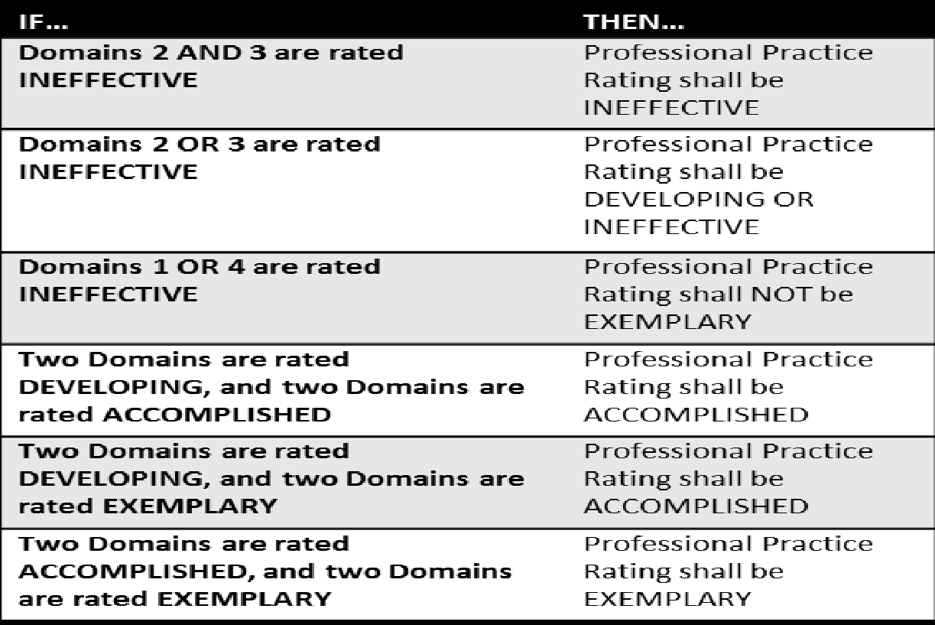

Principal/Administrator Professional Growth and Effectiveness System Components
Overview
Evaluators will look for trends and patterns in practice across multiple types of evidence and apply their professional judgment based on this evidence when evaluating a principal/administrator. The role of evidence and professional judgment in the determination of ratings on standards and an overall rating is paramount in this process. However, professional judgment is grounded in a common framework identified: The Principal Performance Standards (PSEL).
Principal/Administrator Performance Standards
The Principal Performance Measurements are designed to support student achievement and professional best-practice through the standards of Planning, Environment, Instruction, and Professionalism (see Crosswalk). Included in the Performance Measurements are Performance Indicators that provide examples of observable, tangible behaviors that provide evidence of each standard. The Performance Measurements provide the structure for feedback for continuous improvement through individual goals that target professional growth, thus supporting overall student achievement and school improvement. Evidence supporting a principal’s or assistant principal’s professional practice will be situated within one or more of the ten standards. Performance will be rated for each standard according to the four performance levels: Ineffective, Developing, Accomplished, and Exemplary. It is projected that most principals or assistant principals will maintain an Accomplished rating, but will occasionally have exemplary performance on standards at any given time. The summative rating will be a holistic representation of performance, combining data from multiple sources of evidence across each standard.
The use of professional judgment based on multiple sources of evidence promotes a more holistic and comprehensive analysis of practice, rather than over-reliance on one individual data point or rote calculation of practice based on predetermined formulas. Evaluators will also take into account how principals respond to or apply additional supports and resources designed to promote student learning, as well as their own professional growth and development. Finally, professional judgment gives evaluators the flexibility to account for a wide variety of factors related to individual principal performance. These factors may include school-specific priorities that may drive practice in one standard, an educator’s number of goals, experience level and/or leadership opportunities, and contextual variables that may impact the learning environment, such as unanticipated outside events or traumas

Professional Practice
The following sections provide a detailed overview of the various sources of evidence used to inform Professional Practice Ratings.

Professional Growth Planning and Self-Reflection
Completed by principals & assistant principals
The Professional Growth Plan will address realistic, focused, and measurable professional goals. The plan will connect data from multiple sources including site-visit conferences, data on student growth and achievement, and professional growth needs identified through self-assessment and reflection. Self-reflection improves principal practice through ongoing, careful consideration of the impact of leadership practice on student growth and achievement.
Required for all Perry County Administrators
- All principals, assistant principals, and administrators will participate in self-reflection and professional growth planning each year.

ADMINISTRATOR/PRINCIPAL/ASSISTANT PRINCIPAL PGP TIMELINE

Start of the school year | Superintendent/designee reviews expectations of PPGES (PSEL) and training on the evaluation plan within 30 calendar days of reporting for employment.
First Semester | Superintendent/designee Conducts a Site Visit
Documentation | Superintendent/designee will meet with building level principal/assistant principal to develop and approve the completion of the Self-Reflection and Professional Growth Plan. Conferences will be held (2) two times throughout the year (fall and spring) to monitor completion of the Self Reflection and Professional Growth Plan. Documentation of Self Reflections and the Professional Growth Plan will be recorded using district developed electronic documents or the state approved platform and will be kept on file at central office.
*Additional Conferences may be held as deemed necessary to monitor PGP process.
*All dates are tentative based on the adjustment of the school calendar.

Required for all Perry County Principals/Administrators
Conferencing:
At least 2 conferences will take place between Evaluator and Evaluatee throughout the year.
- First Semester (Conference)
- Purpose of the Meeting
- Discuss reflections of data
- Discuss reflections of the Principal Performance Measurements
- Discuss and come to agreement on the Professional Growth Goal and Action Plan
- Discuss first observation/site visit and provide feedback
- Discuss documentation of each standard-determine if any other documentation is needed
- Data analysis with principal and school leadership team
- Questions/Concerns/Comments
- Second Semester/End of Year Review (Conference)
- Purpose of Meeting
- Discuss second observation/site visit and provide feedback
- Share progress toward Professional Growth Goal
- Discuss progress of each measurement-determine if any other documentation is needed
- Data analysis with principal and school leadership team
- Discuss overall rating based on Professional Practice
- Questions/Concerns/Comments

Products of Practice/Other Sources of Evidence
Principals/Assistant Principals may provide additional evidence to support assessment of their own professional practice. These evidence should yield information related to the principal’s/assistant principal’s practice within the domains.

Required for Perry County Administrators:
- Identify other sources of evidence that can be used to support educator practice.

Perry County Principals can choose from the following:
- SBDM Minutes
- Faculty Meeting Agendas and Minutes
- Department/Grade Level Agendas and Minutes
- PLC Agendas and Minutes
- Leadership Team Agendas and Minutes
- Instructional Round/Walk-through documentation
- Budgets
- EILA/Professional Learning experience documentation
- Surveys
- Professional Organization memberships
- Parent/Community engagement surveys
- Parent/Community engagement events documentation
- School schedules
- Other (Evidence the principal/assistant principal feels supports Evidence of Practices)
Determining the Overall Performance Category
Superintendents are responsible for determining an Overall Performance Category for each principal/administrator at the conclusion of their summative evaluation year. The Overall Performance Category is informed by the principal’s ratings on professional practice.
- See schedule
Rating Overall Professional Practice
Required for Perry County Superintendent
- Use decision rules to determine an overall rating.
- Record ratings in the department-approved technology platform.
Professional Practice Ratings will be entered into the department approved technology platform no later than June 15th. *All dates are tentative based upon the adjustments of the calendar year.

REQUIRED
Professional Growth Plans and Self-Reflection

Site-Visit
Impact Survey/Working Conditions
OPTIONAL
Other: District-Determined – Must be identified in the CEP

SUMMATIVE RATINGS
PERFORMANCE MEASURE 1: [I,D,A,E]
SOURCES OF EVIDENCE TO INFORM PROFESSIONAL PRACTICE

PROFESSIONAL JUDGMENT
PERFORMNACE MEASURE 4:
[I,D,A,E]
PERFORMANCE MEASURE 2:
[I,D,A,E]
PERFORMNACE MEASURE 5:
[I,D,A,E]

PERFORMNACE MEASURE 6:
[I,D,A,E]

PROFESSIONAL PRACTICE
PERFORMANCE MEASURE 3:
[I,D,A,E]
PERFORMNACE MEASURE 7:
[I,D,A,E]

PERFORMNACE MEASURE 8:
[I,D,A,E]

PERFORMNACE MEASURE 9:
[I,D,A,E]

PERFORMNACE MEASURE 10:
[I,D,A,E]

A principal’s/assistant principal’s Overall Performance Category is determined by the evaluator based on the principal’s ratings on each standard. Using the sources of evidence for principals/assistant principals, evaluators will use professional judgment to determine a rating for each standard. Next, the evaluator will use the following decision rules for determining the Professional Practice Category:
Determining Professional Practice
- Apply the State Decision Rules for determining an Overall Professional Practice Rating.
CRITERIA FOR DETERMINING A PRINCIPAL OR ASSISTANT PRINCIPAL’S PROFESSIONAL PRACTICE RATING

Standard | Ineffective | Developing | Accomplished | Exemplary
Standard 1:  Mission, Vision, &  Core Values | Fails to maintain or enforce a clear mission or vision ; ignores school data, and demonstrates actions that contradict the shared values of equity, quality, and child-centered education. | Adopts a standard school mission but fails to frequently communicate or strategically implement it; relies on superficial compliance rather than shared stakeholder commitment. | Collaboratively develops, promotes, and implements a shared, data-driven mission and vision focused on student learning, well-being, equity, and continuous growth. | Inspires deeply rooted, systemic ownership of the mission and vision; dynamically adjusts goals based on shifting student demographics and serves as a model advocate across the broader community.
Standard 2:  Ethics &  Professional Norms | Exhibits unethical behavior or professional misconduct ; lacks communication skill, transparency, and personal accountability for student equity or well-being. | Demonstrates ethical personal conduct but struggles to establish clear moral direction or enforce professional expectations, equity, and transparency among faculty and staff. | Consistently models integrity, fairness, transparency, and trust while centering leadership actions and resource choices around student equity. | Cultivates an institutional culture entirely rooted in ethical responsibility; actively addresses underlying systemic biases and empowers others to uphold professional values.
Standard 3:  Equity & Cultural Responsiveness | Ignores institutional biases, student marginalization, or deficit-based schooling ; permits inequitable student access to resources or learning opportunities. | Acknowledges cultural differences but applies equity policies inconsistently; addresses misconduct reactively rather than building positive, fair, and proactive student frameworks. | Actively confronts institutional biases, utilizes student diversity as an asset, and ensures fair treatment and equitable access to resources, teachers, and supports. | Transforms the school ecosystem to eradicate deficit-based schooling; embeds cultural competence across all policies and prepares students to lead productively in a global, diverse society.
Standard 4:  Curriculum, Instruction,  & Assessment | Oversees fragmented or outdated curriculum and instruction systems ; ignores assessment data or fails to align practices with intellectual rigor and academic standards. | Implements required standard academic curriculum but fails to verify that teaching is differentiated, coherent across grade levels, or integrated with technology and student experience. | Ensures intellectually rigorous, coherent, and culturally responsive systems of curriculum, instruction, and technology-fused learning that effectively monitor student progress. | Orchestrates exemplary pedagogical frameworks where data is seamlessly used by educators to personalize learning, cultivate a true love of learning, and maximize student potential.
Standard 5:  Community of Care &  Support for Students | Tolerates a school climate that is emotionally or physically unsafe; ignores individual learning needs and permits toxic peer or adult-student relationships. | Provides basic safety frameworks and standard support services but fails to build an inclusive environment where each student feels uniquely known, valued, and socially engaged. | Cultivates an inclusive, safe, and supportive school learning community that integrates student cultures/languages and satisfies the range of student needs. | Establishes a premier sanctuary of learning where every student is deeply supported, peer and mentor relationships are rich, and positive student conduct is intrinsically driven.
Standard 6:  Professional Capacity  of School Personnel | Fails to provide actionable instructional feedback ; ignores staff turnover, and does not support professional growth, well-being, or teacher leadership capacity. | Evaluates personnel using required compliance tools but fails to offer meaningful, differentiated adult learning opportunities, resulting in stagnating collective instructional capacity. | Recruits, develops, and retains effective personnel through differentiated learning, actionable feedback, and active promotion of staff well-being and teacher leadership. | Empowers a high-performing faculty by anchoring supervision in rich professional growth, cultivating robust succession pathways, and serving as a model for reflective personal learning.
Standard 7:  Professional Community  for Teachers & Staff | Allows a hostile or isolated workplace culture ; fails to establish collective responsibility or mutual accountability for the success of the whole child. | Encourages staff teamwork occasionally but relies on top-down directives rather than anchoring a true professional culture of collective efficacy, open communication, and trust. | Fosters an environment of collective responsibility, mutual accountability, collegial feedback, and job-embedded collaborative learning to improve school-wide practice. | Nurtures an elite professional learning community fueled by collective efficacy, where faculty-initiated innovation and rigorous self-examination of practice are standard norms.
Standard 8:  Meaningful Engagement  of Families & Community | Remains inaccessible or unapproachable to families ; ignores community demographics, context, and potential partnerships while neglecting school advocacy. | Employs one-way communication networks to push information out, but rarely designs genuine, reciprocal partnerships or utilizes community resources for bidirectional benefits. | Sustains welcoming, reciprocal relationships and regular two-way communication with families and community partners to directly support and advocate for student learning. | Promotes a highly visible civic presence; strategically harnesses community, social, and other resources to position the school as a hub for advocacy and family stability.
Standard 9:  Operations &  Management | Mismanages school fiscal or physical resources ; creates disorganized systems that disrupt instructional time or fail to comply with governing laws and regulations. | Operates a functional facility but struggles to strategically schedule personnel, align budgeting with curriculum goals, or utilize data systems to maximize operational efficacy. | Acts as an ethical, accountable steward of resources; effectively manages operations, conflicts, law compliance, and data systems to safeguard instructional time. | Optimizes school infrastructure; utilizes predictive operational data, skillfully leverages central office relationships, and navigates internal/external relationships to fulfill the vision.
Standard 10:  School Improvement | Resists change or acts blindly without evidence-based inquiry ; mismanages reform implementation and fails to build staff improvement capacity or trend readiness. | Initiates isolated or disjointed improvement projects but fails to adopt a systems perspective, manage the risks of change, or instill collective commitment to long-term goals. | Acts as a tenacious agent of continuous improvement using evidence-based inquiry, systemic goal setting, and strategic monitoring to elevate classroom and school outcomes. | Inspires a pervasive culture of courageous innovation and action research; navigates high uncertainty and change to execute seamless, sustainable transformational growth.

Other District Certified Personnel
In this section, “Administrator” means a certified staff member who devotes the majority of employed time in a position for which administrative certification is required by the Education Professional Standards Board. All district administrators shall be evaluated annually by the Superintendent using the PSEL Policy Standards of this plan. The district evaluation tool will be updated to reflect any revised PSEL standards as needed. All components and sources of evidence supporting an administrator’s overall performance category will be stored in paper format in the administrator’s personnel file until such time that an electronic platform is created by the Kentucky Department of Education.
The administrator performance measurements are designed to support student achievement and professional best-practice through the Professional Standards for Educational Leaders: Planning; Environment; Instruction; and Professionalism. The Performance Measures provide the structure for feedback for continuous improvement through individual goals that target professional growth, thus supporting overall student achievement and district improvement. Evidence supporting an administrator’s professional practice will be situated within one or more of the standards. Performance will be rated for each standard according to the four performance levels: Ineffective, Developing, Accomplished, or Exemplary.
The summative rating will be a holistic representation of performance, combining data from multiple sources of evidence across each standard. The use of professional judgment based on multiple sources of evidence promotes a more holistic and comprehensive analysis of practice, rather than over-reliance on one individual data point or rote calculation of practice based on predetermined formulas. Evaluators will also take into account how administrators respond to or apply additional supports and resources designed to promote student learning, as well as their own professional growth and development. Finally, professional judgment gives evaluators the flexibility to account for a wide variety of factors related to individual performances. These factors may include district-specific priorities that may drive practice in one standard, an educator’s number of goals, experience level and/or leadership opportunities, and variables that may impact the learning environment, such as unanticipated outside events. Evaluators will use the following categories of evidence in determining overall performance ratings: worksite visits, self-reflections, professional growth plan, performance checklists, and other products of practice.
Each administrator will develop a professional growth plan following the completion of their self-reflection on the PSEL Performance Standards located in Appendix E. The growth plan also should reflect any current evaluation results and be aligned with the appropriate goals and objectives in the district comprehensive and professional development plans. Progress on the plan will be reviewed during the formative conferences with the immediate supervisor. The growth plan reflects the performance standards to be addressed, rationales for selecting targeted standards, professional growth needed to support the standards work, an action plan, evaluation method and criteria, and the expected benefits related to implementation of the plan. There is also a section that allows for modifications and/or adjustments to the plan and how it will impact student performance.
Administrators can use additional evidence/products of practice to support the assessment of their professional practice. The evidence to be provided will allow the administrator the opportunity to support their work toward meeting the PSEL Performance Measures.
During the evaluation phase, the primary evaluator along with the evaluatee will review any pertinent evidence and using their professional judgement will determine the overall rating for the administrator. An administrator is rated in each of the PSEL standards and given an overall rating for each. The administrator can be given the overall rating of Exemplary, Accomplished, Developing, or Ineffective. An administrator who receives the rating of “Developing” shall have an individual professional growth plan that is developed by the evaluator and evaluatee that will be monitored throughout the next evaluation cycle. An administrator who receives an overall rating of “Ineffective” shall be placed on an individual growth plan that is set by the evaluator and will be monitored throughout a one-year span. The primary evaluator shall hold a summative evaluation conference with the administrator by June 15th. During the conference, the Summative Evaluation Report along with the overall ratings will be shared with the administrator. The Professional Growth Plan will also be reviewed at this time and possible recommendations will be made at this time.

All components and sources of evidence supporting an administrator’s overall performance rating will be stored in district paper and/or electronic format in the administrator’s file until revisions and changes are made by the Kentucky Department of Education regarding an electronic platform for housing documentation.

Appeals
District shall have an appeals process established
According to 156.557 Section 9,
Section 9. (1) A certified employee who feels that the local district is not properly implementing the evaluation plan according to the way it was approved by the Kentucky Department of Education shall have the opportunity to appeal to the Kentucky Board of Education.
(2) The appeal procedures shall be as follows:
(a) The Kentucky Board of Education shall appoint a committee of three (3) state board members to serve on the State Evaluation Appeals Panel. Its jurisdiction shall be limited to procedural matters already addressed by the local appeals panel required by KRS 156.557(5). The panel shall not have jurisdiction relative to a complaint involving the professional judgmental conclusion of an evaluation, and the panel's review shall be limited to the record of proceedings at the local district level.
(b) No later than thirty (30) days after the final action or decision at the local district level, the certified employee may submit a written request to the chief state school officer for a review before the State Evaluation Appeals Panel. An appeal not filed in a timely manner shall not be considered. A specific description of the complaint and grounds for appeal shall be submitted with this request.
(c) A brief, written statement and other document which a party wants considered by the State Evaluation Appeals Panel shall be filed with the panel and served on the opposing party at least twenty (20) days prior to the scheduled review.
(d) A decision of the appeals panel shall be rendered within fifteen (15) working days after the review.
(e) A determination of noncompliance shall render the evaluation void, and the employee shall have the right to be reevaluated. (11 Ky.R. 1107; Am. 1268; eff. 3-12-85; 12 Ky.R. 1638; 1837; eff. 6-10-86; 15 Ky.R. 1561; 1849; eff. 3-23-89; 17 Ky.R. 116; eff. 9-13-90; 19 Ky.R. 515; 947; 1081; eff. 11-9-92; 20 Ky.R. 845; eff. 12-6-93; 23 Ky.R. 2277; 2732; eff. 1-9-97; 27 Ky.R. 1874; 2778; eff. 4-9-2001.)
Required
- According to current regulation, districts shall have an appeals process established.
DUE PROCESS
All parties have had representation in the design, development, and review of the evaluation procedures and instruments. Knowledge and understanding of performance expectations are provided for staff through distribution of this certified evaluation plan.

Every teacher/administrator is provided an opportunity for familiarization with the system, its procedures and use.

If the teacher/administrator feels that any information leading to or included in the summative evaluation is incomplete, inaccurate, or unjust, he/she may submit his/her objections in writing to be attached to the evaluation report to be placed in his/her personnel file. The file copy of such objections shall be signed by both parties to indicate awareness of the content.

All reports of unsatisfactory performance must be in writing and must enumerate shortcomings in a specific manner.
Each teacher/administrator may have access to his/her file upon request after two (2) working days. The request will be honored within two (2) working days.

CERTIFIED PERSONNEL EVALUATION APPEALS

Evaluation review
Evaluation of professional performance, as described in the evaluation process, is not adversary in nature. However, if at the conclusion of the evaluation process, the evaluatee believes the summative assessments are (a) inaccurate (b) unfair, or (c) the evaluation procedures were abridged in some manner, he/she shall have the right to request a hearing before the Evaluation Appeals Panel as stated in 704 KAR 3:345, Section 7, as follows:

Section 7: For an appeal to the local evaluation appeals panel, each local evaluation plan shall provide the following:
- Right to a hearing as to every appeal
- Opportunity reasonably in advance of the hearing for the evaluator and evaluatee to adequately review all documents that are to be presented to the evaluation appeals panel; and
- Right to presence of evaluatee’s chosen representative.
- The evaluatee shall notify the chairperson of the Evaluation Appeals Panel, in writing, of his/her desire to appeal an evaluation within 16 working days of summative appeals.
- The chairperson of the appeals panel shall inform the evaluatee of the procedural guidelines for appeals.

APPEALS PANEL

All members of the appeals panel shall be current employees of the district. Two (2) members of the panel are elected from and by the certified staff of the district. Each certified employee has the right to be nominated and to vote in the process (intern teachers are not fully certified until the end of the internship). One member of the panel is appointed by the local board of education who is a certified employee of the board. The panel shall elect a chairperson for each appeal.
(Reference KRS 156.101 and 704 KAR 3:345)

In the election of the appeals panel members, the persons receiving the first and second greatest numbers of votes shall be members of the appeal pane. The persons receiving the third and fourth greatest number of votes shall be designated as alternates. The superintendent shall appoint an alternate for the appointed panel member. Release time shall be provided for panel members at the discretion of the superintendent. Funding for panel expenses will be provided from the general fund.

The length of term for an appeals panel member shall be three (3) years. Panel members may be re-elected for the position. The panel members shall assume their responsibilities as soon as the election results are announced. Elections shall be conducted and appointments made during the month of September. Panel members may seek training through the Evaluation Coordinator.

The election shall be conducted by the Evaluation Coordinator using the following criteria:
- Open nomination
- Select ballot
- One person/one vote
- All certified employees given the opportunity

No panel member shall serve on any appeals panel on which he/she was the evaluator. Whenever a panel member’s immediate family appeals to the panel, the member shall not serve for that appeal. Panel members who are also members of the immediate family of an evaluator whose decision is being appealed to the panel shall not serve for that appeal. Immediate family shall include parents, siblings, spouse, children, uncle, aunt, nephew, niece, grandparents, and corresponding in-laws.

Any certified employee who believes that he/she was not fairly evaluated on the summative evaluation may appeal to the panel within five (5) working days of the receipt of the summative evaluation. The request shall be presented to the superintendent or designee.

The appeal shall be signed and in writing. The appeal shall state the evaluation records may be presented to and reviewed by the panel.

The certified employee appealing to the panel has the burden of proof. The evaluator may respond to any statements made by the employee and may present written records which support the summative evaluation.

APPEALS PANEL HEARING PROCEDURES

The purpose of the Appeals Panel Hearing is to review the summative evaluation of the employee. Confidentiality and fairness shall be the primary concerns of the panel.

A preliminary hearing will be held to provide documentation to all parties and the panel. Four (4) copies of all documentation to be considered in the appeals shall be available to the panel at this time. The chairperson shall convene the hearing and explain procedures for the process. The evaluatee and evaluator may be represented by legal counsel or their chosen representative. The Board of Education shall provide for legal counsel to the panel if requested. The evaluatee has the right to determine whether the hearing is open or closed. A closed hearing will include the panel, evaluatee, evaluator, and their chosen representatives. Witnesses may be called by either party but will not be allowed to observe the hearing process other than during their testimony. After the evaluatee and evaluator leave, the appeals shall remain and review all documents and formulate questions for the hearing. The chairperson of the panel will arrange for an official record to be made of all hearing procedures.

Within five (5) working days, a hearing will convene to allow the evaluatee and evaluator to present statements, documentation, witnesses, and other information pertinent to the appeal. Again, the chairperson will convene the hearing and establish procedures. The evaluatee shall present his/her opening statement followed by the evaluator’s opening statement. Each party will then be allowed to present his/her documentation including witnesses pertinent to the summative evaluation. Questions both of substance and procedure will be considered by the panel. An opportunity for questioning each party shall be provided. The panel will consider all the information that has been provided. A decision regarding their findings shall be presented to the superintendent within fifteen (15) working days of the filing of the appeal. In case of appeals of evaluations conducted by the superintendent, the panel shall report to the Board of Education.

The panel’s recommendation must include one of the following:
- A new evaluation by another evaluator
- Uphold the original evaluation
- Remove the summative or any part of the summative from the personnel file

Any evaluatee who feels that evaluation procedures have been violated may appeal the decision to the Kentucky Board of Education.

CONFIDENTIALITY OF EVALUATION REPORTS

The confidentiality of evaluation records is a concern to everyone. It is recommended by the committee that the staff evaluation reports be filed by the evaluator and kept in a safe and locked place. The records will not be made available to anyone except the evaluator, evaluatee, and the superintendent or his/her designee.

PERIODIC REVISION

The implementation of the evaluation process begins in Perry County immediately after the Board of Education has approved this recommendation and made it a policy. After the program becomes fully operative, it will be necessary to keep it up-to-date. The evaluation committee will have this responsibility. The evaluation committee will be appointed by the Board of Education with equal representation of teachers and administrators.

ANNUAL REVIEW OF THE EVALUATION PLAN

The evaluation plan will be reviewed annually to ensure that the evaluation system is serving the purpose for which it was established. The evaluation plan will be reviewed by the district evaluation committee under the direction of the evaluation coordinator.

The evaluation committee shall be composed of equal numbers of teachers and administrators. At least one administrative member shall be the superintendent (or his/her designee).

All revisions and/or additions pertaining to the evaluation procedures and/or instruments must be approved by the Perry County Board of Education and then submitted to KDE for approval.

Appendix
Appendix A: Pre-Observation Form

Pre-Observation Information
The Pre-Observation Information form is to be completed by the teacher at least one day prior to the formal observation date.
____________________________________ ___________________________________________
Teacher Class
_____________________________________ ___________________________________________
Date Time

Background: Type of Lesson

____Review _____ Reteaching _____ New Lesson _____ Other (specify)

Focus: Are there any student characteristics and behaviors the observer should be aware of during the observation period?

Objective(s): Identify the major concepts you will focus on during the lesson.

Methods: Procedures, Materials, and Activities: How will learning be accomplished? List methods, procedures, materials required and student activities that will take place.

Evaluation: How will you evaluate the lesson?

Please attach a copy of your lesson plan.
Appendix B: Post Observation Form

Post Observation Document
The Post Observation form is to be completed by the teacher during the post observation conference.

____________________________________ ___________________________________________
Teacher Class
_____________________________________ ___________________________________________
Date Time

For each of the following standards, reflect on the lesson that was observed using the following guided questions to focus your reflections:

In general, how successful was the lesson? Did the students achieve the learning targets? How do you know, and what will you do for those students who did not?
In addition to the student work witnessed by the observer, what other student work samples, evidence of artifacts assisted you in making your determination for question one/
To what extent did classroom procedures, student conduct, and physical space contribute to or hinder student learning?
If you had an opportunity to teach this lesson again to the same group of students, what would you do differently, and why?
What do you see as the next step(s) in your professional growth for addressing the needs you have identified through personal reflection?

*Denotes sharing of results not necessarily agreement with the formative rating
Performance Measure 2: The Classroom Environment ```` | Rating |  |  |  | Performance Measure 3: Instruction | Rating
Creating an Environment of Respect and Rapport | I | D | A | E | Communicating with students | I | D | A | E
Establishing a Culture for Learning | I | D | A | E | Using questioning and discussion techniques | I | D | A | E
Managing Classroom Procedures | I | D | A | E | Engage Students in Learning | I | D | A | E
Managing Student Behavior | I | D | A | E | Using Assessment in Instruction | I | D | A | E
Organizing Physical Space | I | D | A | E | Demonstrating Flexibility | I | D | A | E

___________________________ __ __________________ __________________
Teacher Signature Observer’s Signature Date
Appendix C: Individual Targeted Growth Plan

INDIVIDUAL TARGETED GROWTH PLAN

Evaluatee’s Name: ____________________________ Beginning Date: ________________________

School: _____________________________ Position/ Subject Area / Level: _____________________

Target Completion Date of the Individual Improvement Plan: _______________________________

Targeted Domain

Data

Goals

Procedures and Activities for Achieving Goals

Evidence of Completion (Goals to Meet)

Goals Not Completed

Evaluatee’s Comments

Evaluator’s Comments

Individual Targeted Growth Plan Developed:
_________________ ___________
Evaluatee’s Signature Date

_________________ __________
Evaluator’s Signature Date

STATUS
___Fully Accomplished *____Partially Accomplished
*_______Not Accomplished

____________________ ____________
Evaluatee’s Signature Date

_____________________ ____________
Evaluator’s Signature Date

*Any goals that are not accomplished will require the revision of the individual improvement plan.

Appendix D: Individual Corrective Action Plan

INDIVIDUAL CORRECTIVE ACTION PLAN

Evaluatee’s Name: ______________ Evaluator’ Name: ______________ Beginning Date: ________

School: _____________________________ Position/ Subject Area / Level: _____________________

Target Completion Date of the Individual Corrective Action Plan: ___________________________

Targeted Domain

Data

Goals

Procedures and Activities for Achieving Goals

Evidence of Completion (Goals Met)

Goals Not Completed

Evaluatee’s Comments

Evaluator’s Comments

STATUS ___Fully Implemented _______Not Accomplished
______________________ _____________
Evaluatee’s Signature Date

_______________________ ______________
Mentor’s Signature Date

________________________ ______________
Evaluator’s Signature Date

_________________________ ______________
Other Signature Date

_________________________ ______________
Other Signature Date
Individual Corrective Action Plan Developed:
_________________ _________
Evaluatee’s Signature Date

__________________ _________
Mentor’s Signature Date

__________________ _________
Evaluator’s Signature Date

__________________ _________
Other Signature Date

___________________ _________
Other Signature Date

Appendix E: Individual Growth Plan District Certified Staff

PERRY COUNTY SCHOOLS

Individual Professional Growth Plan
Type of Plan: ___Enrichment Plan ____Improvement Plan
______________  Educator | _____________  Grade/Subject |  |  | ______________  Worksite
Choose an area of personal growth from your educator standards and develop an Individual Growth Plan to enhance your development in this area. (Base decision on information obtained from evaluations and school improvement plan).
Focus for Growth: State the Performance Standards

Rationale: Why did you choose to enhance your growth area? (Relate to evaluation/CSIP/CDIP)

Professional Growth Objectives of this Plan: State your professional growth objectives in measurable or observable term. (Student objectives are not appropriate here).

Action Plan: Describe the actions you plan to take to accomplish objective(s), including times for completion of each action.

Evaluation Methods and Criteria: Describe the methods and criteria you plan to use to evaluate your attainment of this objective(s). (What will be your indicators of success?)

Expected Benefits: Describe the specific education benefits related to your primary responsibilities that you expect to acquire as a result of your implementation of this Individual Growth Plan. (Student objectives are appropriate here.)

The IGP stated above has been reviewed and is appropriate for implementation beginning with the school year _____--______

___________________________________  Evaluator’s Signature |  | _____________  Date: | ________________________  Educator’s Signature: |  | ________________________  Date:

INDIVIDUAL GROWTH PLAN IMPLEMENTATION SUMMARY

Modification/Adjustments to the Plan: Describe the results obtained from implementation of your IGP.

Effects on Students’ Learning: Describe the impact on student performance from your implementation of this IGP.

I verify that I engaged in these activities and that all the information contained in this plan is accurate.
___________________________________________  Educator’s Signature | __________________________________________  Date

I verify that I have monitored and reviewed this IGP
____________________________________________  Evaluator’s Signature | __________________________________________________  Date
The IGP should be developed after the first formal evaluation in the evaluation year. During the non-scheduled observation years (3-year cycle) the plan should be developed prior the beginning of each new school year.

Appendix F: Summative Evaluation Report (District Certified Staff)
Perry County Schools
Summative Evaluation Report
Administrator’s Performance
________________  Administrator | _________________  Evaluator’s Name
________________  Work Site | __________________  Conference Date
Performance Measures and the Professional Standards for Educational Leaders (PSEL) | 4  Exemplary | 3  Accomplished | 2  Developing | 1  Ineffective
Performance Measure 1: Mission, Vision, and Core Values
Performance Measure 2: Ethics and Professional Norms
Performance Measure 3: Equity and Cultural Responsiveness
Performance Measure 4: Curriculum, Instruction, and Assessment
Performance Measure 5: Community of Care and Support for Students
Performance 6: Professional Capacity of School Personnel
Performance 7: Professional Community for Teachers and Staff
Performance 8: Meaningful Engagement of Families and Community
Performance 9: Operations and Management
Performance 10: School Improvement

Overall Performance Evaluation: 4 3 2 1
(Circle One) Exemplary Accomplished Developing Ineffective

______________________________________ ______________________
Administrator Date
______________________________________ _______________________
Evaluator Date
Employment Recommendation to Superintendent:

____________Recommended for re-employment ________Does not recommend for re-employment

_______________________________________ ________________________
Evaluator Date

Any certified employee who believes that he/she was not fairly evaluated on the summative evaluation may appeal to the Appeals Panel within (5) working days of the receipt of this evaluation. Signing the form does not indicate agreement with the evaluation.

Appendix G: Summative Evaluation Form- Certified Teacher
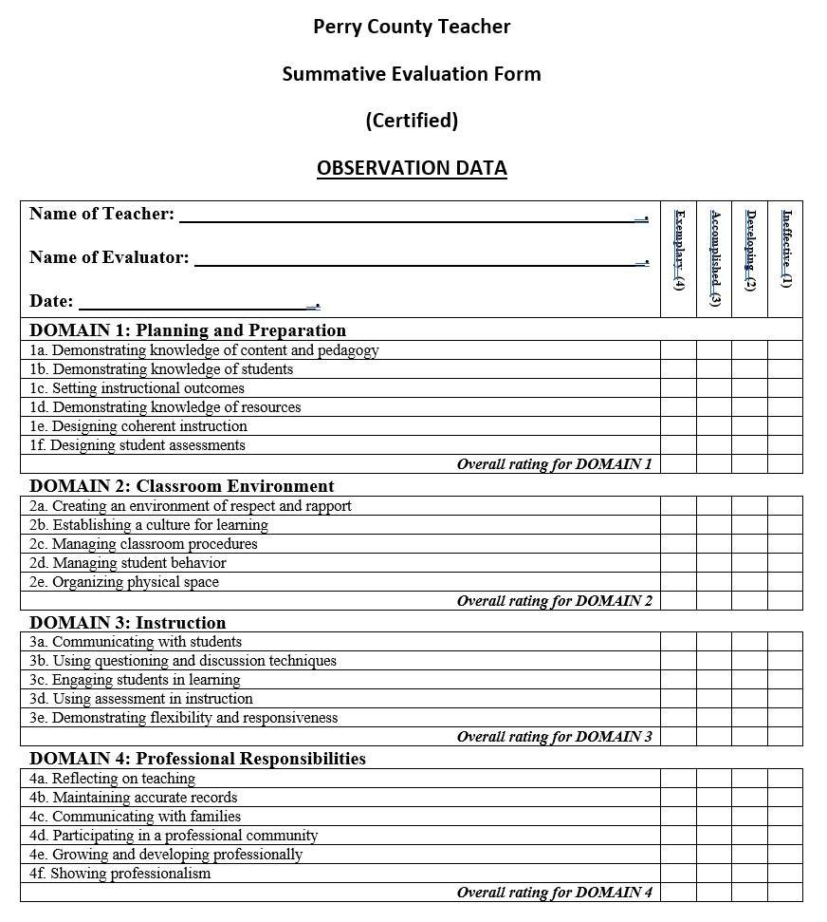
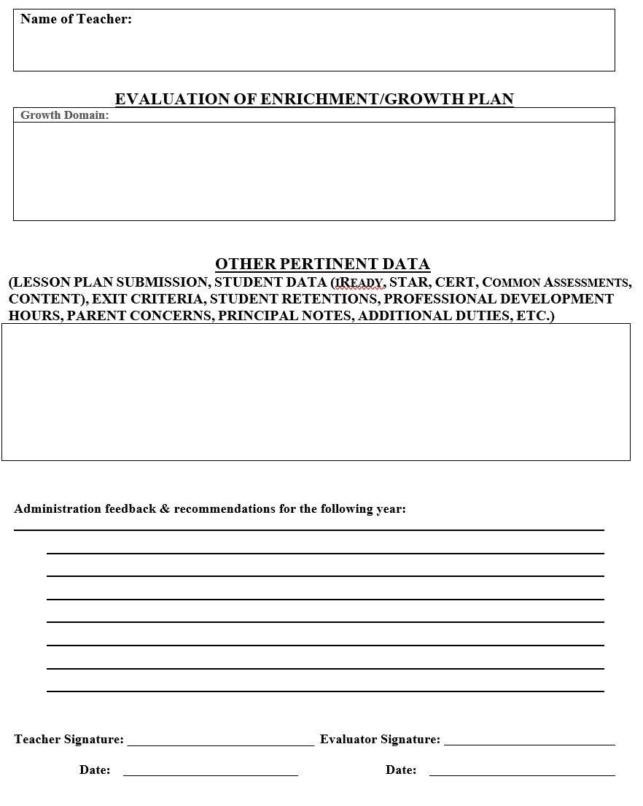
Appendix H: Summative Evaluation Form- Library Media Specialist
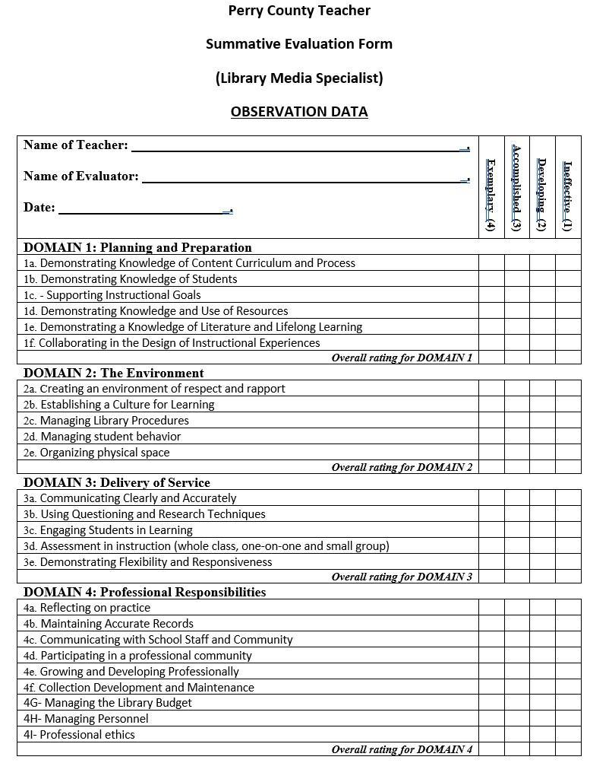
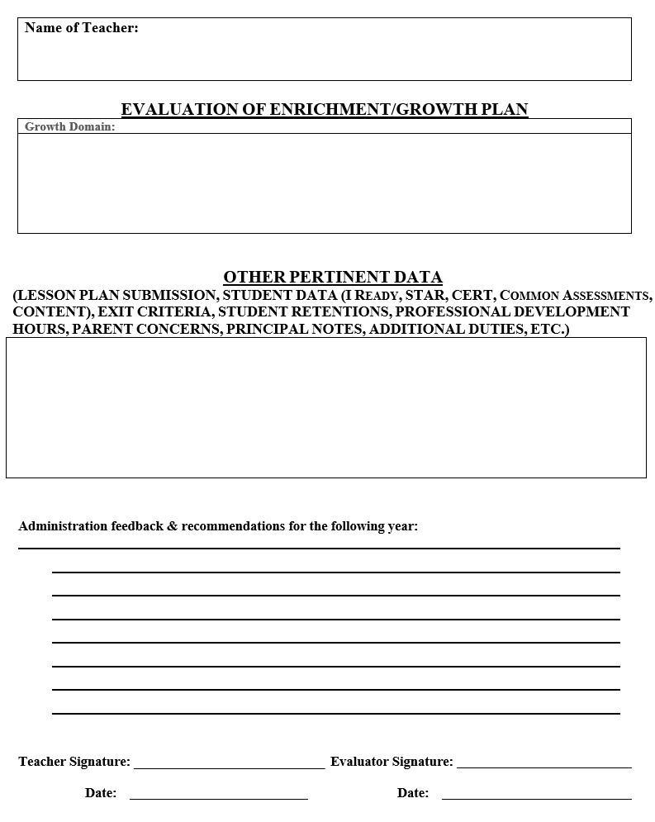
Appendix I: Summative Evaluation Form- School Psychologists
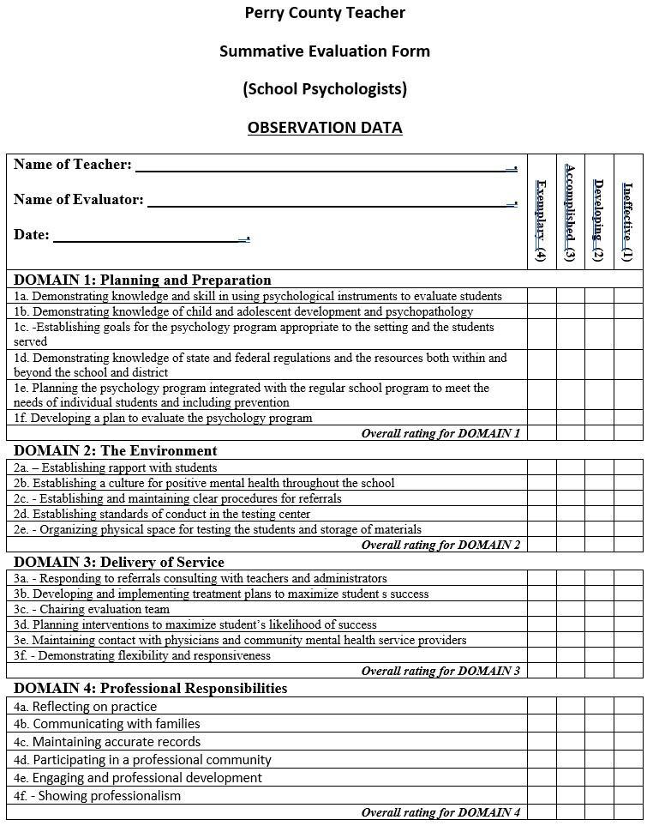
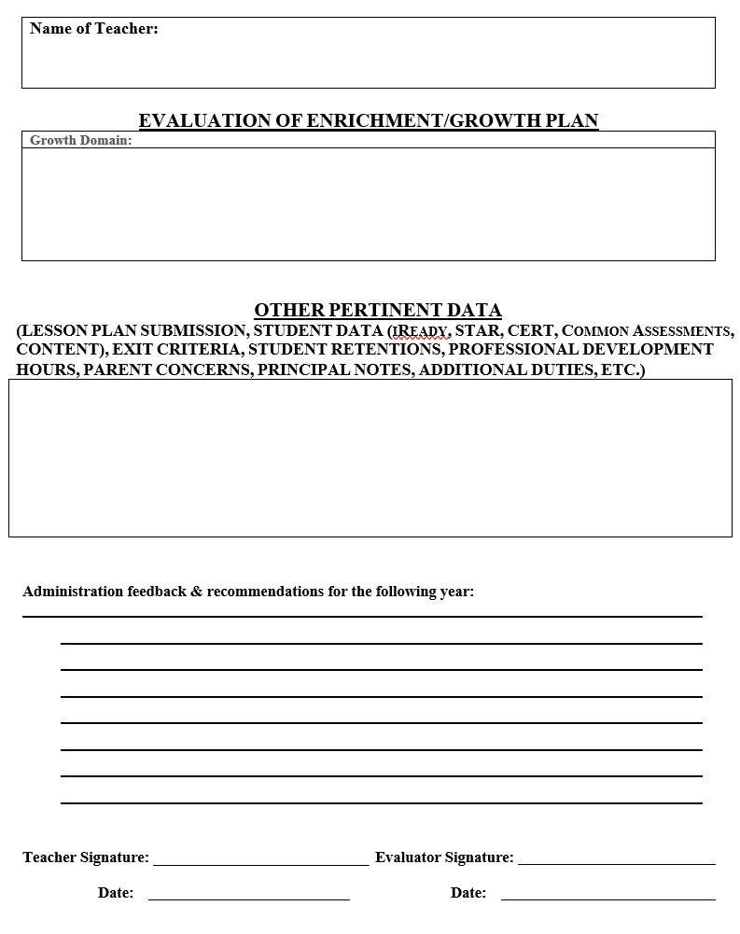
Appendix J: Summative Evaluation Form- Instructional Specialists
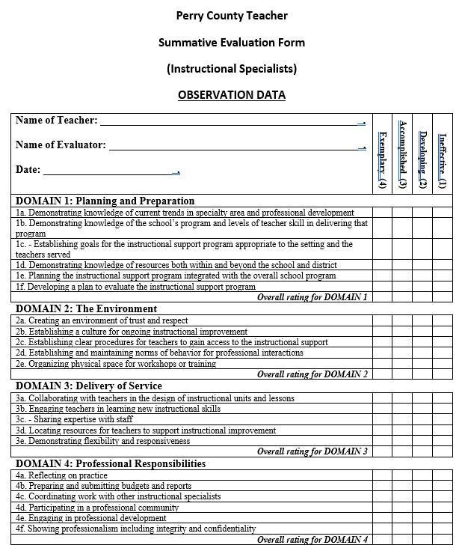
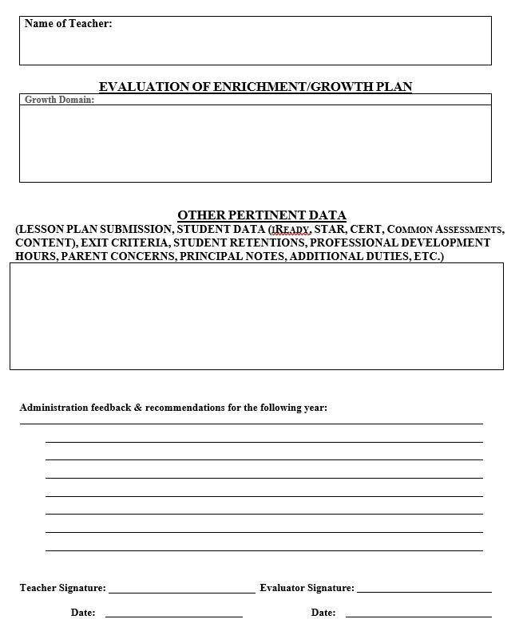
Appendix K: Summative Evaluation Form- School Counselors/Social Workers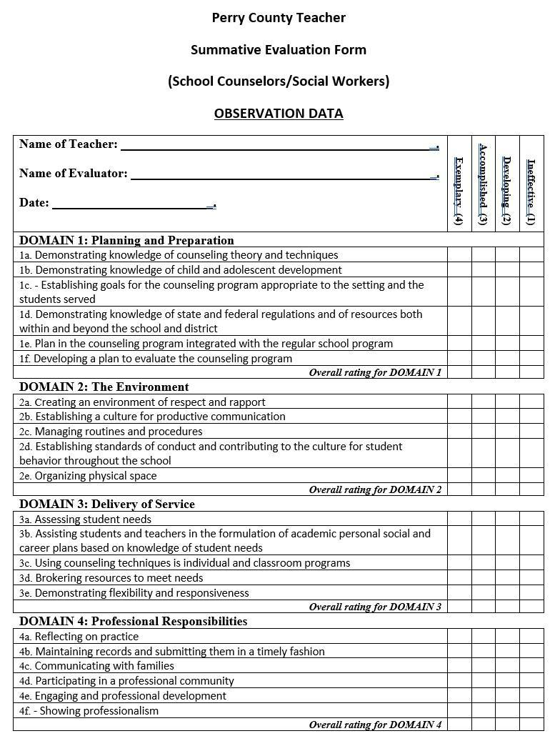
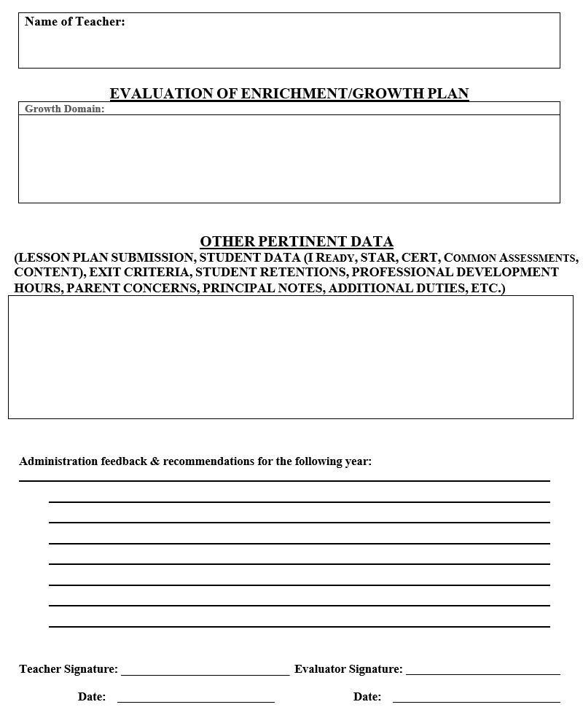

Appendix L: Summative Evaluation Form- Therapeutic Specialists
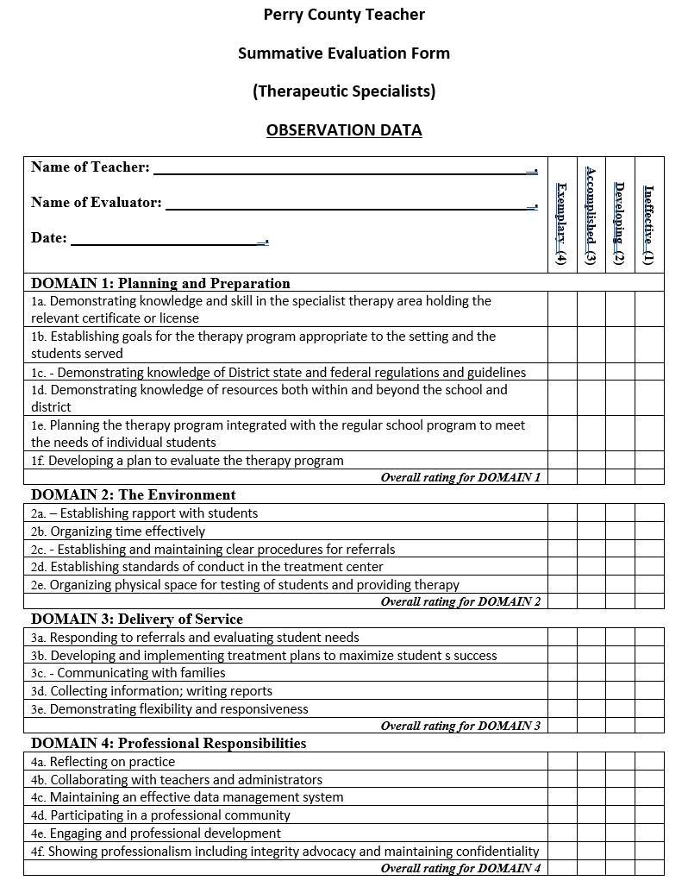
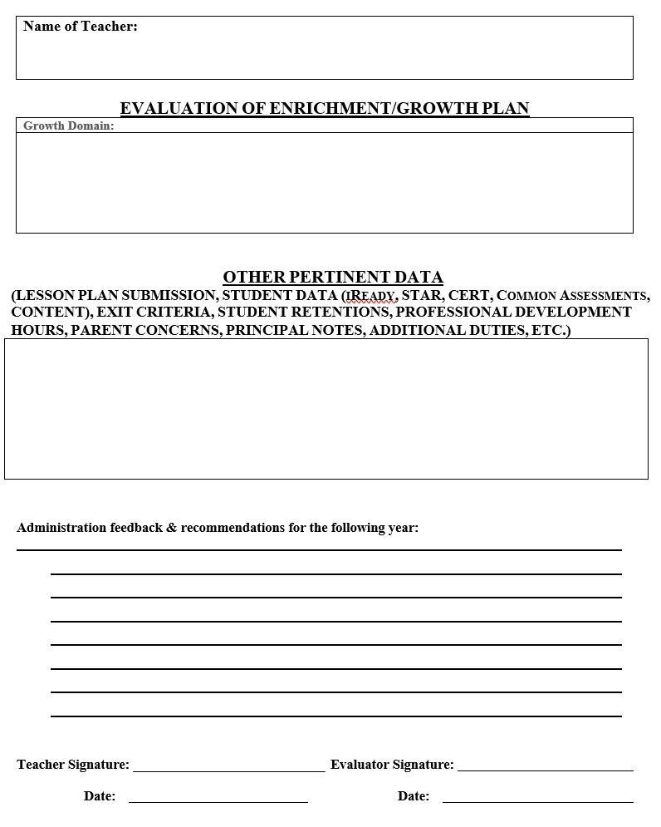

Appendix M: Summative Evaluation Form- Technology Personnel
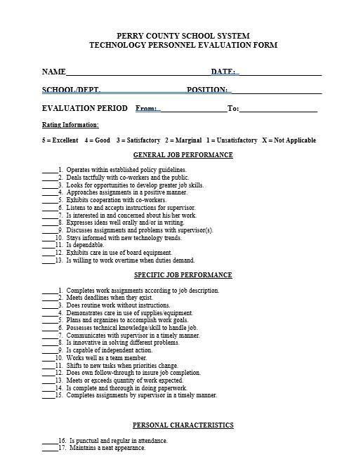
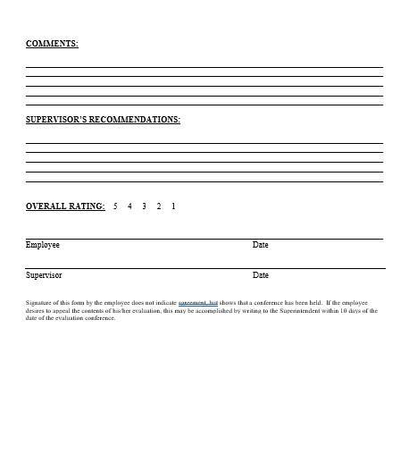

Appendix N: Individual Teacher PD Plan

INDIVIDUAL TEACHER PD PLAN

Teacher Name: ____________________________
School Name: ____________________________
Teacher Assignment (Grade Level-Content): __________________________
Principal Required trainings: ___________________________
PD TRAINING TOPICS/DATES/HOURS:
1.
2.
3.
4.
5.
6.
7.
8.

Principal Signature: ____________________________
Teacher Signature: _____________________________
Date: ___________________

Appendix O: Kentucky Framework for Personnel Evaluation Crosswalk
