What is a School-Parent Compact?  A School-Parent Compact is an agreement  that families, students, and teachers develop together. It explains how families and teachers will work together to make sure all students reach grade level standards:  Effective compacts:  - Link goals to the School Improvement Plan  - Focus on student learning skills  - Describe how teachers will help students develop skills using high-quality instruction  - Share strategies families can use at home  - Explain how teachers and families will communicate about student progress | Activities to Build Partnerships  At McKenzie High School, we strive to provide activities that build partnerships between families, students, and our school. We know that together we can all make a difference.  - Aug 1 – Freshmen Orientation Night  - Aug. 26 – Senior Parent Information Night/Family Night for Form Completion  - Sept. 12 – Parent/Teacher Conferences  - Oct. 25 – Report Cards  - Nov. 14 – Progress Reports  - Jan. 9 – Report Cards  - Feb. 13 – Progress Reports  - Feb. 13 – Parent/Teacher Conference  - March 19 – Report Cards  - April 17 – Progress Reports  - May 23 – Report Cards | McKenzie High School  School-Parent  Compact  2024-2025  Kelly Spivey, Principal  www.mckenziehighschool.org  (731) 352-2133  
Jointly Developed  The families, students, and staff of McKenzie High School developed this School-Parent Compact. Teachers suggested home learning activities, families added ideas to make them more specific, and students told us what would help them learn. Meetings and events are held each year to review the compact and make changes based on student needs.  Families are welcome to contribute comments and suggestions at any time.  If you would like to volunteer or participate, please contact Carol Nanney at nanneyc@mckenzieschools.org or  (731) 352-2133. | Communication About Student Learning  McKenzie High School is committed to frequent two-way communication with families about student’s learning. Some of the ways you can expect us to reach you are:  - Updates on the school website  - Current grades on Powerschool  - Announcements through Notify Me  - Posts on the McKenzie High School, MHS Counseling, MHS Yearbook, McKenzie Rebel Athletics, and the McKenzie High School Library Facebook pages.  - Parent-Teacher Conferences in September and February  Do you have questions about your child’s progress?  Contact your child’s teacher by phone (731) 352-2133. Email addresses are listed on the school website at www.mckenziehighschool.org | 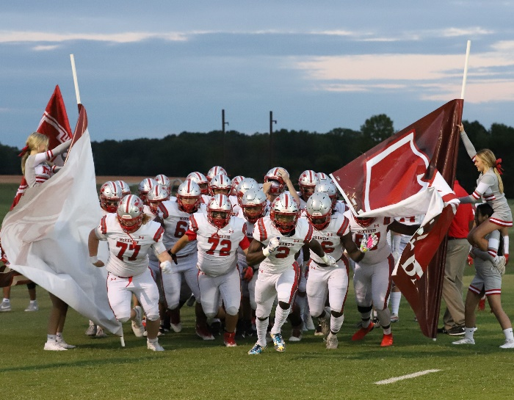

Our Goals for Student Achievement | Teachers, Families, Students – Together for Success
School Goals  - Improve K-12 Literacy  - Improve K-12 Numeracy  - Increase College and Career Awareness and Access  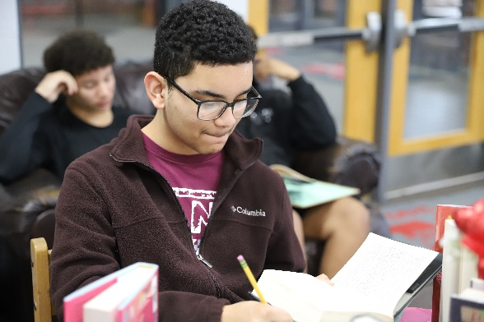  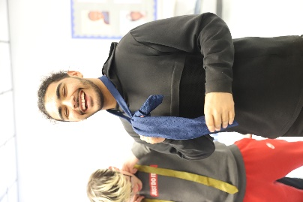  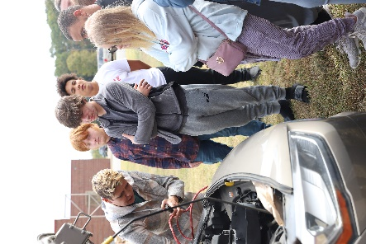  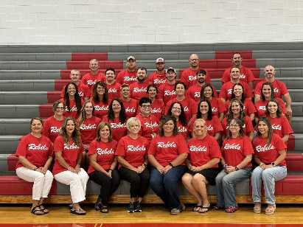  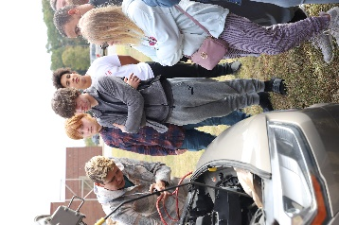 | In the Classroom  McKenzie High School will work with students and families to support students’ success in academics. Some of our key connections with families will be:  - We will provide to each student a curriculum that is high-quality and rigorous in a supportive and accessible learning environment.  - We will hold two parent-teacher conferences per year, as well as individual conferences as needed.  - We will give parents frequent reports of student progress, either by written progress reports, Powerschool, IEP information, TCAP results, Google Classroom information, or by direct contact via telephone or meeting.  - We will supply parents with reasonable access to the staff of the school and give parents, if desired, an opportunity to observe and/or volunteer in the classroom or in extra-curricular activities. | At Home  McKenzie High School families joined staff to develop ideas about how families can support students’ success in academics. Families may have other ideas to add to this list:  - Ensure that your child has regular school attendance and do your part to make sure that he/she comes to school on time.  - Support the school in the efforts to maintain proper discipline.  - Create a time for homework and check to make sure assignments are completed.  - Monitor the time your child spends on technological devices.  - Make an effort to ensure that your child is caught up on work missed due to illness.  - Keep a line of communication open with your child’s teacher and continually review Powerschool.  - Promote your child’s participation in extracurricular activities.  - Attend Parent/Teacher Conferences
Students
McKenzie High School students joined staff and families to develop ideas about how they can succeed in school and reach for the stars in academics. Students thought of the following ideas to make connections between learning at home and school:
- Students will attend class regularly.
- Student will come to class prepared (school planner, text book, paper, pen/pencil, etc…)
- Students will finish homework assignments in a timely manner.
- Students will take responsibility for his/her actions.
- Students will respect authority of the faculty and administration of the school.
- Students will treat other students, faculty, and staff members with kindness and respect.
- Students will not engage in behaviors online or in person that would be considered bullying.
When teachers, students, and families work together, we CAN achieve our goals!

