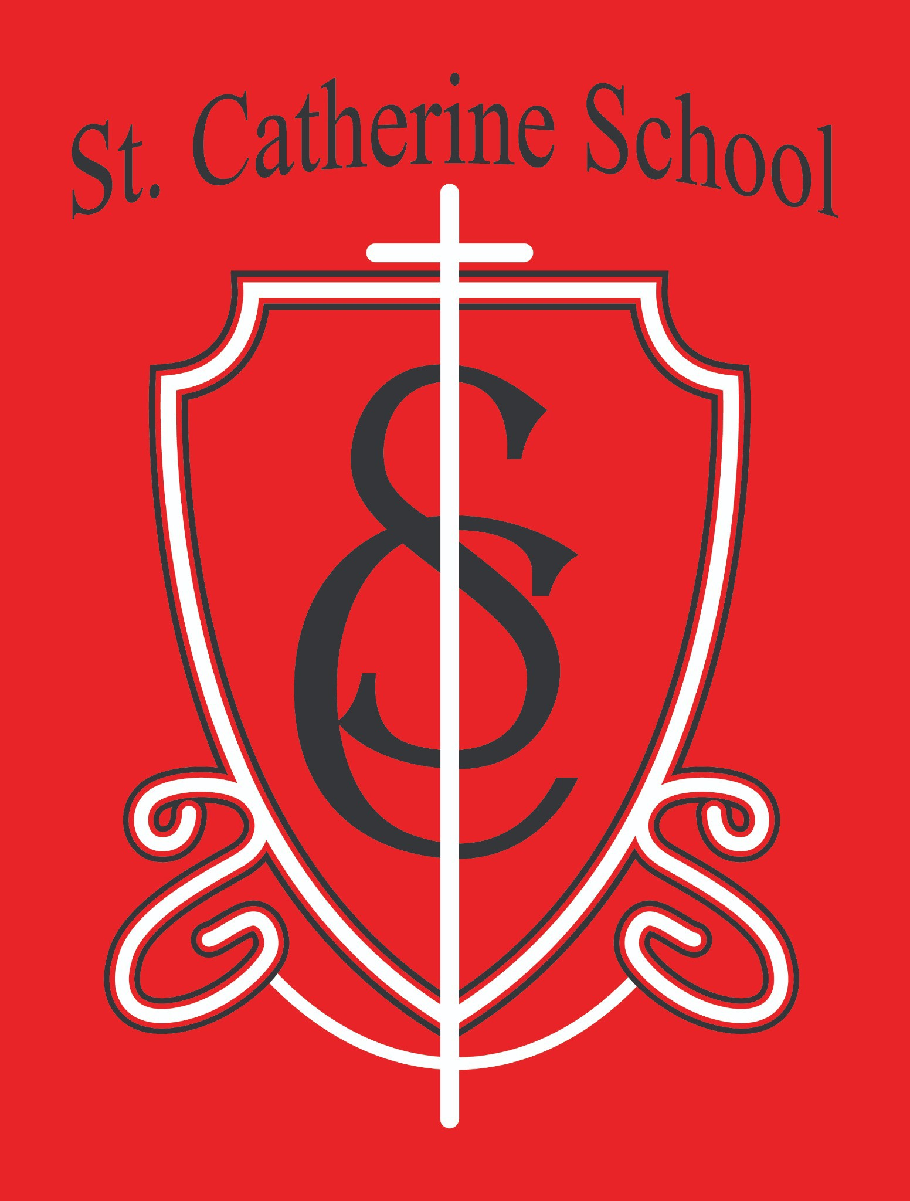

St. Catherine School Weekly Newsletter
https://www.stcatherine.k12.nd.us/parents

Principal's Message
Dear St. Catherine Families,
As we move into the final month of the school year, I want to take a moment to sincerely thank all those who have served our school community this year. Whether through supporting the Fall Auction, volunteering for events and projects, helping with classroom needs, or responding to the many requests I send out throughout the year, your generosity has made a difference.
St. Catherine School is strong because of the families who make up this community. We are blessed by parents, grandparents, parishioners, and friends who believe in our mission and help make it possible each day. Thank you for being part of this school family and for all you do to support our students and staff.

Reminders

Shorts May Be Worn Starting May 1
Per our handbook, students may begin wearing shorts starting May 1st. Weather / Outdoor Gear Update
Next week looks chilly at the start of the week and warmer by the end. Please continue sending your child with long sleeves and clothing needed to stay warm outdoors. I think winter jackets can likely be packed away, but parent discretion is always appreciated.
Students should have at least long sleeves for outdoor recess.

Birthday Invitations at School
If birthday invitations are brought to school for distribution, they must be given to the entire classroom. If invitations are for only select students, please handle those invitations outside of school.

Music Reminder from Ms. Busch
Please continue encouraging instrument practice (recorders, ukuleles, or band instruments) as we enter the final week before the Spring Program.
Grades 3/4 Families: Please help remind your child to return recorders and ukuleles to school. We will be keeping them here in preparation for their big day.

Storm Make-Up Day
There is school on May 1st as a scheduled storm make-up day.

Upcoming Dates & Events
May 6 – Regional Science Olympiad at BCN
May 7 – All School Mass / May Crowning at 10:30 AM with guest lunch to follow
May 7 – Spring Program at 6:30 PM in the gym
May 8 – States and Countries Presentations at 1:30 PM in the gym
May 20 – 6th Grade Graduation Mass at 9:30 AM
May 22 – Last Day of School (Half Day)

Last Day of School Details:
We will follow our regular early dismissal procedures on May 22nd. Lunch will be served and buses will run. Valley City Public Schools has indicated they also plan to have a half day, but I wanted to share this now so families can plan ahead.

Big Ticket Raffle Reminder

We still have over 100 raffle tickets left to sell!
$100 per ticket
Grand Prize: $5,000
Five additional prizes: $1,000 each

Only 300 tickets will be sold
Thanks to a generous benefactor, the prize money has already been donated, meaning every ticket sold supports St. Catherine School and our mission.
Thank you to all who have already purchased tickets. Now may be the perfect time to ask grandparents and extended family if they would like to buy one or two tickets as well!

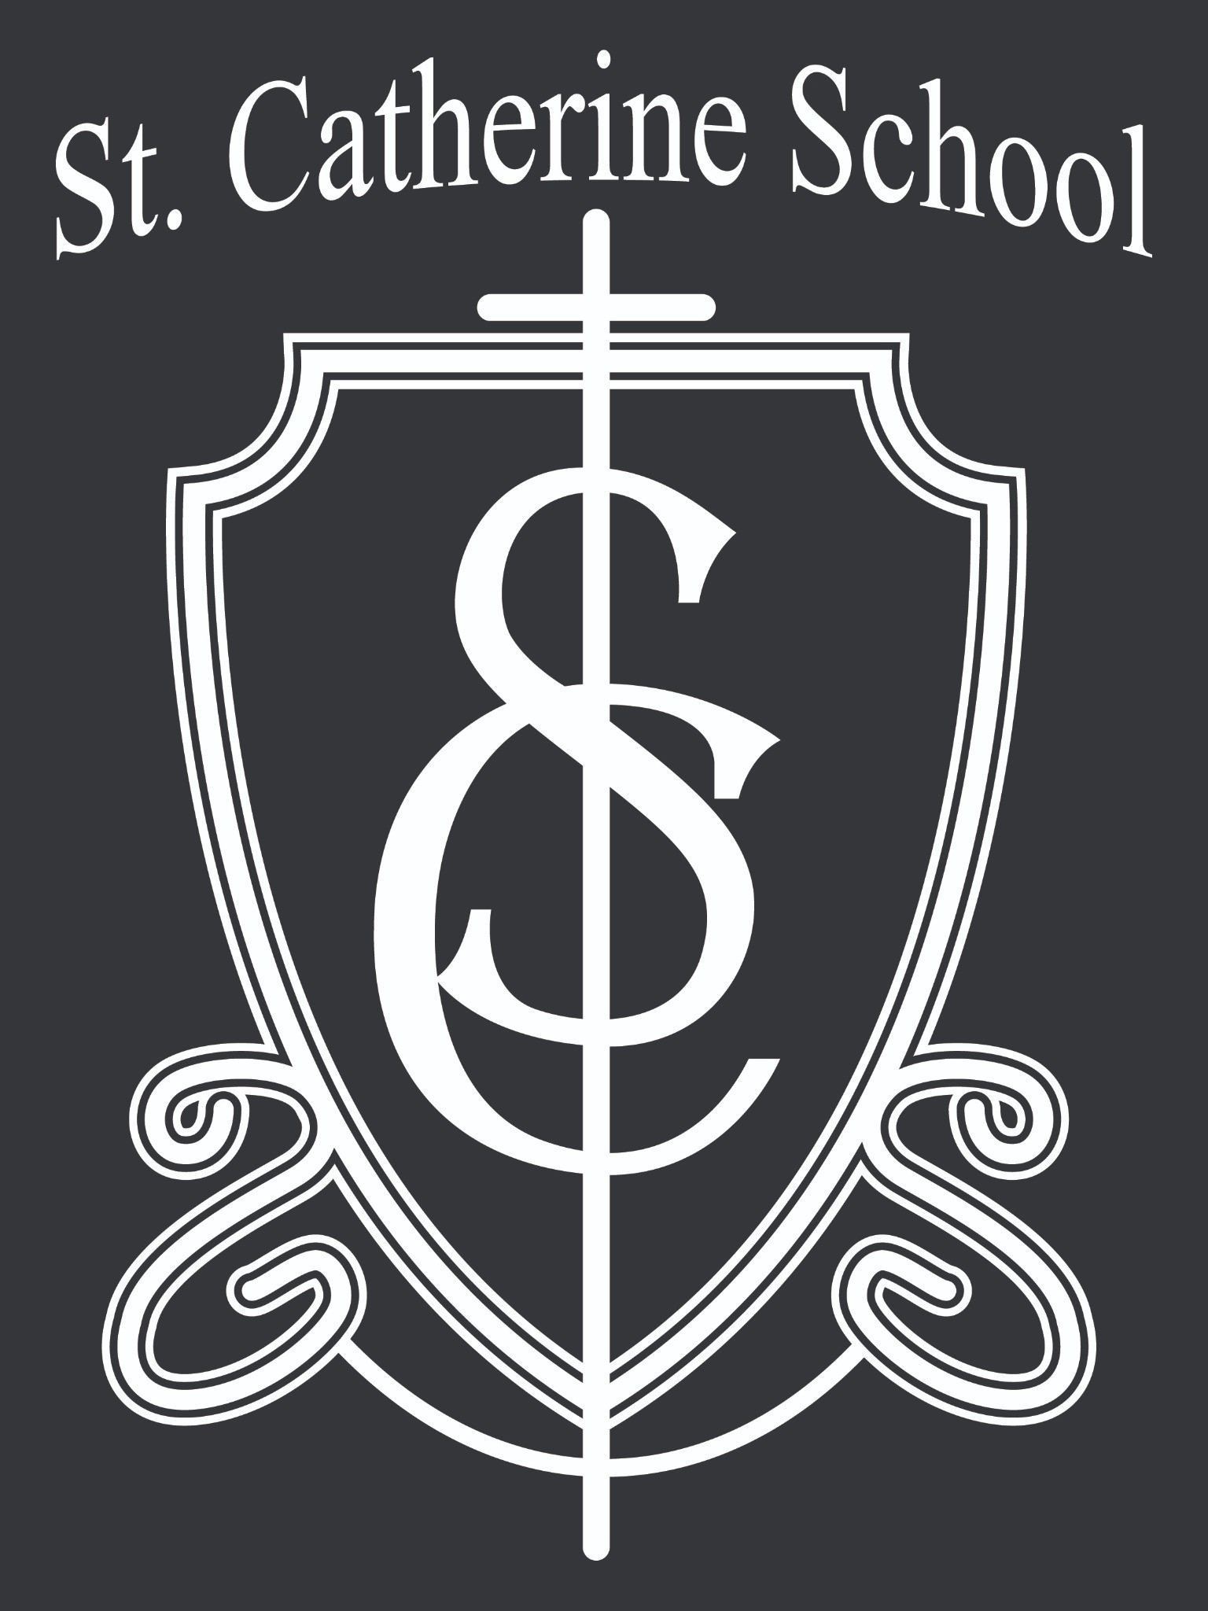St. Catherine Spotlight
The nice weather has meant extra outdoor time for students, and on Friday several classrooms helped serve our school community by cleaning up the playground and outdoor areas surrounding the school.
This was service in action—students taking pride in their school and helping create a welcoming environment for others, including new families who may be joining us through the school or Little Saints Childcare. We are proud of our students for stepping up and helping others.

Stay Connected with St. Catherine School
📍 Address: 540 3rd Ave. NE, Valley City, ND 58072
Email: nicholas.lee1@k12.nd.us
📧
Phone: 1-701-845-1453

📞
Website: www.stcatherine.k12.nd.us

🌐
📘 Follow Us on Facebook: St. Catherine School on Facebook

“Inspiring excellence through faith, learning, and service.”

