Greenwood Leflore Consolidated School District’s

Wellness Policy

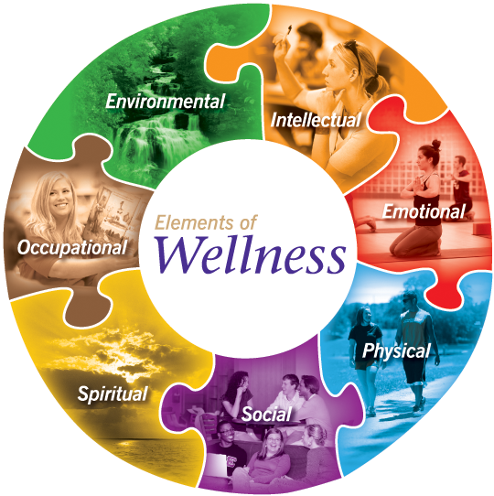

Created by: Members of the Wellness Committee which includes employees of The Greenwood Leflore Consolidated School District, students, parents and representatives from local agencies and organizations

Created for: To satisfy requirements set forth by the United States Department of Agriculture (USDA) and The Office of Child Nutrition (OCN)

Created on: September 25, 2025

The Greenwood Leflore Consolidated School District’s Wellness Policy

To support the relationship between student health and academic achievement, the 2014 Mississippi Public School Accountability Standards (Standard 17.5.1) and the Healthy Hunger-Free Kids Act of 2010 (HHFKA) requires each local school to establish a local school wellness policy. This document seeks to satisfy this requirement. Mississippi Code of 1972, Annotated Section 37-13-134 requires the recommendations made by a school health council to be based on a coordinated approach to school health which also meet state and federal requirements. The Office of Healthy Schools is committed to supporting academic achievement through school health programs that ensure every child has the opportunity to be fit, healthy and ready to succeed.

The following minimum requirements are established by the federal legislation. This law places responsibility of developing a school wellness policy at the local level, so individual needs of each school can be addressed most effectively. States and schools may choose to require or add additional components. Specifically, the federal legislation requires:

Specific goals for nutrition promotion and education, physical activity, and other school- based activities that promote student wellness. LEA’s are required to review and consider evidenced-based strategies in determining these goals;

- Standards and nutrition guidelines for all foods and beverages sold to students on the school campus during the school day that are consistent with Federal regulations for:
  - School meal nutrition standards
  - Smart Snacks in School Nutrition standards

- Standards for all foods and beverages provided but not sold to students during the school day (e.g., in classroom parties, classroom snacks brought by parents, or other foods given as incentives).

- Policies for food and beverage marketing that allow marketing and advertising of only those foods and beverages that meet the Smart Snacks in School Nutrition standards.

LEAs must establish wellness policy leadership who have the authority and responsibility to ensure each school complies with the policy.

At a minimum, LEAs must permit participation by the general public and the school community (including parents, students, and representatives of the school food authority, teachers of physical education, school health professionals, the school board, and school administrators) in the wellness policy process.
Mississippi Code of 1972, Annotated Section 37-13-134 requires the establishment of School Health Councils (SHC). The School Health Council (SHC) is one of the most efficient and effective ways to gather the necessary local input for a school wellness policy, as well as to address the overall health concerns within a local school. The SHC can also play a leadership role in determining the goals for a school wellness policy and in the successful implementation of the policy once it is developed.

Local stakeholders can be invited to join School Health Councils – to provide necessary resources and assist schools in developing appropriate, science-based wellness policies. The following list contains the minimum requirements for members of local school health councils; other key stakeholders should be added as necessary. These councils must make recommendations based on a coordinated approach to school health.

- Healthcare providers-Claude Courtney II, On-site Wellness Coach Active Health Management, Anne Marie Gregory-Dietician, Mississippi State University
- Hospitals and public health departments-John Cook, Physical Therapist
- Non-profit health organizations-Earlean Anderson, MS Tobacco Coalition, Partnership for a Healthy MS
- Physical activity groups-Debra Adams-Greenwood Community Center
- Community youth organizations-Antwoine Williams, Greenwood Youth Sports Program
- University departments and other government agencies- Desiree Norwood, Program Coordinator Plan A Health/MS Municipal League, Member of the Board of Directors

Faith-based organizations, clergy, and churches-Lawrence Shannon, Greater Pentecostal Church of God in Christ
- Parents-Jennifer King
- Teachers-Jennifer King
- Students-Cedric and Grace Jordan
- Board Member-Alice Hilliard, Board Secretary, District 4

The following are guidelines for Mississippi School Health Councils
- School Health Councils must meet a minimum of three times per year.
- School Health Councils must maintain minutes for each meeting for documentation.
- A minimum of one presentation per year must be made to the local school board for approval of all school wellness policies.

Once a local school wellness policy has been developed, school board approval must be obtained using all appropriate and legal timelines and procedures. Federal Child Nutrition legislation does require that any local educational agency participating in USDA school meals programs must have established a local wellness policy by the beginning of school year 2006-2007.

Approving a School Wellness Policy is just the first step toward creating an environment that supports student health and academic achievement. The federal legislation also requires a plan for measuring the implementation and evaluation of the policy, including the designation of one or more persons with the responsibility for ensuring the school meets minimum guidelines.

A School Health Council (SHC) can also be useful in the implementation and evaluation process. In order to insure a smooth and consistent implementation of a locally approved policy, the SHC can help to educate the school and community about the requirements for a policy and its importance for children in Mississippi schools. It can also be involved in measuring progress towards local goals related to nutrition, physical activity, and student wellness.
The Greenwood Leflore Consolidated School District’s Wellness Policy is based on existing state requirements and USDA guidance as of June 2018 and on the experiences of successful schools in Mississippi and around the United States.

This guide contains both minimum requirements and optional policy statements. The minimum requirements, based on federal and state legislation and standards, must be included in any School Wellness Policy adopted by Mississippi schools.

The final rule requires State agencies to assess compliance with the wellness policy requirements as a part of the general areas of the administrative review every 3 years.
LEAs must conduct an assessment of the wellness policy every 3 years, at a minimum. This assessment will determine:

- Compliance with the wellness policy
- How the wellness policy compares to model wellness policies
- Progress made in attaining the goals set by the policy

The “new” ten-component model developed by the Centers for Disease Control and Prevention, – Whole School, Whole Community, Whole Child, provides school health councils the opportunity to focus on health issues and to successfully implement quality school health programs that provide opportunities for all children to be fit, healthy, and ready to succeed.

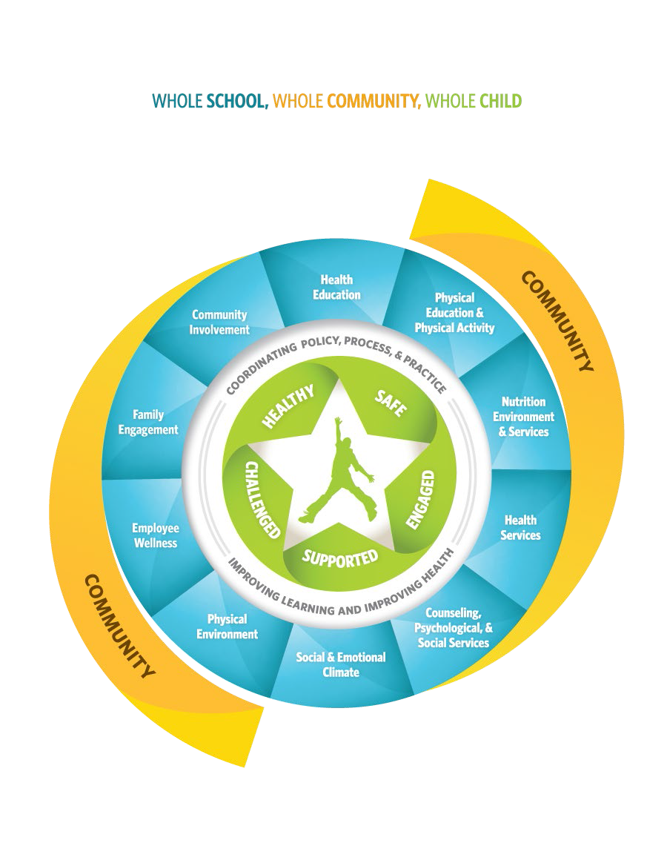
The Greenwood Leflore Consolidated School District’s Wellness Policy

Rationale:

The link between health of students and learning is well documented. If children are to be successful in school they cannot be tired, hungry, sick, suffering from drug abuse, or worried that school is an unsafe environment in which they could become a victim of a violent act. It has become apparent that problems such as poor nutrition, lack of physical activity, substance abuse, depression, teen pregnancy, obesity, bullying, and more – can adversely affect not only a child’s health, but also his or her ability to learn! And that is precisely why a coordinated approach to school health can make a difference! A coordinated approach to school health improves kids’ health and their capacity to learn through the support of families, schools, and communities working together. At its very core, a coordinated approach to school health is about keeping students healthy over time, reinforcing positive healthy behaviors throughout the school day, and making it clear that good health and learning go hand in hand.

Goal:
All students in The Greenwood Leflore Consolidated School District shall possess the knowledge and skills necessary to make healthy choices that promote healthy lifestyles. All staff members in The Greenwood Leflore Consolidated School District are encouraged to model a lifestyle of healthy eating patterns and moderate physical activity as a valuable part of their daily lives.

To meet this goal, The Greenwood Leflore Consolidated School District adopts this school wellness policy with the following commitments to implementing a coordinated approach to school health. This policy is designed to effectively utilize school and community resources and to equitably serve the needs and interests of all students and staff, taking into consideration differences in culture.

In determining these goals for nutrition promotion and education, physical activity, and other school-based activities that promote student wellness, The Greenwood Leflore Consolidated School District’s Health Council has reviewed and considered evidenced-based strategies. They are outlined below

Nutrition Environment and Services
Minimum requirements:
The Greenwood Leflore Consolidated School District will:
- Offer a school lunch program with menus that meet the meal patterns and nutrition standards established by the U.S. Department of Agriculture (USDA) and the Mississippi Department of Education, Office of Child Nutrition Programs.
- Offer school breakfast and snack programs (where approved and applicable) with menus that meet the meal patterns and nutrition standards established by the USDA and the Mississippi Department of Education, Office of Child Nutrition Programs.
- Promote participation in school meal programs to families and staff.
- Operate all Child Nutrition Programs with school foodservice staff who are properly qualified according to current professional standards (Mississippi Board of Education Policy, Code 2001).
- Follow State Board of Education policies on competitive foods and extra food sales (Mississippi Board of Education Policy, Code 2002).
- Include goals for nutrition promotion, nutrition education, physical activity and other school-based activities to promote student wellness.
- Implement Nutrition Standards as adopted by the State Board of Education in accordance with the Mississippi Healthy Students Act (State Board of Education Policy 4011),
- Healthy food and beverage choices;
- Healthy food preparation;
- Marketing of healthy food choices to students, staff and parents;
- Food preparation ingredients and products;
- Minimum/maximum time allotted for students and staff lunch and breakfast;
- Availability of food items during the lunch and breakfast periods of the Child Nutrition Breakfast and Lunch Programs;
- Methods to increase participation in the Child Nutrition School Breakfast and Lunch Programs.
- Establish guidelines in accordance with USDA Smart Snacks in Schools for all foods available on the school campus during the school day with the objective of promoting student health and reducing childhood obesity. (see Nutrition Environment and Services section of the Tools That Work – Your Guide to Success for Building a Healthy School Toolkit that is found on the Office of Healthy Schools website at www.mde.k12.ms.us/ohs/home http://www.mdek12.org/OHS )

Establish standards for all foods and beverages provided but not sold to students during the school day (e.g. in classroom parties, classroom snacks brought by parents, or other foods given as incentives).
- Establish guidelines in accordance with USDA Smart Snacks in Schools for the sale of food items for fundraising.
- Use Smart Snacks Resources to educate the school community about the importance of offering healthy snacks for students and staff members.
- http://www.fns.usda.gov/healthierschoolday/tools-schools-focusing-smart-snacks Smart Snacks Product Calculator:
- The Alliance for a Healthier Generation Smart Snacks Product Calculator is an effective online instrument that has been determined by the USDA, Food and Nutrition Service to be accurate in assessing product compliance with the federal requirements for Smart Snacks in Schools. The calculator can be used for food and beverage products. https://www.healthiergeneration.org/

Food Safe Schools
- Implement a food safety program based on HACCP principles for all school meals, as required by the USDA and the Mississippi Department of Education, Office of Child Nutrition Programs and ensure that the food service permit is current for the school sites. HACCP Principles for K-12 schools can be downloaded at: http://www.nfsmi.org/ResourcesOverview.aspx?ID=151
- Develop a food safety education plan for all staff and students, consistent with Fight Bac® (www.fightbac.org) and other national standards for safe food handling at home and in schools.
- Ensure that all staff has received instructions to support food safety on the school campus. Food Safety resources have been developed by the Office of Child Nutrition to assist with the training of school staff members. These resources which include a training power-point

presentation, food Safety Post Test and Food Safety Post Test Answer Key can be found on the Office of Healthy Schools website at www.mde.k12.ms.us/ohs/home . http://www.mdek12.org/OHS
- All school personnel (school board members, administrators, teachers, school nurses, instructional and health services paraprofessionals, foodservice staff, custodians and facilities managers, and administrative support staff) will receive copies of the Local School Wellness Policy that includes food safety policies and procedures and provides for relevant professional development.
- Adequate access to hand-washing facilities and supplies will be available whenever and wherever students, staff, and families prepare, handle, or consume food.
- The food safety assurance plan must address strategies that minimize risks for students and staff who have food allergies and intolerances.

Optional policy statements (adopt as appropriate for local school goals):
- Encourage students to make food choices based on the Healthy Hunger-Free Kids Act of 2010 (HHFKA) and the ChooseMyPlate resources, by emphasizing menu options that feature baked (rather than fried foods), whole grains, fresh fruits and vegetables, and reduced-fat dairy products. Read more about HHFKA at ChooseMyPlate at http://www.choosemyplate.gov/
- Replace deep fat fryers with combination oven steamers.
- Eliminate use of food as rewards for student accomplishment and the withholding of food as punishment (e.g., restricting a child’s selection of flavored milk at mealtime due to behavior problems). Also, do not use any type of physical activity as a means of punishment.

Physical Education/Physical Activity

Minimum requirements:

The Greenwood Leflore Consolidated School District will:
- Provide 150 minutes per week of activity-based instruction for all students in grades K-8 (in accordance with Section 37-13-134, Mississippi Code of 1972, ann., reference 2014 Mississippi Public Schools Accountability Standards 27.1.
- Provide Physical Education/Activity in accordance with the Physical Education Rules and Regulations as approved by the State Board of Education in compliance with the Mississippi Healthy Students Act (State Board of Education Policy 4012).
- Require fitness testing for all 5th grade students.
- Require fitness testing for high school students; during the year they acquire the ½ Carnegie unit in physical education as required for graduation by the Mississippi Healthy Students Act (State Board of Education Policy 4012).
- Offer a planned sequential program of physical education instruction incorporating individual and group activities, which are student centered and taught in a positive environment.
- Instruction must be based on 2013-2014 Mississippi Physical Education Frameworks.
- Implement the requirements of the Mississippi Healthy Students Act of 2007 (Senate Bill 2369).
- Graduation requirements for 9th through 12th grade students shall include ½ Carnegie unit in physical education.
- Beginning with 9th graders in school year 2015-2016, provide instruction in Cardiopulmonary Resuscitation (CPR) and use of Automated External Defibrillator (AED) for students in grades 9-12 in the school year they earn their ½ Carnegie Unit for physical education or health Education. MS Code 37-13-134 (Senate Bill 2185)
- Address concussions by adopting and implementing a policy for students in grades 7-12 who participate in activities sanctioned by the Mississippi High School Activities Association (MHSAA). This policy will include a concussion recognition course that has been endorsed by the Mississippi Department of Health. This course will provide information on the nature and risk of concussions for students participating in athletics. Also included in the policy, parents/guardians will be provided with a concussion policy before the start of regular school athletic season. (House Bill 48)

Optional policy statements (adopt as appropriate for local school goals):
- Create opportunities for students to voluntarily participate in before- and after-school physical activity programs like intramurals, clubs, and at the secondary level, interscholastic athletics.

STATE REQUIREMENTS MONITORED BY THE OFFICE OF HEALTHY SCHOOLS

Health Education

Minimum requirements:

The Greenwood Leflore Consolidated School District will:
- Provide ½ Carnegie unit of health education for graduation (2012 Mississippi Public School Accountability Standard 20, Appendix A).
- Instruction must be based on the Mississippi Contemporary Health for grades 9-12 (2012 Mississippi Public School Accountability Standard 20, Appendix A).
- Implement the requirements of the Mississippi Healthy Students Act of 2007, which requires 45 minutes per week of health education instruction as defined by the State Board of Education for grades K through 8.
- Instruction must be based on the Mississippi Contemporary Health for grades K-8.
- Implement the requirements of MS Code 37-13-171, which requires the development of a sex related education policy and instruction on medically accurate or evidenced based abstinence-only or abstinence-plus curricula.
- Beginning with 9th graders in school year 2015-2016, provide instruction in Cardiopulmonary Resuscitation (CPR) and use of Automated External Defibrillator (AED) for students in grades 9-12 in the school year they earn their ½ Carnegie Unit for health education or physical education. MS Code 37-13-134 (Senate Bill 2185)

Optional policy statements (adopt as appropriate for local school goals):
- Address the attendance of HIV infected students, uphold confidentiality and maintain procedures to protect HIV-infected students and staff from discrimination.
- Provide students with quality disease prevention instruction based on the Contemporary Health Education Framework and other selected materials approved by the district.
- Host a School Health Fair for students.

Health Services

Minimum requirements:

The Greenwood Leflore Consolidated School District will:
- Ensure all school nurses are working under the guidelines of the June 2018 Mississippi School Nurse Procedures and Standards of Care (updated 2019).

Provide for teachers and staff training regarding signs and symptoms of asthma. (MS Code Sections 37-11-71 and 73-25-37)
- Every child who has been diagnosed with asthma must have an asthma action plan on file in the school office.
- Know the district anaphylaxis policy. Providing training by a healthcare professional, preferably a school nurse, for the individuals that will be responsible for implementing the policy at the school site. (MS Code Sections 37-11-71 and 73-25-37)

Optional policy statements (adopt as appropriate for local school goals):
- Offer comprehensive health services for students in grades K-12, through the employment of school nurses, as a means to academic success.
- Work with students, parents, and local healthcare providers to effectively manage and treat chronic diseases.
- Promote healthy lifestyles through school and community events (PTA meetings, open houses, health fairs, teacher in-services and other events.)

Counseling, Psychological and Social Services/Social and Emotional Climate

Minimum requirements:
The Greenwood Leflore Consolidated School District will:

Adhere to the details outlined in the Licensure Guidelines (436 or 451) when hiring guidance counselors and psychologists. The state does not have a policy specifically outlining the requirements for a school social worker. For licensure as a social worker in the state of Mississippi, a candidate must: provide verification of a baccalaureate degree in social work from a college or university accredited by the Council on Social Work Education (CSWE) or Southern Association of Colleges and Schools (SACS) and scores a minimum of 70 on the ASWB basic exam.
- Abide by Mississippi Code 37-9-79 (Amended 2014) as the school provides for counseling and guidance for students.
- Hire school guidance counselors with a minimum of a master’s degree in Guidance and Counseling, or in an emergency situation, an appropriate certification as determined by the Commission on Teacher and Administrator Education, Certification and Licensure and Development. MS Code 37-9-79 – (Amended 2014-Senate Bill 2423)
- Hire school counselors who agree to abide by the American School Counselor Association Code of Ethics.
- Ensure that all school guidance counselors provide comprehensive counseling services such as:
  - Academic and personal/social counseling.
  - Student assessment and assessment counseling.
  - Career and educational counseling.
  - Individual and group counseling.
  - Crisis intervention and preventive counseling.
  - Beginning with the 2017-2018 school year, the State Department of Education shall require that local school districts conduct in-service training on suicide prevention education for all school district employees. Thereafter, only new employees are required to have training.
The Mississippi Department of Mental Health will be responsible for developing the content of the training (HB 263).
  - Referrals to community agencies.
  - Educational consultations and collaborations with teachers, administrators, parents and community leaders.
  - Education and career placement services.
  - Follow-up counseling services.
  - Conflict resolution.
  - Professional school counselors must spend a minimum of eighty percent (80%) of their contractual time to the delivery of services to students as outlined by the American School Counselor Association

Family Engagement and Community Involvement

Minimum requirements:
The Greenwood Leflore Consolidated School District will:

Invite parents and community members to participate in school health planning by serving on the local School Health Council.
- Establish methods to inform and update the public regarding the LSWP and the assessment of the LSWP

Optional policy statements (adopt as appropriate for local school goals):
- Invite family or community members to eat a meal at school.
- Encourage health education skill-building activities at home by including homework for health instruction, personal goal setting for healthy behaviors, and other health education-related activities.
- Schedule school health fairs and invite parents and the public to attend.
- Increase PTA/PTO Membership.

Employee Wellness

Optional policy statements (adopt as appropriate for local school goals):
The Greenwood Leflore Consolidated School District will:
- Make as a Requirement that all staff are aware of the Mississippi State and School Employees’ Health Insurance Plan that has been enhanced to include My Active Health, a wellness and health promotion program designed to help individuals live a healthy lifestyle and increase their overall wellness benefit – http://www.MyActiveHealth.com/Mississippi
- Develop relationships with community health providers (e.g., local health departments, hospitals, neighborhood clinics, health professionals), recreational facilities, voluntary health organizations (e.g., American Cancer Society, American Lung Association, American Heart Association), and other community members who can provide resources for or support school employee wellness activities.
- Coordinate school employee wellness activities with student health-promotion activities.
- Coordinate Staff Wellness events and activities with state and national health observances throughout the year.

Marketing a Healthy School Environment

Minimum requirements:
  - Eliminate advertising or promoting unhealthy food choices on the school campus. Advertising must be restricted to only those foods and beverages that meet the Smart Snacks in School Nutrition Standards.

Optional policy statements (must adopt a minimum of one policy as appropriate for local school goals):

The Greenwood Leflore Consolidated School District will:
  - Involve students in the local school health council for planning and marketing school health messages throughout the school.
  - Create awareness of the link between the health of students and academic performance.
  - Prepare media releases that share successes to local newspapers.

Implementation

Minimum requirements:

The Greenwood Leflore Consolidated School District will:
  - Establish a plan for implementation of the school wellness policy.
  - Designate one or more persons to ensure that the school wellness policy is implemented as written. The Greenwood Leflore Consolidated School District designates Yvette Totten for this purpose.
  - Establish and support a School Health Council (SHC) that addresses all aspects of a coordinated school health program, including a school wellness policy (Mississippi Code of 1972 Annotated, Section 37-13-134).
  - Conduct a review of the progress toward school wellness policy goals each year to identify areas for improvement.
  - Prepare and submit a yearly report to the school board regarding the progress toward implementation of the school wellness policy and recommendations for any revisions to the policy as necessary to update and modify the program as appropriate.
Optional policy statements (adopt as appropriate for local school goals):
  - Use monitoring instruments, developed by the Office of Healthy Schools, to conduct a self assessment that identifies strengths and weaknesses toward implementation of the minimum requirements. Monitoring instruments can be downloaded at http://www.mdek12.org/OHS - Click on Resources

USDA Nondiscrimination Statement
In accordance with federal civil rights law and U.S. Department of Agriculture (USDA) civil rights regulations and policies, this institution is prohibited from discriminating on the basis of race, color, national origin, sex (including gender identity and sexual orientation), disability, age, or reprisal or retaliation for prior civil rights activity.
Program information may be made available in languages other than English. Persons with disabilities who require alternative means of communication to obtain program information (e.g., Braille, large print, audiotape, American Sign Language), should contact the responsible state or local agency that administers the program or USDA’s TARGET Center at (202) 720-2600 (voice and TTY) or contact USDA through the Federal Relay Service at (800) 877-8339.
To file a program discrimination complaint, a Complainant should complete a Form AD3027, USDA Program Discrimination Complaint Form which can be obtained online at: https://www.usda.gov/sites/default/files/documents/ad-3027.pdf, from any USDA office, by calling (866) 632-9992, or by writing a letter addressed to USDA. The letter must contain the complainant’s name, address, telephone number, and a written description of the alleged discriminatory action in sufficient detail to inform the Assistant Secretary for Civil Rights (ASCR) about the nature and date of an alleged civil rights violation. The completed AD-3027 form or letter must be submitted to USDA by:
1. mail:
U.S. Department of Agriculture Office of the Assistant Secretary for Civil Rights
1400 Independence Avenue, SW
Washington, D.C. 20250-9410; or

2. fax:
(833) 256-1665 or (202) 690-7442; or

3. email:
Program.Intake@usda.gov

This institution is an equal opportunity provider.



Mississippi Department of Education The Office of Healthy Schools
359 North West Street, Suite 207
Jackson, Mississippi 39205-0771
601.359.1737

