FRANKLIN COUNTY HIGH SCHOOL
EXAMPLE COLLEGE, CAREER & TECHNICAL EDUCATION FOUR-YEAR PLAN
CLASS OF 2026 or Later

NAME: _____________________________________________________ DATE: ________________________________
Tennessee Graduation Requirements:

English: 4 credits
Math: 4 credits
Science: 3 credits
Social Studies: 3 credits
Personal Finance: 0.5 credit
Wellness: 1 credit
PE: 0.5 credit
Elective Focus: 3 credits
*Fine Arts: Not required for Tech School
*Foreign Lang: Not required for Tech School

Additional Requirements/Information:
In addition to the above requirements, Franklin County requires 6 additional credits for a total of 28 credits needed in order to graduate. Students are required to take the ACT. Students on this path may take honors courses, dual credit courses, and/or AP courses if he/she meets prerequisites.
More Information:
*If a student on this path plans to attend college, they should take Fine Arts and Foreign Language as listed on this four-year plan to complete college entrance requirements. Career & Technical Education classes and Work Based Learning are the focus of this path. Please visit our website at https://fchs.fcstn.net/ and click on “Guidance” for information.
FCHS REQUIRES 28 CREDITS FOR GRADUATION
9th Grade 10th Grade
1. English I 1. English II
2. Algebra I 2. Geometry
3. Physical Science 3. Biology I
4. World History 4. Tennessee History
5. Wellness 5. Career & Technical Elective (Focus)
6. Career Exploration/PE 6. Career & Technical Elective (Focus)
7. Career & Technical Elective (Focus) 7. Fine Arts* or CTE Elective
8. Elective 8. Elective

11th Grade 12th Grade
1. English III 1. English IV
2. Algebra II 2. Pre-Calculus, Statistics, Applied Math, or SAILS Math
3. Chemistry 3. US Gov’t & Civics/Contemporary Issues or TBD
4. U. S. History and Geography 4. Personal Finance/Economics
5. Foreign Language I* or CTE Elective 5. CTE Elective, WBL, or Foreign Language III*
6. Foreign Language II* or CTE Elective 6. Career Technical Elective or Work Based Learning
7. Career & Technical Elective 7. Career Technical Elective or Work Based Learning
8. Elective or Work Based Learning (2nd Sem) 8. Career Technical Elective or Work Based Learning or Foreign Language III*

POST SECONDARY PLANS
2 Year College: _____ 4 Year College: _____ Tech School: _____ Military: _____ Job: _____
*************************************************************************************
The above is a general plan based upon state guidelines. Plans may change from year to year.
Student Signature__________________________________________________________________________
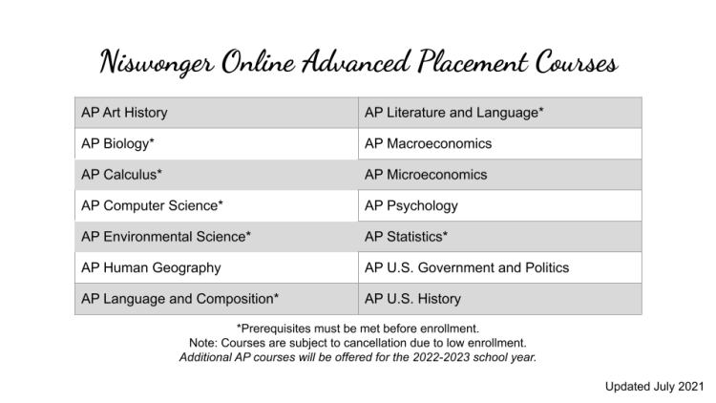
Prerequisites:
AP Art History: No prerequisite - Great introductory AP course!
AP Biology: In person Niswonger prerequisites are Biology I and Chemistry I. Algebra I is
recommended. FCHS prerequisite is honors Biology.
AP Calculus AB: In person Niswonger prerequisites are Algebra I, Geometry, Algebra II, Pre-Calculus or Trigonometry/Analytical Geometry. FCHS prerequisite is honors Calculus.
AP Calculus BC: Prerequisites are Algebra I, Geometry, Algebra II, Pre-Calculus or Trigonometry
AP Computer Science A: Prerequisite is Algebra I. Algebra II is recommended.
AP Environmental Science: Prerequisite is Algebra I. Two years of high school science with labs is recommended.
AP Human Geography: No prerequisite - Great introductory AP course!
AP Language & Composition: Prerequisites are English I and English II.
AP Macroeconomics: No prerequisites. Algebra I is recommended.
AP Microeconomics: No prerequisites. Algebra I is recommended.
AP Psychology: No prerequisite - Great introductory AP course!
AP Statistics: Prerequisite is Algebra II.
AP US Government & Politics: No prerequisite
AP US History: No prerequisite
AP Literature & Composition: Prerequisites are English I, English II, and English III or AP Language & Composition.

