**Annual Media Release**

**2025-2026 School Year**

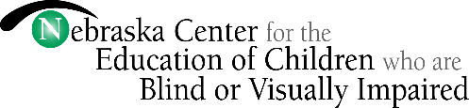

Student Name: _________________________________________________________________

I hereby authorize NCECBVI staff, with the approval of the NCECBVI Leadership Team, to allow the use of pictures and/or voice reproductions or other identifiable information of my child for the purpose of educational projects, data collection/assessment purposes, public relations, school publicity, and other beneficial endeavors as long as such usage is not for the financial or personal benefit to any individual and/or groups or private company. This includes posting of photos on the NCECBVI website, Facebook page, and sending press releases/photos to newspapers in Nebraska City and in your local community.

Check **one**: _____ YES _____ NO

If you have concerns or restrictions, please specify: ___________________________________

_____________________________________________________________________________

_____________________________________________________________________________

_____________________________________________________________________________

Parent/Guardian Signature: ______________________________________ Date: __________

9/10/2024