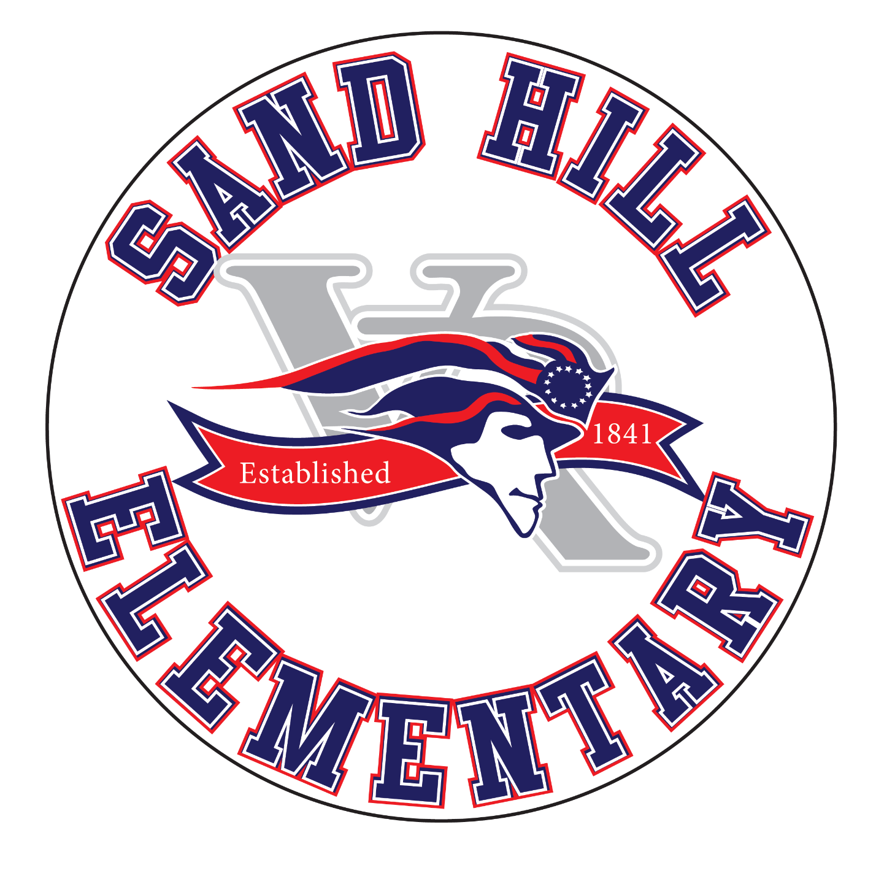
Pre-K Supply List
2026-2027

- Backpack- big enough to hold nap towels/blankets, an agenda, and a complete change of clothes (Lunch box is optional)
- Complete change of clothes (shirt, pants, underwear, socks)- please be sure it is appropriate for the season
- Water Bottle
- 2 Class Snacks- individually wrapped (20 students)
- Small Towels/Blankets for rest time (*no roll-up nap mats or pillows; blanket MUST fit in your child backpack)
- Crayons
- Markers
- Glue Sticks & Glue Bottles
- 1-subject spiral notebook (any color)
- ½ inch white binder with clear front pocket
- Plain white t-shirt (1 size large then current shirt size)

Wish List

Hand Sanitizer | Sticker labels 1”x2-⅝” (30/sheet)
Disinfectant wipes | Baby wipes
Power towels | Tissues
Lysol spray | Bandaids
Index Cards | Envelopes
Ziplock bags (gallon, quart, sandwich)

***Please only label these items with your child’s name: blanket, water bottle, backpack, lunchbox, and change of clothes.***

