**HOLLY SPRINGS SCHOOL DISTRICT DROPOUT PREVENTION PLAN**

**2024 - 2025**



**840 HWY 178 EAST**

**HOLLY SPRINGS, MS 38635**

[www.hssdk12.org](http://www.hssdk12.org/)

*Education is the most powerful weapon which you can use to change the world.*

*Nelson Mandela*

**Table of Contents**

**Dropout Prevention Planning Team 3**

**10-Year Graduation Rates. 4**

**10-Year Dropout Rates. 5**

**School and District Dropout Prevention Strategies 6**

**Additional Strategies and Targeted Groups 7**

**Early Warning System and Indicators 9 - 13**

### Dropout Prevention Planning Team Members

|  |  |
| --- | --- |
| **Team Members** | **Position** |
| Cravin Turnage | Principal |
| Dr. Jorgell Jones | Assistant Principal |
| Maurica Sims | GED Coordinator |
| Rhonda Richard | Counselor |
| Susie Brown | Career and Technical Director |
| LaTanya Burgin | Career and Technical Counselor |
| Laverne Sanders | Career and Technical Student Services Coordinator |
| Tannya Sanders | Holly Springs Junior High Principal (Feeder School) |
| Shelia Fiddis | Holly Springs Junior High Counselor |
| Eileen Dowsing | District Office Representative |

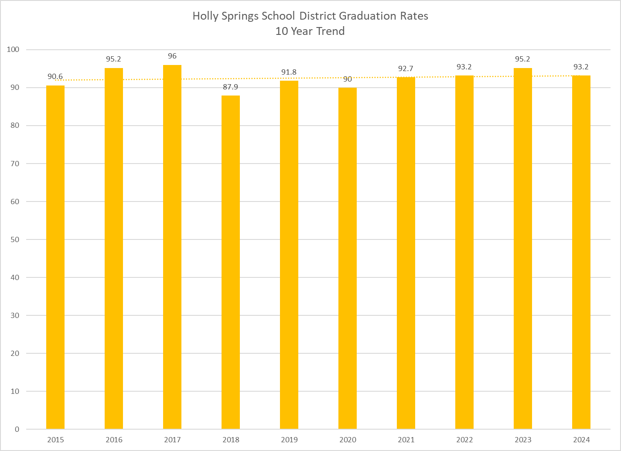

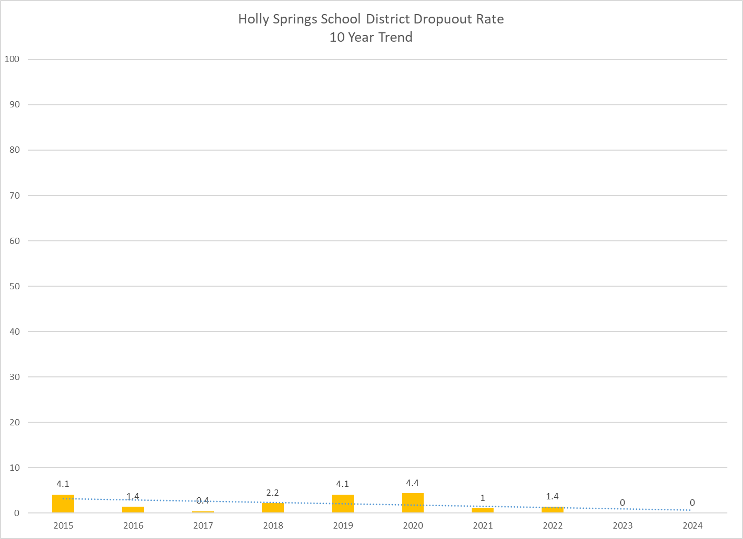

|  |  |  |  |  |  |
| --- | --- | --- | --- | --- | --- |
| **15 Dropout Prevention**  **Strategies** | **District/School Dropout Prevention Strategies** | | | | |
| **District -wide** |  | **Primary and**  **Intermediate**  **School** | **Junior**  **High**  **School** | **High School** |
| **Systemic**  **Renewal** | Strategic  Planning | Strategic  Planning A+ Plan  (Improvement) | Strategic  Planning A+ Plan  (Improvement) | Strategic  Planning A+ Plan  (Improvement) |
| **School-**  **Community**  **Collaboration** | Parent Seminars  Community Forums  Pastoral Alliances | Parent  Seminars/  Back-to-School  Night/  Federal  Programs  Advisory  Committee/  Career Days | Parent  Seminars/  Back-to-  School Night/  Federal  Programs  Advisory  Committee/  Career Days | Parent  Seminars/  Back-to-  School Night/  Federal  Programs  Advisory  Committee/  Career Days |
| **Safe Learning**  **Environments** | Safety and Crisis  Management  Plans  Positive  Behavior  Support | Safety and  Crisis  Management  Plans  Positive  Behavior  Support | Safety and  Crisis  Management  Plans  Positive  Behavior  Support | Safety and  Crisis  Management  Plans  Positive  Behavior  Support |
| **Family**  **Engagement** | Parent  Seminars | Parent Seminars  Monthly Parent  Training Sessions  Report  Card/Parent  Conferences | Parent Seminars  Monthly Parent  Training Sessions  Report  Card/Parent  Conferences | Parent Seminars  Monthly Parent  Training Sessions  Report  Card/Parent  Conferences |
| **Early Childhood**  **Education** | Collaboration  with Head Start | Collaboration  with Head Start |  |  |
| **Early Literacy Development** | Head Start Partnerships  Parent Centers | Head Start Blended Program | Parent Centers  Monthly Parent Training Sessions | Parent Centers  Monthly Parent  Training Sessions | Parent Centers  Monthly Parent Training Sessions |

#### District/School Dropout Prevention Strategies

**Additional Dropout Prevention Strategies**

The district will utilize the Multi-Tiered System of Support (State Board of Education Policy Part 3, Chapter 41.1) which includes the Early Warning System of Support to address students in danger of dropping out on all levels as well as other targeted groups of students in danger of failing in all grades.

#### Intervention Process

In compliance with the Mississippi Department of Education, the Holly Springs School District School District shall require an instructional model designed to meet the needs of every student. The model shall consist of three tiers of instruction.

Tier 1: Quality classroom instruction based on MS Curriculum Frameworks

Tier 2: Focused supplemental instruction

Tier 3: Intensive interventions specifically designed to meet the individual needs of students

Teachers should use progress monitoring information to (a) determine if students are making adequate progress, (b) identify students as soon as they begin to fall behind, and (c) modify instruction early enough to ensure each and every student gains essential skills. Monitoring of student progress is an ongoing process that may be measured through informal classroom assessment, benchmark assessment instruments and large-scale assessments.

If strategies at Tiers 1 and 2 are unsuccessful, students must be referred to the Teacher Support Team. The TST is the problem-solving unit responsible for interventions developed at Tier 3. Each school must have a Teacher Support Team (TST) implemented in accordance with the process developed by the Mississippi Department of Education. The chairperson of the TST shall be the school principal as the school's instructional leader or the principal's designee. The designee may not be an individual whose primary responsibility is special education. Interventions will be:

* + designed to address the deficit areas;
  + research based;
  + implemented as designed by the TST; and
  + supported by data regarding the effectiveness of interventions.

After a referral is made, the TST must develop and begin implementation of an intervention(s) within two weeks. No later than eight weeks after implementation of the interventions(s), the TST must conduct a documented review of the interventions to determine success of the intervention. No later than 16 weeks after implementation of the intervention(s), a second review must be conducted to determine whether the intervention is successful. If the intervention(s) is determined to be unsuccessful, then the student will be referred for a comprehensive assessment.

In addition to failure to make adequate progress following Tiers 1 & 2, students will be referred to the TST for interventions as specified in guidelines developed by the MDE if any of the following events occur:

1. Grades K -3: A student has failed one (1) grade;
2. Grades 4-12; A student has failed two (2) grades;
3. A student failed either of the preceding two grades and has been suspended or expelled for more than twenty (20) days in the current school year;
4. A student scores at the Minimal level on any part of the Grade 3 or Grade 7 Mississippi Academic Assessment Program (MAAP) tests; or
5. A student is promoted from Grade 3 to Grade 4 under a Good Cause Exemption of the Literacy – Based Promotion Act.

### Strategies to Address Retention Rates in K-2

The district will utilize the Multi-Tiered System of Support (State Board of Education Policy Part 3,

Chapter 41.1) which includes the Early Warning System of Support to address students in danger

of failing in all grades. To ensure students have a strong start the staff at Holly Springs Primary School

will utilize the MTSS process to address the retention rate and students in danger of failing in grades K-2.

### Recovery Initiatives for Students Age 17-21

For Ages 17-21 the MTSS Team will:

* Identify students who have not graduated or dropped out in the age range identified
* Develop and plan to help students meet requirements in order to graduate
* Offer credit recovery for students to gain credits through the Ombudsman credit recovery program
* Implement prevention and intervention programs that provide supplemental academic support for

students in at-risk situations.

### Students Transitioning from Detention Centers

Students Transitioning from Detention Centers, the MTSS Team will:

* Conduct transition meetings with representatives from detention centers
* Conduct a transition meeting with student and parent upon the student's return from the detention center and Principal designee to discuss and review the student's attendance, and behavior,
* Develop and plan to help students meet requirements in order to graduate
* Offer credit recovery for students to gain credits through the Ombudsman credit recovery program
* Implement prevention and intervention programs that provide supplemental academic support for students in at-risk situations.

**EARLY WARNING SYSTEM ASP ART OF THE MTSS PROCESS**

**The strongest predictors of high school graduation are:**

- Student Attendance

-Behavior

-Course Performance

(University of Chicago Consortium on

Chicago School Research, 2014).

|  |  |  |
| --- | --- | --- |
| **Status** | **Threshold: Number of Days Absent** | |
| **Each Quarter** | **Full Year** |
| **Off Track (Tier III)** | **5 days** | **18 days** |
| **Sliding (Tier II)** | **3 – 5 days** | **10 – 18 days** |
| **On Track to Graduate (Tier I)** | **2 days or less** | **9 days** |

# ATTENDANCE INDICATORS

# BEHAVIOR INDICATORS

|  |  |  |  |  |
| --- | --- | --- | --- | --- |
| **Status** | **Number of Office Referrals** | | **Number of Days Suspended** | |
| **Each Quarter** | **Full Year** | **Each Quarter** | **Full Year** |
| **Off Track (Tier III)** | **2** | **6** | **1** | **2** |
| **Sliding (Tier II)** | **1** | **3 - 5** | **0** | **0 - 1** |
| **On Track to Graduate (Tier I)** | **0** | **0 - 2** | **0** | **0 - 1** |

# COURSE PERFORMANCE INDICATORS (Elementary Schools)

|  |  |  |
| --- | --- | --- |
| **Status** | **Thresholds** | |
| **Math and Language Arts Grades K - 5** | **3rd Grade Reading Test (Literacy Based Promotion Act)** |
| **Off Track (Tier III)** | Report Card Grade of U or F | Failed 3rd Grade reading test |
| **Sliding (Tier II)** | Report Card Grade of N or D | Good Cause Promotion Transfer from 3rd to 4th Grade |
| **On Track to Graduate (Tier I)** | Report Card Grade of E, S or A, B, C | Passed 3rd Grade Reading Test |

# COURSE PERFORMANCE INDICATORS (Middle and High Schools)

|  |  |  |
| --- | --- | --- |
| **Status** | **Thresholds** | |
| **Math and English Grades Middle School 6th – 8th** | **Core Courses High School 9th – 12th** |
| **Off Track (Tier III)** | Report Card Grade of F | Report Card grade of F |
| **Sliding (Tier II)** | Report Card Grade of D | Report Card grade of D |
| **On Track to Graduate (Tier I)** | Report Card Grade of A, B, C | Report Card grade A, B, or C |