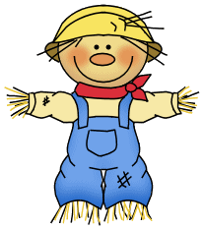October

October 30- November 3, 2023

**Weekly focus:**

**Theme**– bats/ spiders

**Letters**- Xx, Yy

**Sight words**- if, of

**Math**- count to 50 by ones, write recognize and work with numbers 0-10, addition to 5, name 2d and 3d shapes, sort objects, positional words

**Reading/ language-** ask and answer questions about what is read, identify characters in a story, identify parts of a book, produce rhyming words, isolate and identify beginning & ending sounds, identify letters and sounds of the alphabet

**Writing**- their name and all letters of the alphabet from memory, invented spelling

**Important dates:**

* October 31st- bring $1 to wear a costume
* November 1st- Cedar Hill Farm field trip
* November 10th-Veterans Day program
* November 20th-24th- Thanksgiving break

**\*ice cream and Chick-Fil-A biscuits must be PAID FOR and PRE ORDERED- this is optional**

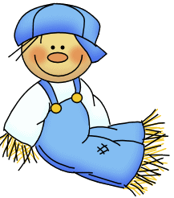

**Reminders:**

*Million cans recycling contest- send in your aluminum cans

*ice cream order forms and money are due Thursday- kiddos will get ice cream on Friday for snack if they purchased

*practice sight words and letters/ letter sounds, and writing letters at home

*check folders daily

**Field trip info:**

We will be leaving school at 8:45 Wednesday morning, please make sure your child is on time. They need to wear their class shirt or color and comfortable walking shoes. Parents will meet us there and will be able to sign your child out if you want. They do not need to bring anything to school except their sack lunch and drink. We will have lunch there and should return to school around 1:30.

