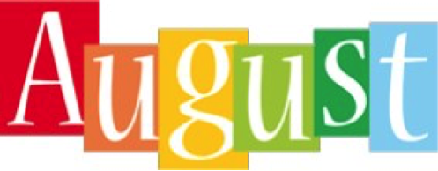
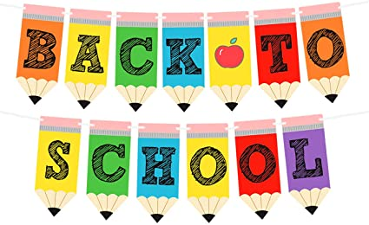
What an exciting time this will be for you and your child. Mrs. Amy and I are thrilled about welcoming each one of you to PLES and Pre-K. This will be a year of FUN, Making Friends, Singing, Drawing, Painting, Creating and Playing TO Learn! We hope that you will ENJOY it as MUCH as we will! During the month of August, we will be getting acquainted with the school rules and discovering colors and shapes. Also, we will explore the topic, “All About Me” where we learn about your child and family.
We will also work on literacy and math skills. We appreciate your participation in your child’s education. Please work on the items listed below with your child.
Identifying First & Last Name
Colors
Shapes

Mark Your Calendar
August 11th First Day of School (Boys)
August 12th First Day of School (Girls)
August 13th Boys (Only)
August 14th Girls (Only)
August 17th Everyone Attends
Wear RED
August 18th^{th} Wear Blue
August 19th Wear Yellow
August 20th Wear Green
August 21st Wear Orange
August 24th Wear Purple
August 25th Wear Brown
August 26th Wear Black/White
August 27th Wear Gray/Pink

Upcoming Events
August 24th (All About Me Poster Due) ***
Directions to Come
September 7th - Labor Day (No School)

Reminders
Daily – Send your Child with a filled Water Bottle (Labeled with your Child’s Initials or Name)
Weekly – Send your Child a Small Blanket for Nap
Please send your child a change of clothes to keep in our classroom.

