
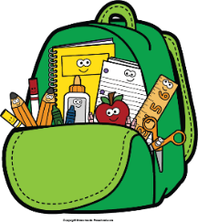
Mr. Marks’ Messages
November 18th-22nd, 2024
Assessments
Thursday Assessments: vocabulary quiz, grammar quiz, Math Topic 5/6 test
Friday Assessments: Spelling Test, Reading Test, weekly math quiz
Reminders
- Thanksgiving Break- November 25th-29th
- We will be collecting can goods for the food drive this week
- Please check your child’s binder daily for important information, homework, and their behavior chart.
Reading Story and Skills:  Story: Gross Jobs  Phonics/Fluency:  Long /a/ spelled a, a-e, ai, ay  Writing:  Informational writing  Text-Based Comprehension:  Main Idea and Details  Grammar/Language:  Quotation marks and commas in dialogue |  | Vocabulary Words  - vital: very important; necessary  - clogged: blocked or filled up  - waste: material that is thrown away; leftover  - plant: a building or factory  - install: to put in place for use or service  - flexible: able to bend without breaking; not stiff  - expired: no longer usable  - landfill: an area of land where garbage is covered by soil  - flee: to run away  10. ensure: to make sure of something; guarantee
Math  Topic  Lesson 1-4  Students will use various strategies to subtract within 100. We will complete the study guide for topic 5 on Wednesday and Test on Thursday. |  |  |  | Social Studies/Science  Science:  We will begin our unit on National Holidays. This week we will focus on Thanksgiving. We will also read a chapter book about Thanksgiving.
Spelling Words:
- stay  - May | - play  - rain |  | - chain  - paid |  | - base  - trace | - April  10. fable

