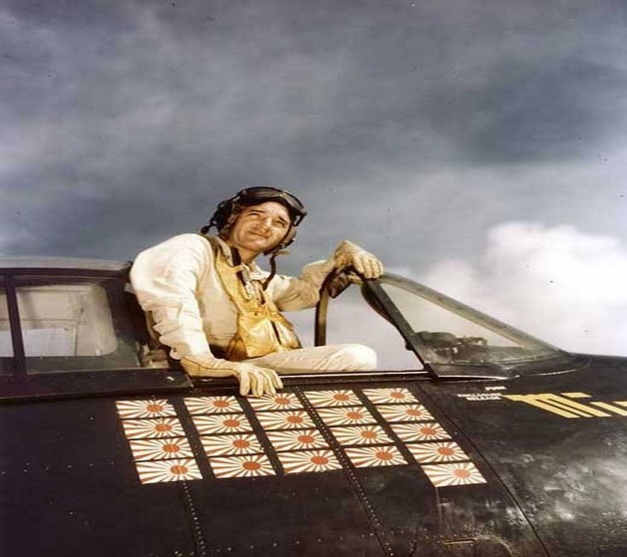

Commander (USN) David McCampbell
David McCampbell, was born in Bessemer, Alabama in 1910. CDR McCampbell was known as "naval aviation's Ace of Aces," according to a New York Times obituary.
During WWII, CDR McCambell shot down 34 enemy aircraft. The 34 planes he shot down in World War II set a record that stood at the time of his death in 1996.
While serving as Commander of Air Group 15, he was awarded the Medal of Honor for his actions in the first and second battles of the Philippine Sea in 1944. His citation read,
"An inspiring leader, fighting boldly in the face of terrific odds, Cmdr. McCampbell led his fighter planes against a force of 80 Japanese carrier-based aircraft bearing down on our fleet on 19 June 1944. Striking fiercely in valiant defense of our surface force, he personally destroyed seven hostile planes during this single engagement during which the outnumbering attack force was utterly routed and virtually annihilated. During a major fleet engagement with the enemy on 24 October, Commander McCampbell, assisted by but one plane, intercepted and daringly attacked a formation of 60 hostile land-based craft approaching our forces. Fighting desperately but with superb skill against such overwhelming airpower, he shot down nine Japanese planes and, completely disorganizing the enemy group, forced the remainder to abandon the attack before a single aircraft could reach the fleet."
The nine planes dispatched in 95 minutes by Commander McCampbell and his Grumman Hellcat were regarded as a WWII record for a single mission.

