TANQUE VERDE UNIFIED SCHOOL DISTRICT NO. 13 REGULAR SESSION OF THE GOVERNING BOARD AGENDA
Tuesday, February 27, 2018 ‐ 7:00 p.m.
Tanque Verde Unified School District Administrative Office 2300 N. Tanque Verde Loop Road, Bldg. # 1
Tucson, AZ 85749
(520) 749‐5751

Pursuant to A.R.S. §38‐431.02, notice is hereby given by the members of the Governing Board of the Tanque Verde Unified School District No. 13 and to the general public, that the Board will convene a regular session Governing Board meeting open to the public on Tuesday, February 27, 2018, in the Board Room of the Tanque Verde Unified School District Administrative Office. The Governing Board reserves the right to move into executive session for legal advice with its attorneys for any item listed on the agenda, in person or by telephone, pursuant to A.R.S. §38‐431.03.(A)(3). Members of the Governing Board will attend either in person or by telephone conference call. A copy of the agenda background material provided to board members (with the exception of material relating to possible executive sessions) is available for public inspection at the administrative office. The official site for posting agendas of the Board, committees and subcommittees is in the display case (by the front door) of the Tanque Verde Unified School District Administrative Offices. Agendas are also posted on the website as a courtesy at www.tanqueverdeschools.org.

CALL TO ORDER
- PLEDGE OF ALLEGIANCE
- ROLL CALL
- APPROVAL OF AGENDA
- CONSENT AGENDA
  - Personnel Report
  - TVHS Travel Request: UA Sky School – Mt. Lemmon
  - Tax Authorization – Business Form #10193

INFORMATION AND DISCUSSION ITEMS
  - ACES ‐ Student Presentation: Reading Fair – Ms. Jessica Feldman
  - Special Education Audit – Dr. Scott Hagerman
  - Writing program feedback – Dr. Scott Hagerman
  - STEM update – Dr. Scott Hagerman
  - 301 Plan 2018‐19 SY – Dr. Scott Hagerman

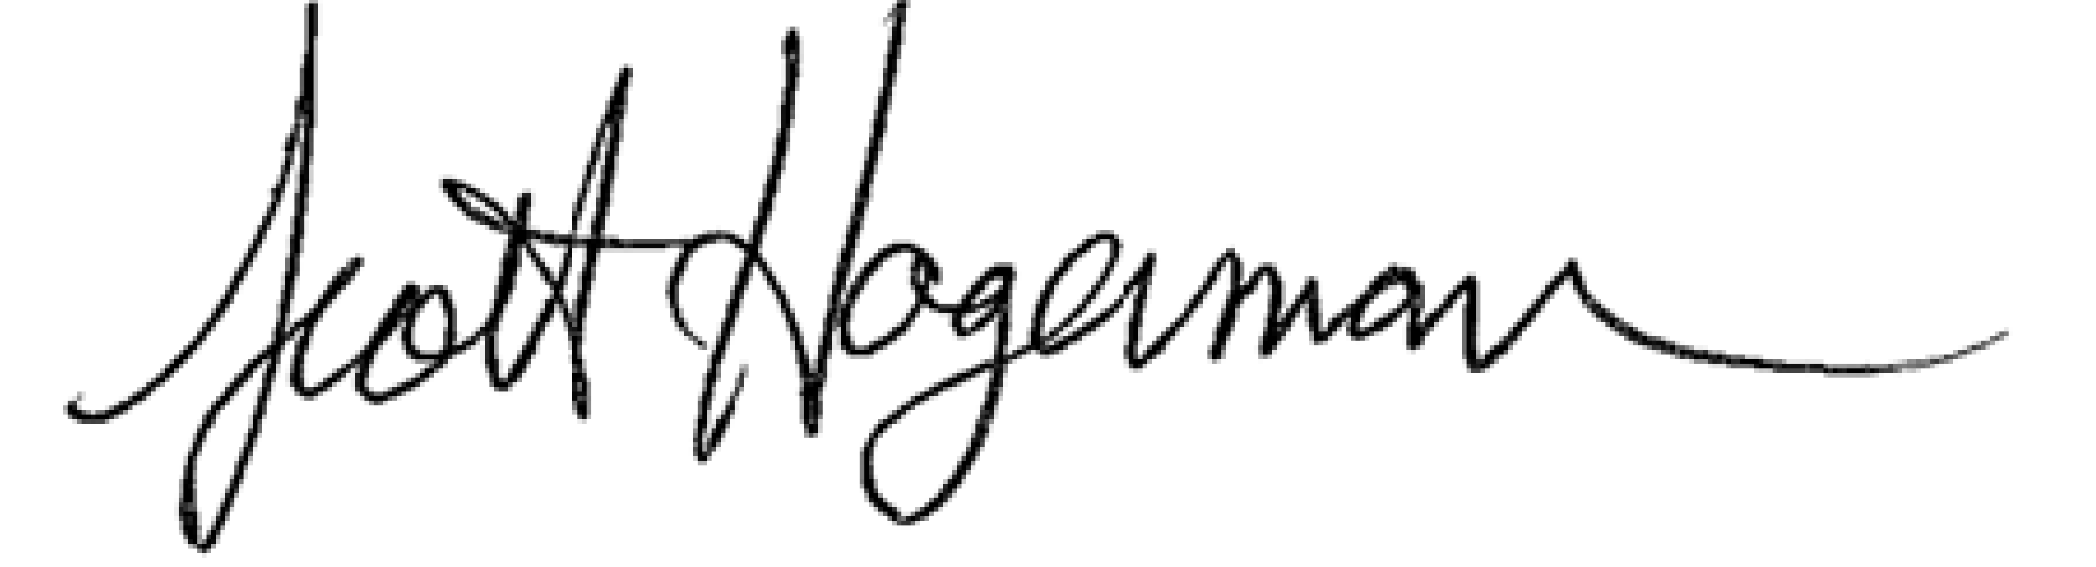

February 27, 2018 page 2 of 2

  - Board Goals: Professional Learning Community training update – Dr. Scott Hagerman
  - Behavior Matrix – Dr. Scott Hagerman

ACTION ITEM
  - May 10, 2018 Board meeting conflict ‐Reschedule to May 8, 2018 – Dr. Hagerman

BOARD AND SCHOOL EVENTS
See attached School Events Calendar
District Office – Preschool Screening – February 28, 2018 8:30 – 11:30 Taste of Tanque Verde – April 21
MEC – Advocacy Award CARLOS RUIZ – April 27

FUTURE BOARD AGENDA ITEMS
Board Goals: Vision and Mission at the sites and Board ‐ March
Board Goals: Community Involvement ‐ April
Board Goals: Evaluation 2017‐18 SY / 2018‐19 SY ‐ May

ADJOURNMENT

Dated February 21, 2018
Tanque Verde Unified School District #13

Dr. Scott Hagerman, Superintendent

