## A group of leaves on a black background

Ms. Mann’s Class News

October 14-18, 2024

**Classroom Needs**

Baby wipes

Treats for treasure box

Dry Erase Markers,

Highlighters

**Paper Towels** We need each student to bring two rolls a month to keep up with our demand.

As always, thank you so much.

**Important Dates**

October 17, Report Cards

October 18, last day to turn in Thanksgiving Lunch reservations and money

Nov 11, Veteran’s Day

Nov 25-29 Thanksgiving holidays

December 20, ½ day

December 23-January 3 Christmas Holidays

Students return on Jan 7

**Yellow Pod Student of the Month for October**

Gabe Milhouse

Congratulations Gabe!

**What we are studying this week.**

**Math-**arrays, reviewing even/odd

**Science-**Science Spin from Scholastic News

**Social Studies**- Lady Liberty Studies

**Language Arts**- Irregular plural nouns

**Reading-***Our Government at Work*

**Spelling**- long u words.

**Tests this week- Friday-math test on arrays**

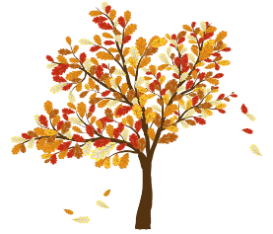

[This Photo](https://www.pngall.com/september-png/download/67901) by Unknown Author is licensed under [CC BY-NC](https://creativecommons.org/licenses/by-nc/3.0/)

