Vermilion Association for Special Education

Restraint, Timeout, and Isolated Timeout Reduction Plan

Adopted by the School Board
June 6, 2022

Restraint, Timeout, and Isolated Timeout Reduction Plan Process and Members

In accordance with the requirements set forth in Illinois School Code 5/2-3.130 and Public Act 102-0339, the Vermilion Association for Special Education has created an oversight team to develop a plan and procedures to reduce and eventually eliminate the use of physical restraint, timeout, and isolated timeout (RTO).

Committee Members
Kristin Dunker, Director of Special Education
Sarah Imhoff, Assistant Director of Special Education
Nicole Provost, Middlefork Principal
Alex Goudy, Special Education Administrator
Heather Hayworth, Speech-Language Pathologist
Rebecca Jones, School Social Worker
Kyle Ryan, School Psychologist
Lori Gooden, Special Education Teacher
Sandra Jones, Special Education Teacher
Joe Compton, Special Education Teacher
Lacey Zaayer, Paraprofessional
Simon Hepburn, Paraprofessional

Purpose of the Restraint, Time out, and Isolated Time out Reduction Plan
The Vermilion Association for Special Education recognizes that RTO is only used in the most extreme situations where imminent danger of harm is present. RTO is only used after less intrusive interventions have been tried and failed to eliminate the imminent danger. The RTO Reduction Plan supports a vision of cultural change that reinforces the following:

- Positive behavior interventions and support rather than physical restraint, timeout, and isolated time out,
- Effective ways to de-escalate situations to avoid physical restraint, time out, and isolated time out,
- Crisis intervention techniques that use alternatives to physical restraint, time out, and isolated time out,
- Use of debriefing meetings to reassess what occurred and why it occurred to think through ways to prevent use of RTO interventions next time.

Cooperative Goals for Progress

Illinois State Board of Education Guiding Goal: Twenty-five percent reduction in the use of physical restraint, time out, and isolated timeout over a 12-month period for students experiencing five-plus instances in a 30-day period.

The Vermilion Association for Special Education will determine progress towards the reduction and eventual elimination of the use of restraint, time out, and isolated time out by answering the following questions:

- Did the overall number of incidents requiring the use of RTO decrease?
- Did the overall number of students requiring the use of RTO decrease?

The RTO Oversite Team will meet quarterly to monitor progress of the goal. The RTO oversite team will reference the flowchart below to inform their conversations related to progress.

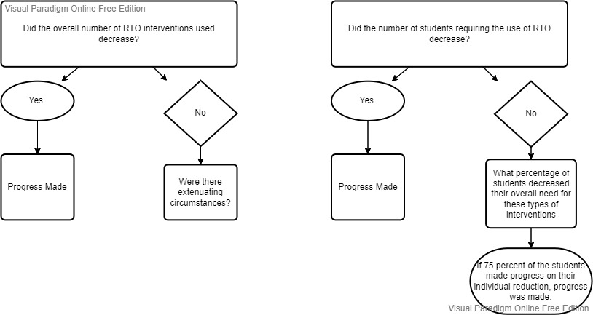

Actions Set Forth to Reduce the Use of Restraint, Time out, and Isolated Time out

The Vermilion Association for Special Education has a five-step plan that will be implemented to reach out RTO reduction goals.

1). The Vermilion Association for Special Education will create an extension professional development plan that includes a focus on evidence-based practices for behavior modification. The training will include, but is not limited to:
- Behavior De-escalation
- Restoractive Practices
- Trauma Informed Practices
- Positive Behavior Supports
- Autism Training
- Self-regulation/Self-monitoring Training
- Conducting a Functional Behavior Analysis
- Writing and Implementing an Effective Behavior Intervention Plan
- Executive Functioning

2). The Vermilion Association for Special Education will implement the use of Ukeru Systems to reduce the number of hands-on restraints necessary to keep staff and students safe. Ukeru Systems include the use of blocking pads. The system teaches how to “practice new tools that keep people not only physically, but also psychologically safe.” Staff will be provided with training in the use of the system. Funding will be used to purchase the blocking pads.

3). The Vermilion Association for Special Education will develop a multi-tiered system of support for social-emotional supports. The plan will include, but is not limited to:
- Tier I- PBIS or Zones of Regulation
- Tier II- Check n Connect, Check in Check Out, Self-monitoring with goal setting
- Tier III- Social work or Counseling Services, Specialized Curriculum targeting student’s individual weaknesses

Staff will be properly trained in the use of data for placement in each tier as well as movement from within tiers.

4). The Vermilion Association for Special Education will train staff in the Crisis Team Meeting process. Within 24 hours (one business day) of a RTO, the classroom staff will meet to debrief about the incident and determine the plan for next steps in the child’s education. The staff will be trained in the proper analysis of individual behavior incidents to ensure correct interpretation of the antecedents/setting events and triggers. They will be trained in how to determine changes that could be made to the environment, student’s schedule, staff’s interactions, what skills instruction is necessary to close the lagging skills gap, and how to implement the instruction effectively.

5) The Vermilion Association for Special Education will form partnerships with outside consultants and agencies for Board Certified Behavior Analyst to observe and provide feedback for students who struggle behaviorally.

Proactive Student Planning Conference

The Vermilion Association for Special Education understands the importance of proactive communication about our students with adverse childhood experiences. Any student with a history suggesting potential use of RTO due to behavior that could result in imminent danger will have an annual Student Support & Problem Solving Conference to discuss available historical information including, but not limited to:
- History of physical and/or sexual abuse
- Relevant medical mental health information
- Previous adverse reaction to the use of RTO interventions.

Meetings must occur on or prior to the student’s first day of school attendance, within three days of a mid-year enrollment, or within three days of new knowledge of adverse childhood experiences.

Notes from the meeting will be documented on the Student Support & Problem Solving Conference Notes Page (Appendix 1).

Crisis Team Meeting Procedures

The Vermilion Association for Special Education has a policy requiring that a Crisis Team Meeting (CIT) is held following any use of physical restraint, time out, or isolated time out. The CIT Team Meeting his held within one business day of the intervention being used. The process for each meeting held is:
- Classroom Team completes the RTO ISBE Form (11-01) and send the form to the parent/guardian. Principal submits the information in the ISBE Student Information System (SIS).
- The Classroom Team hold the Crisis Team Meeting following the required agenda. (Appendix 2)
- The Classroom Team completes the Individual Student Plan document. (Appendix 3)

Plan Modifications

The Vermilion Association for Special Education RTO oversight team will meet annually to revisit, rework, and redefine the plan if data does not show progress towards our defined goals.

Plan for Informing Community, Staff, and Families of RTO Reduction Plan

The Vermilion Association for Special Education RTO reduction plan will be published on the district’s website. A direct link to the plan will be placed in the VASE Student Handbook.

Appendix 1

Student Support & Problem Solving Conference Notes Page

Student Name: _____________________________ Date: __________________________
Attendance: _____________________________ _______________________________
_____________________________ _______________________________
_____________________________ _______________________________
_____________________________ _______________________________

Summary of Relevant Information (Physical and/or sexual abuse, mental health information, previous adverse reaction to use of RTO, etc):
___________________________________________________________________________________________________________
___________________________________________________________________________________________________________
___________________________________________________________________________________________________________
___________________________________________________________________________________________________________
___________________________________________________________________________________________________________
___________________________________________________________________________________________________________
___________________________________________________________________________________________________________

Steps to be taken as Result of Relevant Information:
___________________________________________________________________________________________________________
___________________________________________________________________________________________________________
___________________________________________________________________________________________________________
___________________________________________________________________________________________________________
___________________________________________________________________________________________________________
___________________________________________________________________________________________________________
___________________________________________________________________________________________________________

Appendix 2
Crisis Team Meeting Agenda
Date:
Student:
Type of Intervention: Restraint: ____ Time-out: ____ Isolated-Time out: ____
Attendees:

- Summary of the incident
  - Antecedent- What happened prior to the incident? What actions were taken by school personnel?
  - Trigger- Slow triggers? Fast triggers?
  - Hypothesis for behavior- Why do we believe the behavior occurred?

- Review of Student Strengths
  - What are the student’s strengths that we can build upon?
  - What strategies are working?
  - Are there any reinforcers that appear successful?

- Environmental Changes
  - Classroom Routines
  - Schedule Changes (need for visual or written schedule)
  - Personnel
    - Certain individual triggering?
    - What adult behaviors need to change?

- Curricular Accommodation, Adaptations, or Modifications?
  - Task too Difficult
  - Task to Easy
  - Type of Activities- (i.e. Hands-on versus Worksheet, technology versus pen and paper)

- Instructional Plan for Strengthening Weaknesses
  - Instructions in Lagging Skills- (Math, reading, Social-emotional skills, coping strategies)
  - What strategies/curriculum will we use to teach them?
  - Who will be involved?
  - When?

- As a result of the discussion, is an IEP amendment required? Yes___ No____

- As a result of the discussion, is an IEP meeting necessary? Yes___ No____

Appendix 3
Individual Student Plan
Student Name: _____________________________ Date: __________________________
Attendance: _____________________________ _______________________________
_____________________________ _______________________________
_____________________________ _______________________________
_____________________________ _______________________________
Summary of the Incident: _____________________________________________________________________________________
___________________________________________________________________________________________________________
___________________________________________________________________________________________________________
Antecedent: _____________________________________________________________________________________________
Trigger for Incident: __________________________________________________________________________________________
Hypothesis for Behavior: _____________________________________________________________________________________
Students Strengths, Preferences, and/or Interests: ________________________________________________________________
___________________________________________________________________________________________________________
Successful Strategies: _______________________________________________________________________________________
___________________________________________________________________________________________________________
Environmental Changes: _____________________________________________________________________________________
___________________________________________________________________________________________________________
Curricular Accommodation, Adaptations, or Modifications: ________________________________________________________
___________________________________________________________________________________________________________
___________________________________________________________________________________________________________
Instructional Plan for Strengthening Weaknesses/Lagging Skills: ___________________________________________________
___________________________________________________________________________________________________________
___________________________________________________________________________________________________________
Other Changes: Document other changes to the student’s individual plan here. (Are there adult behaviors that need to be changed? Is a specific person in the student’s presence causing a trigger? Has a classroom routine changed recently? Has there been a change at home?) _____________________________________________________________________________
__________________________________________________________________________________________________________
__________________________________________________________________________________________________________

