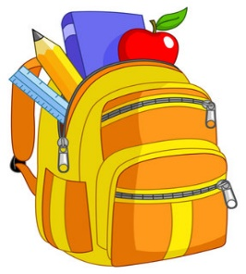

The Cambria County Backpack Program and Portage School District

August 19, 2024

In conjunction with The Cambria County Backpack Program through The Learning Lamp, Portage School District would like to offer your child(ren) nutritious snacks and meals for over the weekend free of charge, should your family benefit from receiving extra food. The staff will distribute the bags near the end of each week until the end of the school year or until you no longer wish to participate.

You can access the application online on their website, [www.ccbackpack.org](http://www.ccbackpack.org). Click on the “How to Apply” tab on the top of the webpage. If you do not have access to a computer, please contact the school social worker and I can fill out the application for your family.

The program will begin September 10, 2024 for this school year.

If you have any questions or need help completing the online application, please contact me at 814-736-9636 ext. 1620.

Sincerely,

Ashley Shaffer, LSW

Portage School Social Worker