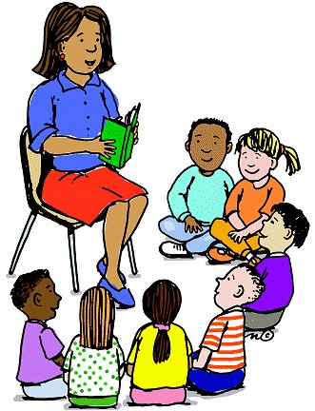

**Counselor’s Newsletter**

***Ms. Cunningham August 2022***

**Dear Parents/Guardians,**

I am so happy to be here at Dixon Elementary again this year! Let the school year begin! I always want my first lesson of the year to include and introduction to School Counseling and what that means here at Dixon. This month’s lesson will be an Introduction to School Counseling. The Introduction to School Counseling lesson will allow students to learn more about my duties as a school counselor and how I can help them here at school.

**News**

Parents/guardians, if you have a first grader, they received free folders here at school from College Counts, Alabama’s 529 Savings Plan, and the Alabama State Department of Education. This program encourages parents/guardians to start small contributions toward their child’s future educational plans. Parents/guardians, you can visit [www.collegecounts529.com](http://www.collegecounts529.com) to start this process and learn more about the program, you can also visit collegecounts529/first grade for contribution giveaways.

Parents/guardians be on the look for ordering Bullying T-shirts for Bullying Month in October this school year. By ordering bullying t-shirts, you are supporting our mission of preventing bullying in our schools. Ordering information will be announced in our school newsletter, school’s website, and Facebook Page. Students will also be sent home with an ordering form.

**Monthly Character Word**

**Citizenship**

We are all citizens – citizens of our country, our community, and our schools. However, what does it mean to be a good citizen? How can you show others you devote yourself to the development of these different areas? You can be a good neighbor. Take care of where you live and be proud of what you have. Obey rules – both in school and out of school!