Math Review Week # 10 Name__________________
Day 1

1. How many sides?__ How many vertices?__

2. Draw 8 Xs in the box:

3. Is a cylinder a 2D shape or a 3D shape?_____

Mental Math ______________________
_________________________________________
_________________________________________
Math Review Week # 10 Name__________________
Day 2

- If this month is November, what will next month be?
June December

2. Trace these numbers: 13 14 15 16 17 18
3. Write the number that comes after 7: ____

Mental Math ______________________
Math Review Week # 10 Name__________________
Day 3

- What shape is this? sphere cylinder

- Is the above shape 2D or 3D?______

- Count backwards: 10, 9, ___, ___, ___, ___, ___

Mental Math ______________________
_________________________________________
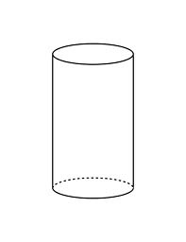
_________________________________________
Math Review Week # 10 Name__________________
Day 4

- Count forwards: 9, 10, ___, ___, ___, ___, ___, 16

2. Put an X on the number 5: 20 11 21 3 14 5

3. Write the number 14 in the cone:
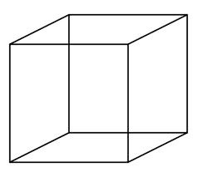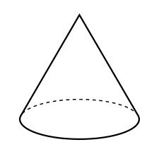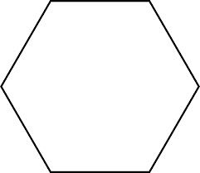

Mental Math ______________________
Math Review Week # 11 Name__________________
Day 1
1. Trace these numbers: 10 11 12 13 14 15

2. How many books are there?_________

3. Which shape does not belong?

Mental Math ______________________
_________________________________________
_________________________________________
Math Review Week # 11 Name__________________
Day 2

- If today is Thursday, what will tomorrow be?
Friday Saturday
2. Write a 14 in the square:

3. Write the number that comes after 16: ____

Mental Math ______________________

Math Review Week # 11 Name__________________
Day 3
1. Color all the 2D shapes:

- Count forwards: 13, 14, ___, ___, ___, ___, ___

- How many apples are there?_________
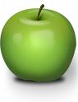

Mental Math ______________________
_________________________________________
_________________________________________
Math Review Week # 11 Name__________________
Day 4
- Color all the 3D shapes:

2. Put an X on the number 15: 10 11 19 3 14 15

3. Count backwards: 10, 9, 8, ___, ___, ___, ___, ___

Mental Math ______________________
Math Review Week # 12 Name__________________
Day 1
1. Trace these numbers: 13 14 15 16 17 18

- If today is Tuesday, what was yesterday?
Wednesday Monday

3. Color the group with the most cones in it.
Mental Math ______________________
_________________________________________
_________________________________________
Math Review Week # 12 Name__________________
Day 2
- Circle the group than shows 10:

2. Draw a rectangle:

- Write the number that comes after 13: ____

Mental Math ______________________

Math Review Week # 12 Name__________________
Day 3
1. Write a 19 in the cone:

- Count forwards: 11, 12, ___, ___, ___, ___, ___

- How many shapes in all?______

Mental Math ______________________
_________________________________________
_________________________________________
Math Review Week # 12 Name__________________
Day 4
- Trace the numbers: 15 16 17 18 19 20
- Circle the group with the most balloons in it.

3. Draw a square:

Mental Math ______________________

Math Review Week # 13 Name__________________
Day 1
1. Subtract 5 - 3 =______

2. Which group of paintbrushes has the most?

3. How many paintbrushes are there in all?____

Mental Math ______________________
_________________________________________
_________________________________________
Math Review Week # 13 Name__________________
Day 2

- Circle the group with the most strawberries in it.
2. Draw an oval:

3. Count backwards: 10, ___, ___, ___, 6, ___, ___, 3

Mental Math ______________________

Math Review Week # 13 Name__________________
Day 3
1. Color the 3D shapes:

- Count forwards: 11, 12, ___, ___, ___, ___, ___

- How many triangles are there?_______

Mental Math ______________________
_________________________________________
_________________________________________
Math Review Week # 13 Name__________________
Day 4

1. Which group of paintbrushes has the least?
- How many sides? ___ How many vertices?___

3. Is a cylinder a 2D shape or a 3D shape?_____

Mental Math ______________________
Math Review Week # 14 Name__________________
Day 1
1. Trace these numbers: 11 12 13 14 15 16 17
2. Which group of cows has the most?
3. How many cows are there in all?____

Mental Math ______________________
_________________________________________
_________________________________________
Math Review Week # 14 Name__________________
Day 2

- Circle the object that is most like a square:
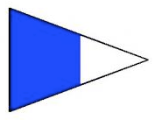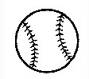
2. Compare the circles using <, >, =:
_____

3. What number comes after 15? _____

Mental Math ______________________

Math Review Week # 14 Name__________________
Day 3

Compare the flowers using <, >, =:
______
- Count forwards: 3, 4, ___, ___, ___, ___, ___

- Add: + = ________
Mental Math ______________________
_________________________________________
_________________________________________
Math Review Week # 14 Name__________________
Day 4

1. Circle the object that is most like a triangle:
- Count backwards: 8, 7, ___, ___, ___, ___, ___, 1

3. Is a triangle a 2D shape or a 3D shape?_____

Mental Math ______________________

Math Review Week # 15 Name__________________
Day 1
1. Compare the cubes using <, >, =:
_____
2. Circle the group that has the most:
- If this month is March, what was last month?
April February

Mental Math ______________________
_________________________________________
_________________________________________
Math Review Week # 15 Name__________________
Day 2
1. Circle the object that is most like a rectangle:
2. If this month is June, what was last month?
April May

3. How many sides? ___ How many vertices? ___
Mental Math ______________________

Math Review Week # 15 Name__________________
Day 3

- Write the number 17 in the circle:
- Count forwards: 13, 14, ___, ___, ___, ___, ___

- Which group of bears has the least amount?
Mental Math ______________________
_________________________________________
_________________________________________
Math Review Week # 15 Name__________________
Day 4

1. Circle the object that is most like a circle:
2. Compare ducks the using <, >, =:
_____
3. Is a cube a 2D shape or a 3D shape?_____
Mental Math ______________________

Math Review Week # 16 Name__________________
Day 1
1. Write the number 19 in the square:
2. Add: + = ________

- What shape does not belong?

Mental Math ______________________
_________________________________________
_________________________________________
Math Review Week # 16 Name__________________
Day 2

1. How many 3D shapes are there?____
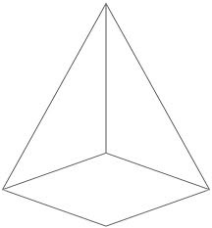

2. Add: + = ________

3. Write the number that comes after 13:____

Mental Math ______________________
Math Review Week # 16 Name__________________
Day 3

1. Compare the cookies using <, >, =:
______
- Count backwards: 10, 9, ___, ___, ___, ___, ___

- Put an X on the number 20: 20 11 2 3 14 5

Mental Math ______________________
_________________________________________
_________________________________________
Math Review Week # 16 Name__________________
Day 4

1. Color the shapes with 0 vertices:
2. Trace the numbers: 15 16 17 18 19 20

3. How many sides? __ How many vertices?__

Mental Math ______________________

Math Review Week # 17 Name__________________
Day 1
- 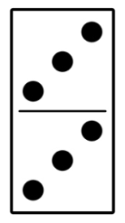 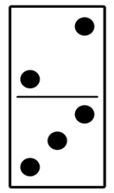 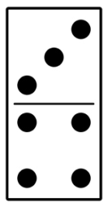 How many dots in all?______

- Subtract 4 - 2 =________

- Trace the numbers: 12 13 14 15 16 17

Mental Math ______________________
_________________________________________
_________________________________________
Math Review Week # 17 Name__________________
Day 2

- How many bears?_____

2. How many sides? ___ How many vertices?___

3. Write the number that comes after 16:____

Mental Math ______________________

Math Review Week # 17 Name__________________
Day 3

1. Compare the books using <, >, =:
______
- If this month is September, what was last month?
October August

- Subtract 3 - 2 = _______

Mental Math ______________________
_________________________________________
_________________________________________
Math Review Week # 17 Name__________________
Day 4

1. Color the shapes with 4 sides:
2. Trace the numbers: 10 11 12 13 14 15
3. Write the number that comes after 19:_____

Mental Math ______________________

Math Review Week # 18 Name__________________
Day 1
- 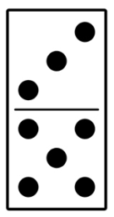 How many dots in all?______
- Draw 14 Xs in the box:

3. Compare fish the using <, >, =:
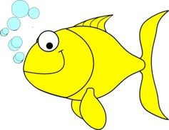 _____

Mental Math ______________________
_________________________________________
_________________________________________
Math Review Week # 18 Name__________________
Day 2

1. Compare the bears using <, >, =:
_____
2. Subtract 3 - 2 = _______
3. Which shape does not belong?

Mental Math ______________________

Math Review Week # 18 Name__________________
Day 3
1. Color the shapes with 3 vertices:
- Count backwards: 10, 9, 8, ___, ___, ___, ___, ___

- Compare the cookies using <, >, =:
______
Mental Math ______________________
_________________________________________
_________________________________________
Math Review Week # 18 Name__________________
Day 4

- Subtract 4 - 2 =________

2. Trace the numbers: 6 7 8 9 10 11 12

3. Finish the AB pattern: ____ ____ ____

Mental Math ______________________

