KEEP CHILDREN SAFE AT THE BUS STOP
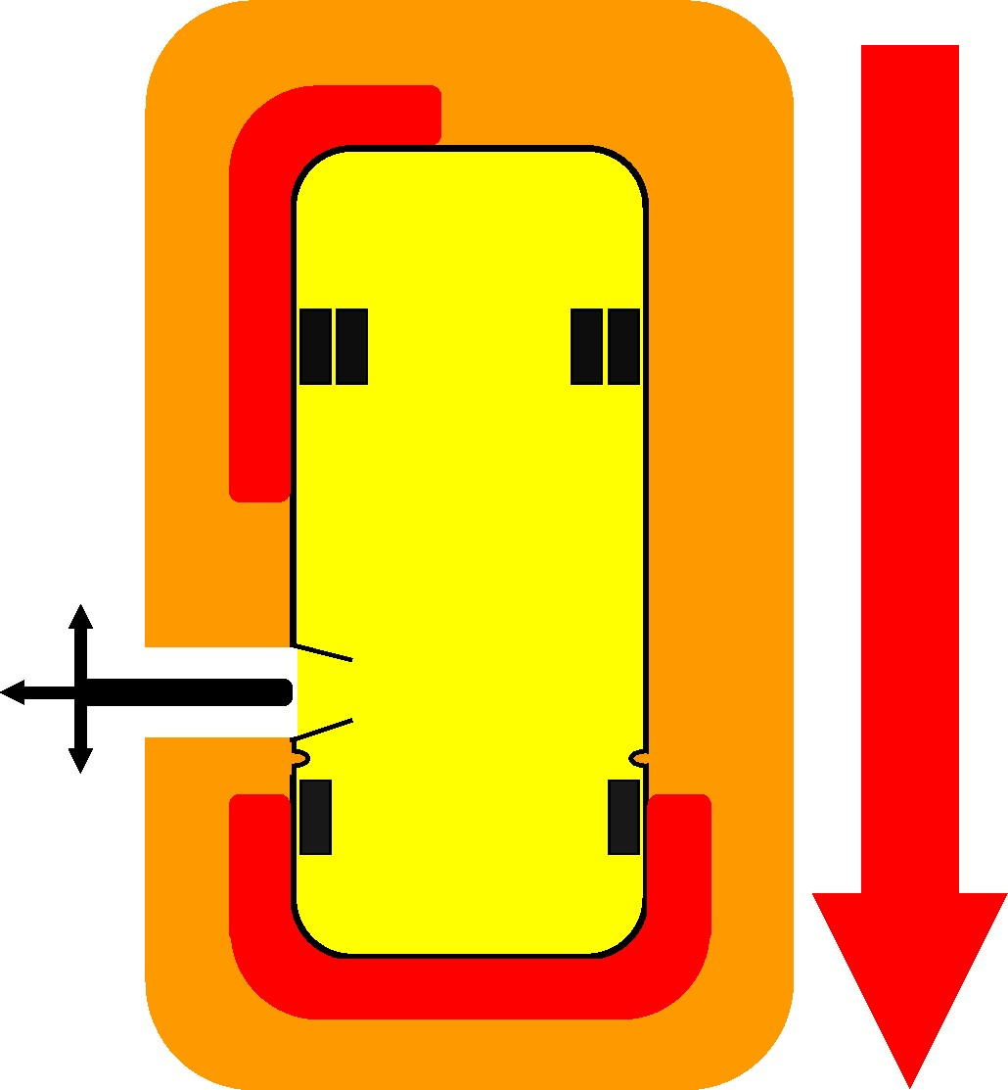
- Arrive at the bus stop five minutes early.

M
o
s
t
D
a
n
g
e
r
ou
s

D
ang
e
r

Z
on
e

D
a
ng
e
r

Zon
e

Sc
hoo
l

Bus

Danger from Passing Cars
Walking Area Walking Area
-
12

F
e
e
t
-

Most Dangerous

Danger from Passing Cars

Danger Zone
Danger Zone
-
12

F
e
e
t
-

Danger from Passing Cars

- Have all items in your book bag.
- Never use an electronic device or wear ear buds when boarding.
- Wait at the bus stop in a safe place, 12 feet away from the road.
- Wait in an orderly group.
- Stay on your side of the road until the bus comes.
- Only load at your assigned bus stop.

THE SCHOOL BUS DANGER ZONE
The Danger Zone is the 12 foot area that surrounds a stopped school bus where the bus driver might not see you or where cars might be moving when you are getting on and off the school bus.
- When outside a school bus, remember if you can see the bus driver, the bus driver can see you.
- NEVER return to the bus after unloading.
- Leave any object dropped or forgotten, and get out of the danger zone.
- Gain the bus driver’s attention by waving your hands and arms above your head.
- Wait for the driver to see you and give you instructions before returning to the bus or before picking up anything dropped.
- If you do not get the bus driver’s attention, you should not return to the bus.
- Always be aware that cars may not stop for the bus as required. Keep a watchful eye on all moving traffic around a school bus.
- If you hear the bus horn, it means DANGER. Look for passing motorists and seek safety.

LOADING THE SCHOOL BUS
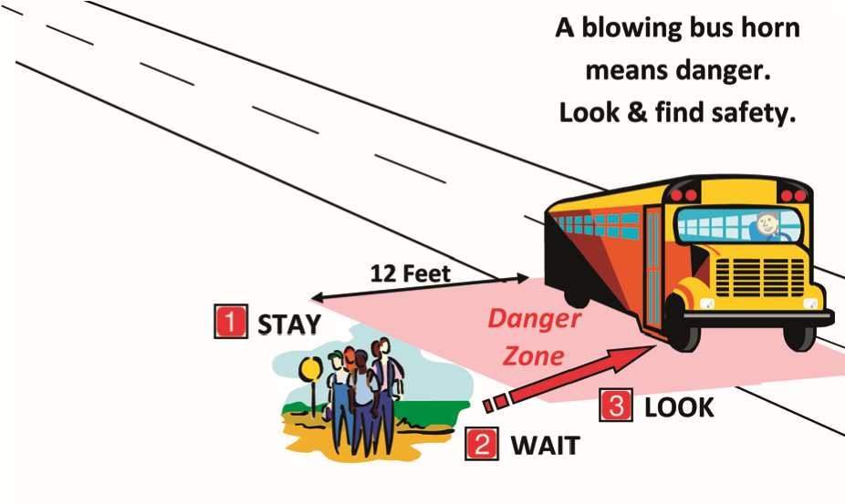
- Wait 12 feet off the road, wait for the bus to stop, the door to open and the red lights to be activated.
- Look to be sure all cars have stopped before walking towards the bus.

UNLOADING THE SCHOOL BUS
- Exit your bus only at your assigned stop.
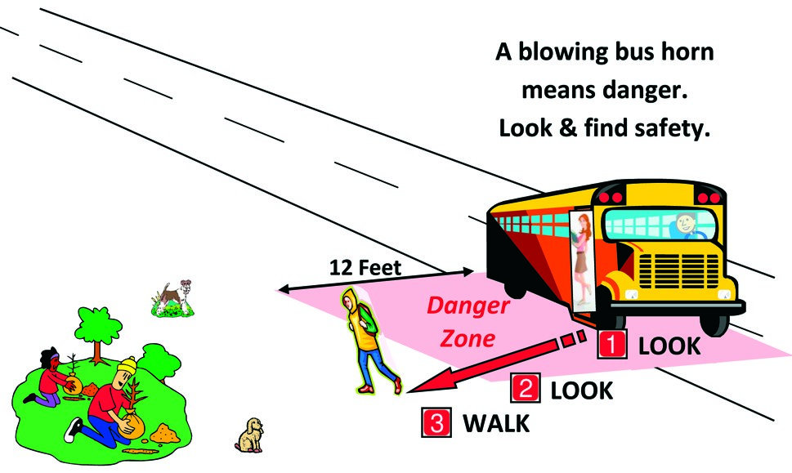
- Remain seated until the bus comes to a full stop.
- Never use an electronic device or wear ear buds until safely unloaded and 12 feet off the roadway.
- Wait for your bus drivers signal to unload.
- When exiting the bus, make sure everything is in your book bag and all straps are secured so they will not be caught on handrails or in the door.
- Look for cars in both directions before stepping off the bus.
- Exit in full view of the driver. Keep walking until you are out of the Danger Zone (12 feet away from the bus).

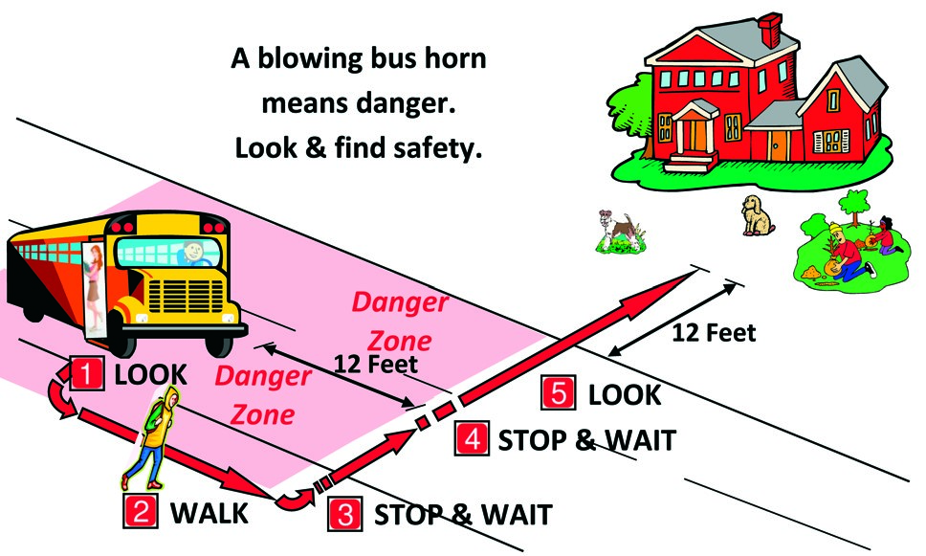
CROSSING STREET TO UNLOAD SCHOOL BUS
- Walk in a straight line away from the right front of the bus, in the bus driver’s full view.
- Wait for the driver’s signal that it is safe to cross at the end of the crossing gate and AGAIN at the center of the road.
- Be alert and aware of moving traffic. Do not enter the road until all cars are stopped.
- NEVER cross behind the bus.

For additional bus stop safety information please visit:
http://www.gadoe.org/Finance-and-Business-Operations/Pupil-Transportation/Pages/School-Bus-Safety.aspx

