1-800-262-7
Kentucky River Regional Prevention Center
Crisis Information
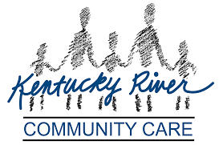
24 Hour Crisis / Information Hotline
1-800-262-7491
Deaf and Hard of Hearing (TTY)
1-800-787-5043

