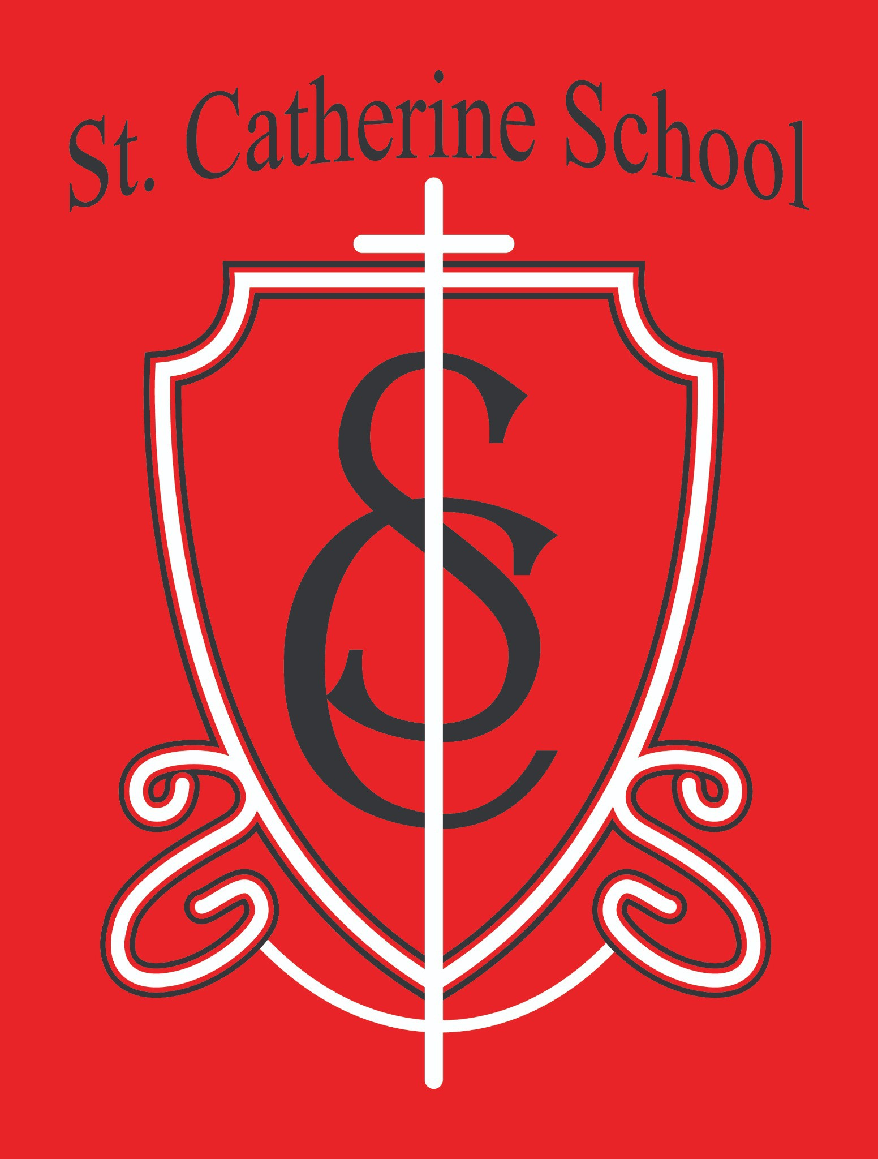

St. Catherine School Weekly Newsletter
Week of November 24-26 - Happy Thanksgiving! https://www.stcatherine.k12.nd.us/parents

Principal's Message
Dear St. Catherine Families,
As we wrap up Thanksgiving week and turn toward Advent, our focus on the virtue of
). This
generosity this week seemed very fitting given the week (I wonder who planned that week, we reflected on the example of Blessed Solanus Casey, a Capuchin friar who embraced radical poverty and served the sick, the poor, and the hungry with deep joy.
During the excitement that always fills the short week before Thanksgiving—busy lunchrooms, energetic recesses, and the early stirrings of holiday anticipation—I found myself grateful. Even on the hectic days, I see generosity lived out in our children, our teachers, and our parish community. Solanus Casey often reminded people to “thank God ahead of time,” and that spirit is alive here at St. Catherine School. Thank you for the daily ways you support our mission and help form young disciples.

Reminders

Parking Lot Safety

As winter weather settles in, please be extra cautious in the parking lot. Our snow removal company does a great job, but during ongoing snow, surfaces can still be slippery. Please follow all parking lot procedures and pull into a parking spot for drop-off and pick-up.

Winter Gear at School

Please make sure your child comes with full winter gear each day—snow pants, boots, coat, hat, and gloves.

Winter Weather Policy for End-of-Day Dismissal

Students picked up by parents must leave wearing coats, hats, and gloves. Students walking home must leave wearing coats, hats, gloves, and boots. Parents may request additional items to go home daily.
Students may always choose to take more gear home.
Winter gear will be sent home on weekends or when it’s dirty/wet.

Boots can stay at school, but if they become… aromatic, they will be sent home for cleaning!

Correction Regarding VCPS Bus Requirements

VCPS has clarified their expectations for winter riding:

Beginning Monday, December 1, all K–12 students riding a school bus or district vehicle (including for activities) must have at least a winter coat, hat, and gloves to board.

Full winter gear is encouraged, but only the coat, hat, and gloves are required for bus riding.

Christmas Program – Next Thursday, December 4th

Our Christmas Program is next Thursday, December 4th. Important reminders:
All students must arrive by 6:10 PM and report to the cafeteria.

Cast members need an Ugly Christmas sweater/Christmas Sweater. All students need a Santa hat or elf hat.
Questions? Contact Ms. Alexis Busch at alexis.a.busch@k12.nd.us.

Little Saints Childcare – Now Hiring

Little Saints Childcare Center is hiring for:
Part-Time Childcare Staff Assistant Cook (Part-Time)

Shared with the school

For more information or to apply, contact: Nick Lee – nicholas.lee1@k12.nd.us Beth Nadelin – beth.nadelin@k12.nd.us

St. Catherine Spotlight

Kindergarten–2nd Grade Thanksgiving Celebration
Our Kindergarten, 1st, and 2nd graders enjoyed a Thanksgiving “celebration” complete with pie! Lots of smiles and excitement about getting pie, and the students had a wonderful time together.

4th Grade “Charlie and the Chocolate Factory” Watch Party
To wrap up their reading unit, the 4th graders held a watch party for Charlie and the Chocolate Factory. It was a fun way to bring the story to life and share the experience as a class. Good job, Ms. Hilgemann, for planning a fun activity!

First Snowfall Fun
The first snowfall of the season brought joy to most of the kids and most seemed to have a fun time playing in it. So, I will take that mostly as a win! There’s something special about playing outside in the snow when seen through a child's eyes.

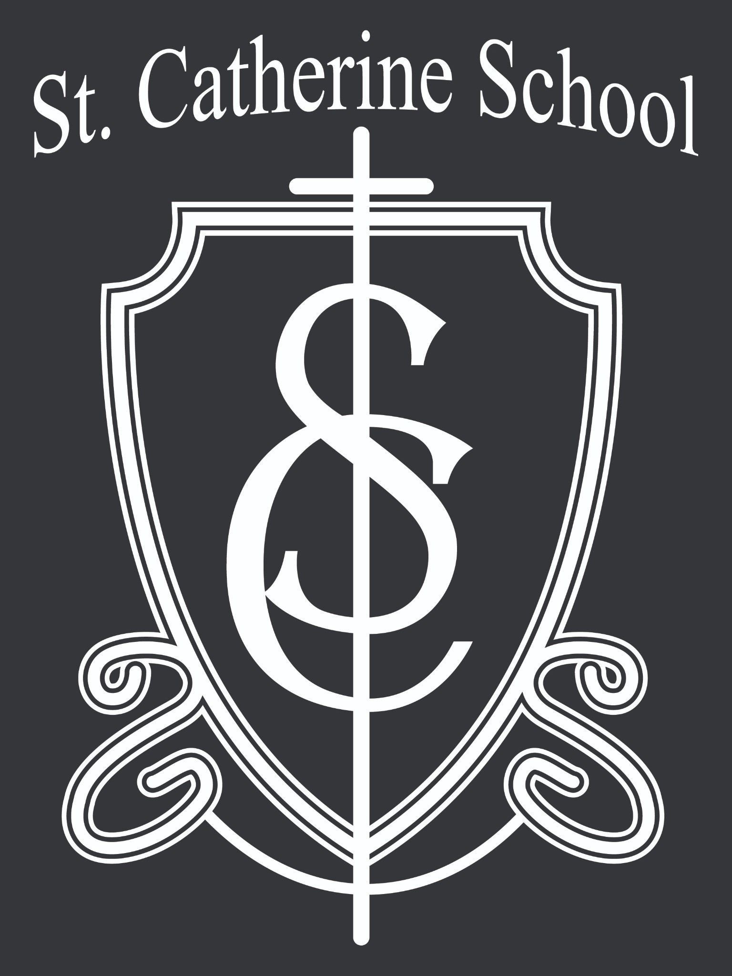

Stay Connected with St. Catherine School
📍 Address: 540 3rd Ave. NE, Valley City, ND 58072
Email: nicholas.lee1@k12.nd.us
📧
Phone: 1-701-845-1453
📞
Website: www.stcatherine.k12.nd.us
🌐
📘 Follow Us on Facebook: St. Catherine School on Facebook

“Inspiring excellence through faith, learning, and service.”

