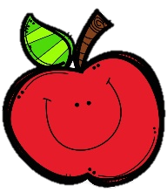
Mrs. Burns’ Messages
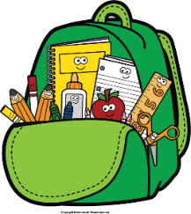
October 11-14, 2022

Reading Assessments
Thursday Quizzes: Phonics, Inferencing, Complete/Incomplete Sentences, Vocabulary
Friday Assessments: Reading Skills Test, Grammar Test, Spelling Test
Friday, October 14: Attendance Party
Monday, October 17: Report Cards Issued
Tuesday, October 18: Fundraiser Kick-Off

Reading Story and Skills:  Story: Mattland  Phonics/Fluency:  /ā/ spelled a, a_e  /ī/ spelled i, i_e  Text-Based Comprehension:  Making Inferences  Grammar/Language:  Complete and  Incomplete  Sentences |  | Vocabulary Words  - jagged– having sharp points that stick out  - peaks – high mountains or the pointed tops of ones  - tufts – bunches of hair, grass, thread, or other things that  grow or are fastened at one end and are loose at the  other  - smoothed – made even or level  - pasture– piece of land on which animals graze  - plucking – pulling off; picking  - wind – to move or cause to move in one direction and then in  another  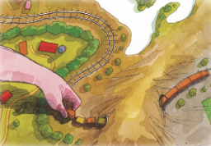  - culverts – drains for water under roads, sidewalks, and  railroads  - prickly – having small, sharp thorns or  points  - cleared – became free from darkness;  was bright
Math  Topic 4: Fluently Add Within 100  Lesson 1: Add 2-Digit Numbers Using Models  Lesson 2: Continue to Add 2-Digit Numbers Using Models  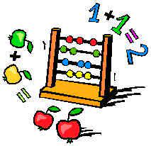  Lesson 3: Add with Partial Sums  Lesson 4: Add Using Mental Math  and Partial Sums |  |  |  | Social Studies/Science  This week we will identify national historical figures and celebrations that exemplify fundamental democratic values, including equality, justice, and responsibility for the common good.
Spelling Words:
- mild  - pale | - pilot  - paper |  | - bake  - time | - sale  - ride | - able  - kind
Tuesday, October 11: 6:00 p.m. STEAM
Night
Wednesday, October 12: End of 1st 9 Weeks

