# Prime Numbers

A prime number can be divided, without a remainder, only by itself and by 1. For example, 13 can be divided only by 13 and by 1. 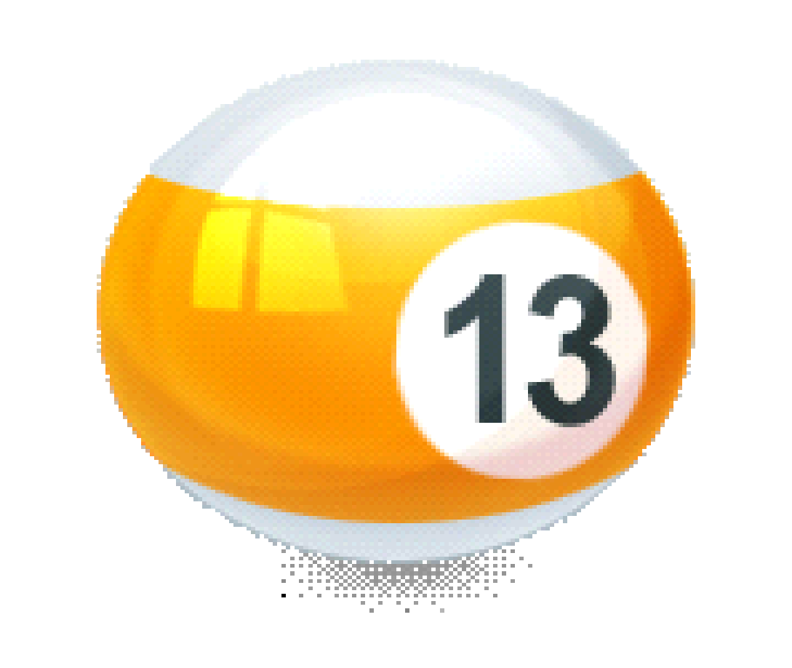Some facts:

* The only even prime number is 2. All other even numbers can be divided by 2.
* If the sum of a number's digits is a multiple of 3, that number can be divided by 3.
* No prime number greater than 5 ends in a 5. Any number greater than 5 that ends in a 5 can be divided by 5.
* Zero and 1 are not considered prime numbers.
* Except for 0 and 1, a number is either a prime number or a composite number. A composite number is defined as any number, greater than 1, that is not prime.

To prove whether a number is a prime number, first try dividing it by 2, and see if you get a whole number. If you do, it can't be a prime number. If you don't get a whole number, next try dividing it by prime numbers: 3, 5, 7, 11 (9 is divisible by 3) and so on, always dividing by a prime number (see table below).Here is a table of all prime numbers up to 277:

|  | 2 | 3 | 5 | 7 | 11 | 13 | 17 | 19 | 23 |
| --- | --- | --- | --- | --- | --- | --- | --- | --- | --- |
| 29 | 31 | 37 | 41 | 43 | 47 | 53 | 59 | 61 | 67 |
| 71 | 73 | 79 | 83 | 89 | 97 | 101 | 103 | 107 | 109 |
| 113 | 127 | 131 | 137 | 139 | 149 | 151 | 157 | 163 | 167 |
| 173 | 179 | 181 | 191 | 193 | 197 | 199 | 211 | 223 | 227 |
| 229 | 233 | 239 | 241 | 251 | 257 | 263 | 269 | 271 | 277 |