ISSUE

**Capturing Carver**

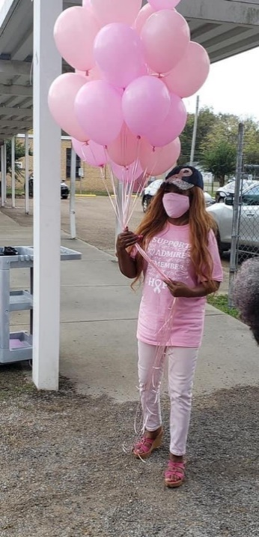 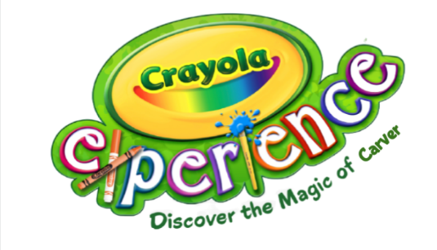

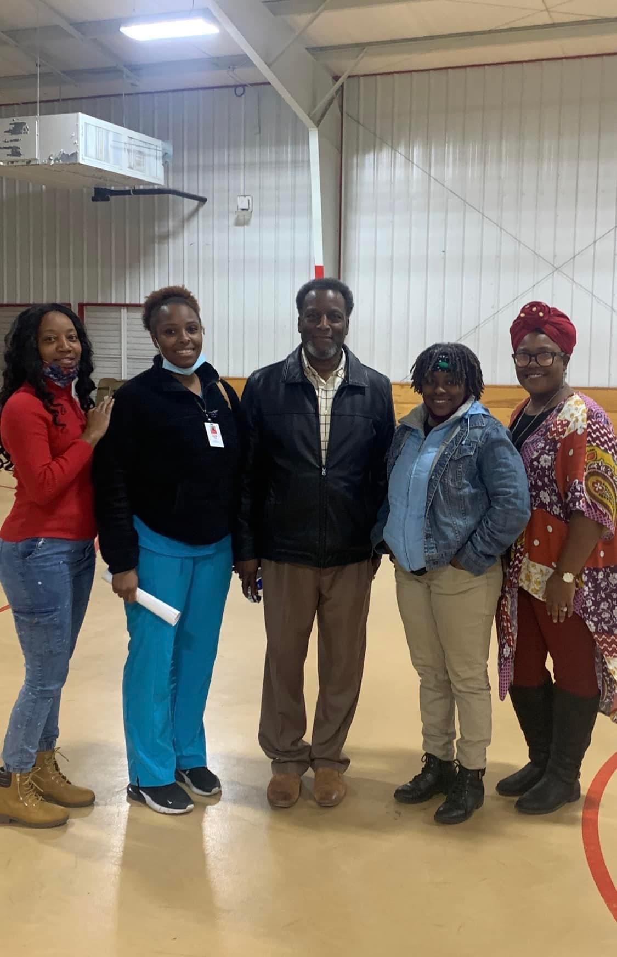 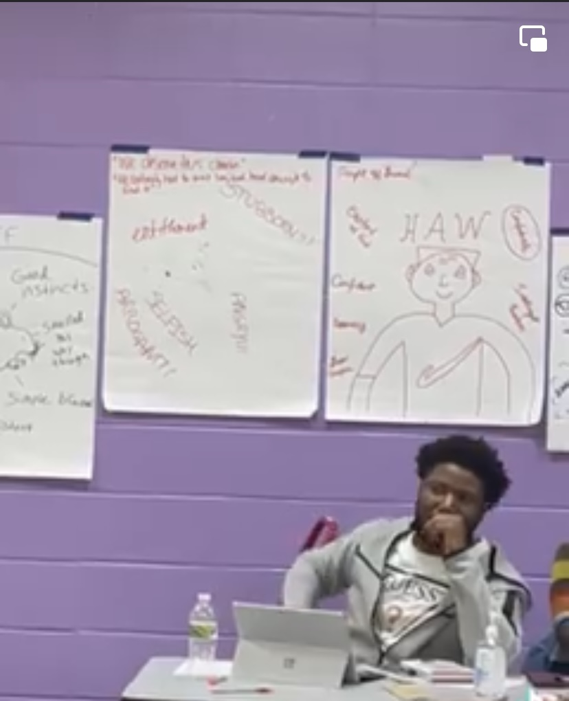 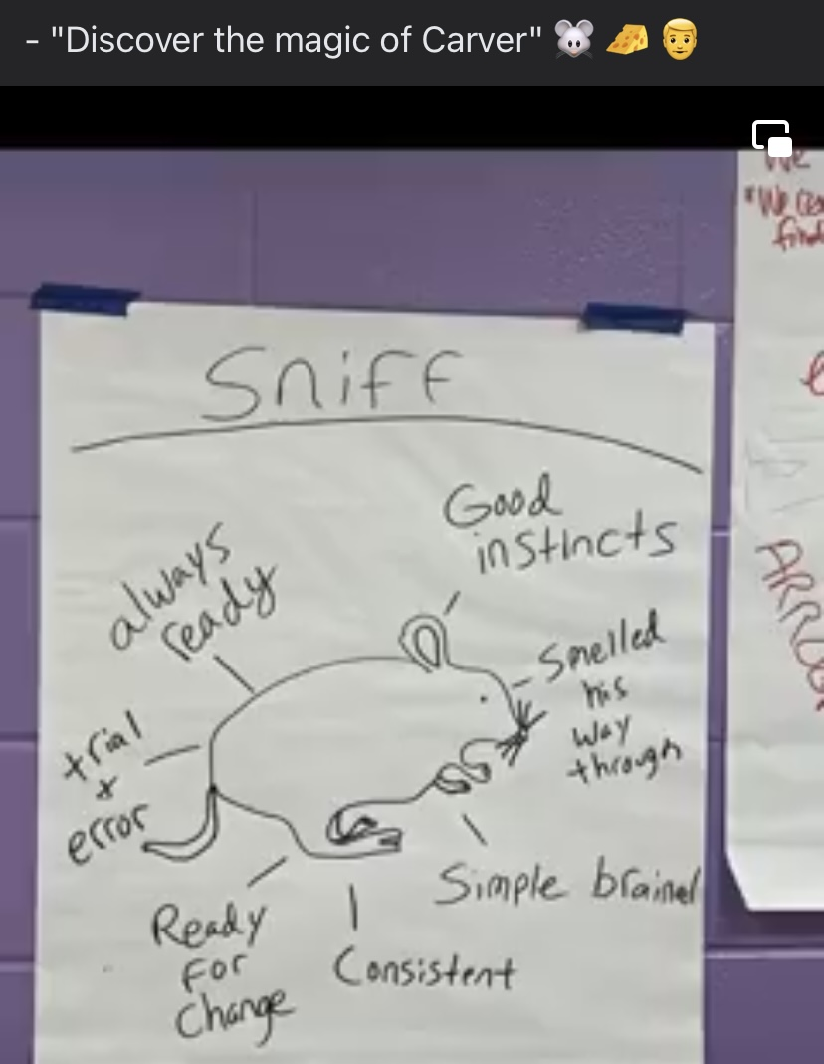 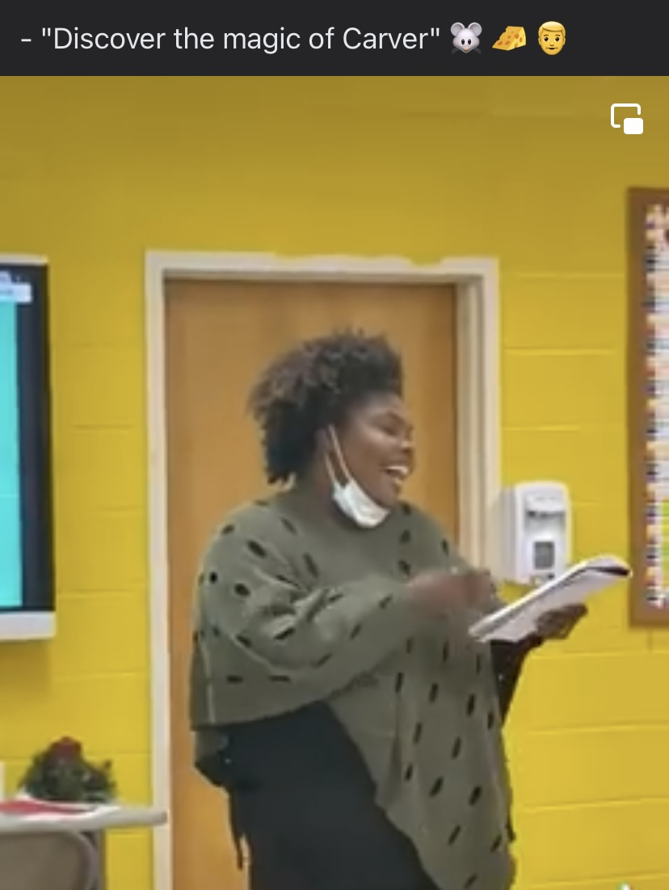 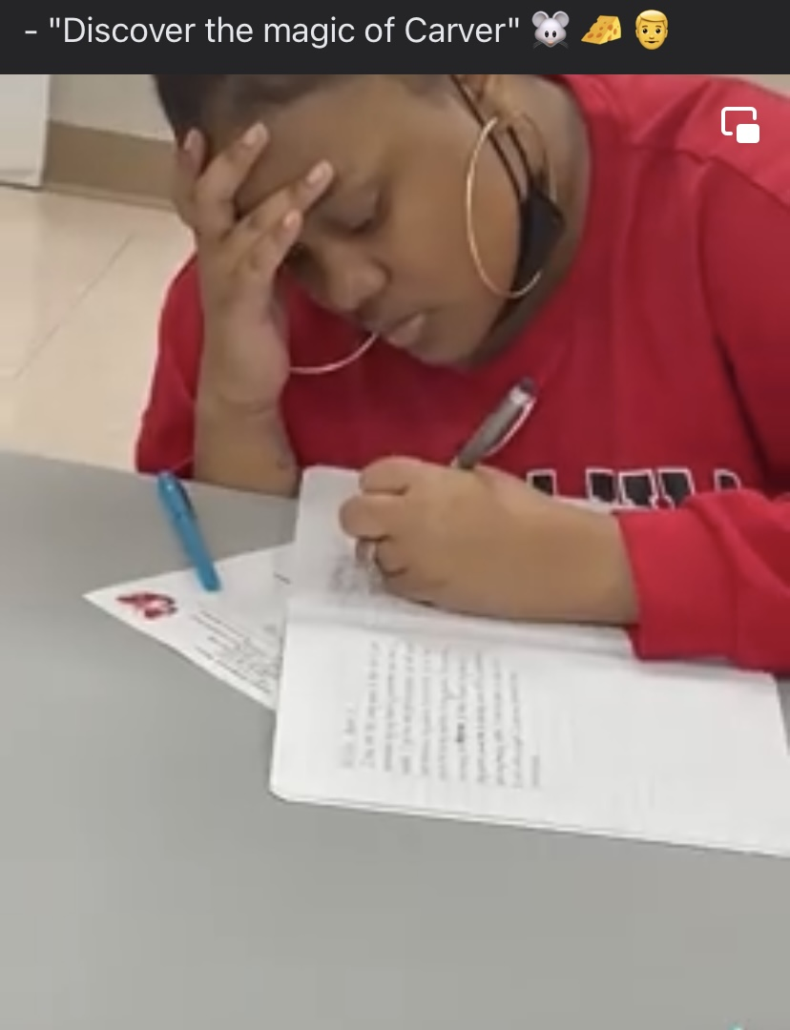 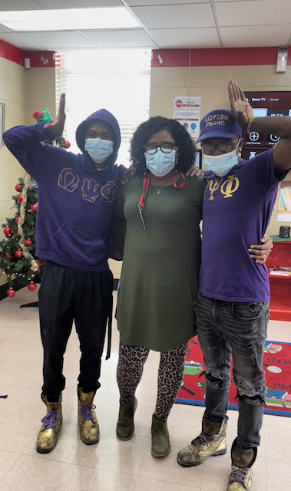 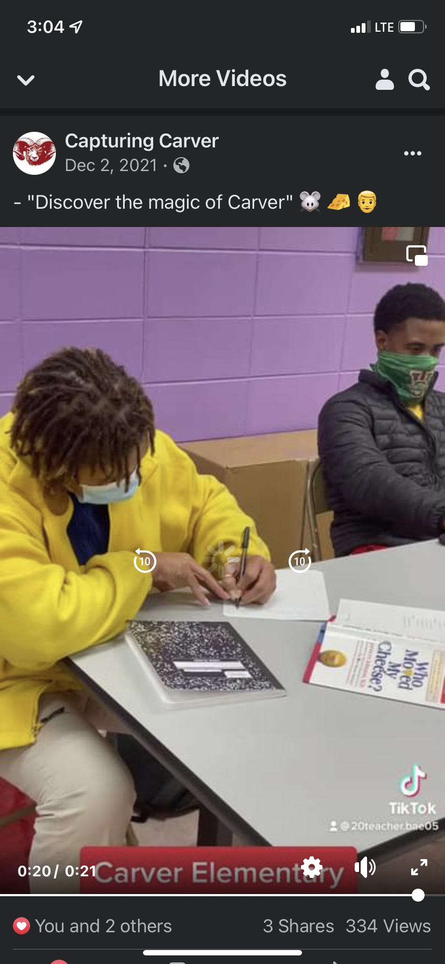 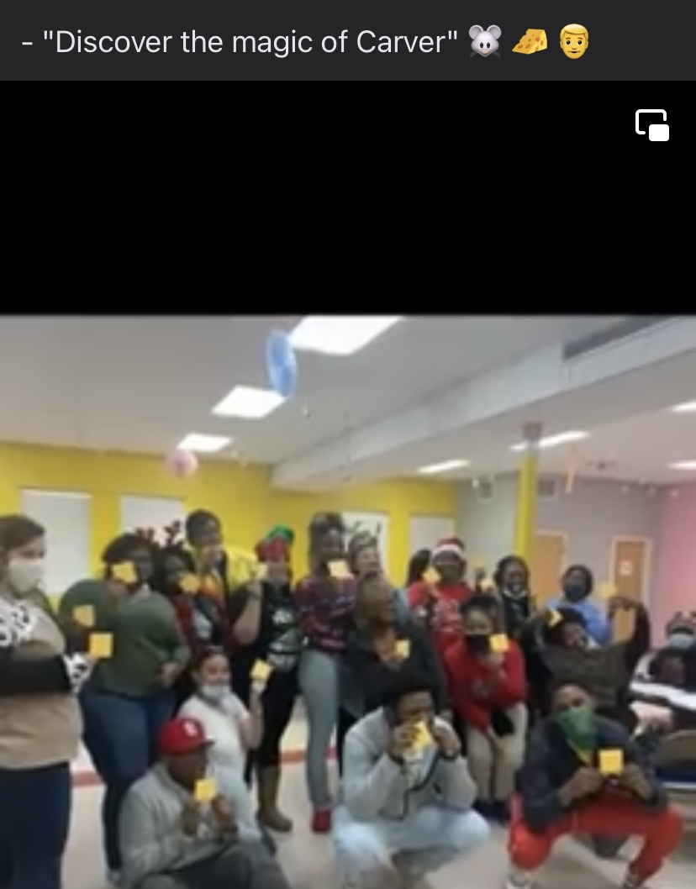 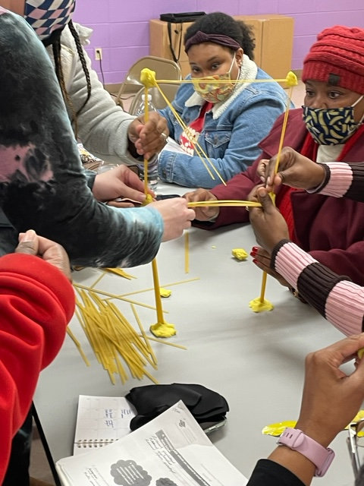 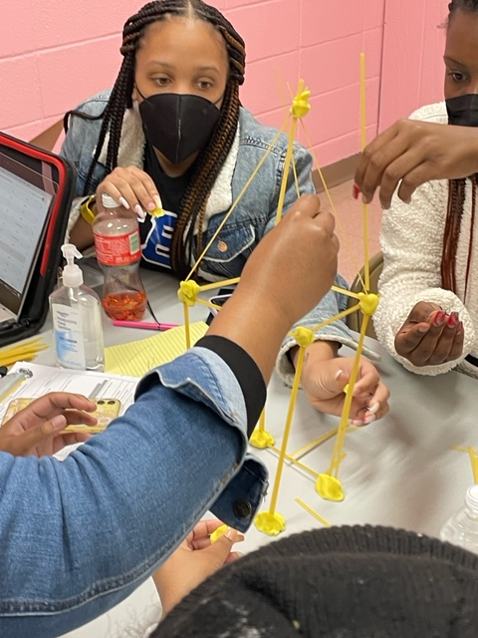

Greetings to All Carver Stakeholders,

We have wrapped up another successful semester of in-person learning.  The road has not always been an easy one, but it has been worth going through with the students, parents, and staff of Carver Elementary.  During the second nine weeks, we proved that if our students and teachers are present, they can achieve at their highest potential.  This can be seen in our total accumulated points from our benchmarks. In a joint effort, we secured 417 points on our 2nd Benchmark, showing that our students and teachers performed on a “B” level.  We want to thank you all for all of your support in helping reach this milestone. But we are not done.  We want to push for more. As a collective unit at the school, we have set to gain 442 points on the 3rd benchmark.  Additional goals have been set by the teachers and students. Talk with your child about their new goals for the 3rd 9wks. Be sure to reach out to your child’s teacher for more information. Below, you will find the points we will work to get in each category.

Thanks for all you do to help us stay Carver Strong.

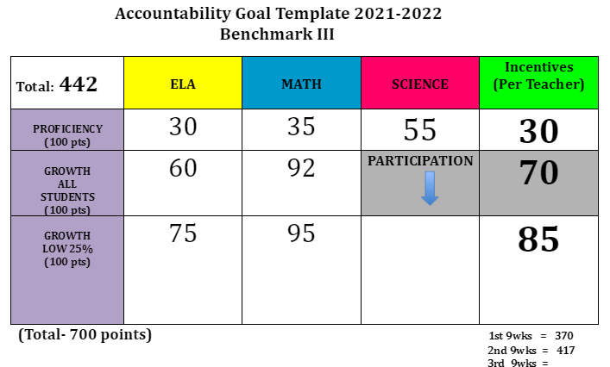

404 Jefferson Street

Indianola, MS 38751

Tel: (662) 884-1250

Fax: (662) 887-7086

Mrs. Sonia Bolden,

Principal

[Srobinson-bolden@sunflower.k12.ms.us](mailto:Srobinson-bolden@sunflower.k12.ms.us)

Mr. Robert Moore,

Asst. Principal

[romoore@sunflower.k12.ms.us](mailto:romoore@sunflower.k12.ms.us)

Ms. LaWanda Berdin,

Academic Coach

[lberdin@sunflower.k12.ms.us](mailto:lberdin@sunflower.k12.ms.us)

Mrs. Lamisha Johnson, Counselor

[lamjohnson@sunflower.k12.ms.us](mailto:lamjohnson@sunflower.k12.ms.us)

Ms. Fetima Brown, Secretary

[fbrown@sunflower.k12.ms.us](mailto:fbrown@sunflower.k12.ms.us)

Vision:

Carver Elementary School will service every child to grow at least two levels by 2022 while guiding students in a safe, inviting environment.

Motto:

“Big journeys begin with small steps.”

~*Author unknown*

#CarverStrong

**January 2022**

06

**Carver’s View**

**Counselor’s Corner**

Hello!!!

The word for the month of January is **Responsibility**.

Quote : “Every person who has changed the world has taken responsibility for something that mattered not just to them, but to mankind.” – Mike Stutman

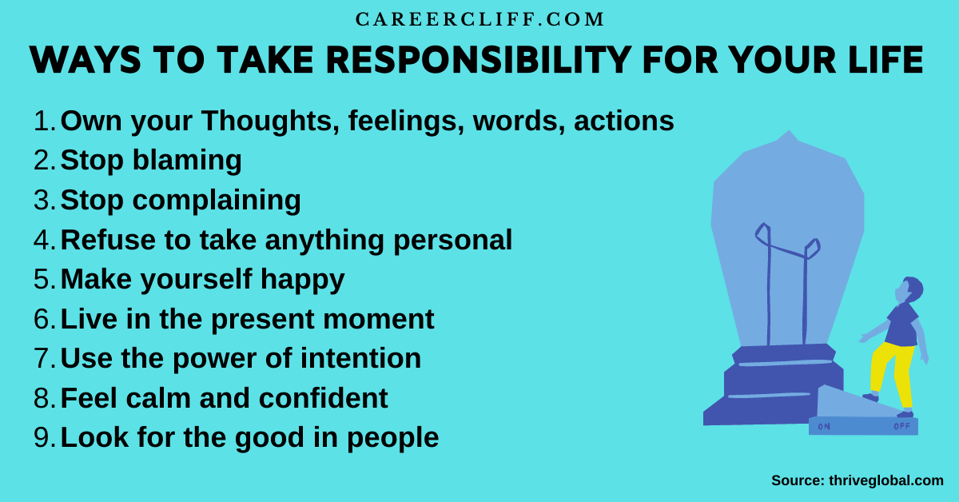

**Upcoming Events**

**Reading Fair:**

**January 13, 2022**

**Report Card Pick-Up:**

**January 13, 2022**

**MLK Holiday**

**(Schools and Offices Closed)**

**January 17, 2022**

**ADA**

**98%**

**“Every day Counts”**

Ms. Akela Barnes, District Attendance Officer

Mr. Adrian Gooden, School Resource Office

As a school and a district, we understand that we are not quite out of the woods with COVID-19 yet. We will continue to follow the CDC and district protocols for social distancing and sanitation, ensuring that all facets of our journey during the school day is one that is aligned . Our goal is, and has always been, to provide a safe learning environment. You can help us keep everyone safe by ensuring your child has a mask on daily before arriving at school.

Librarian’s Corner

**Book of the Month**

Who Moved My Cheese?

Spencer Johnson, M.D.

***Who Moved My Cheese?*** is a #1 International Best Seller. It is a parable about change. The characters represent a different attitude towards change. It’s time to change our mindsets at Carver. I believe reading this book will curtail poor behavior choices and make our students more conscious of their daily decisions. We want our students to enjoy more success and less stress.

 