December 2022
9-12 Lunch
MONDAY | TUESDAY | WEDNESDAY | THURSDAY | FRIDAY
 |  |  | 1  Chicken Bites  Tater Tots  Carrots w/ Ranch  Fruit  Roll  Milk  Alternate: Cheeseburger | 2  Pizza  French Fries  Romaine Salad  Corn  Fruit  Pudding  Milk  Alternate:  Crispitos
5  Country Steak w/ Gravy  Creamed Potatoes  Green Beans  Roll  Fruit  Milk  Alternate:  Chicken Sandwich | 6  Sweet & Sour Chicken  Fried Rice  English Peas  Stir Fry Vegetables  Fruit  Milk  Alternate:  Quesadilla | 7  Vegetable Beef Soup  Grilled Cheese Sandwich  Broccoli  Fruit  Milk  Alternate:  Corn Dog | 8  Cheeseburger Nuggets  Corn  Sweet Potato Fries  Romaine Salad  Roll  Fruit  Milk  Alternate:  Pizza | 9  Hot Wings  Carrots w/ Ranch  French Fries  Breadstick  Animal Crackers  Fruit  Milk  Alternate:  Grilled Cheese Sandwich
12  Hot Dog  Sweet Potato  Baked Beans  Broccoli w/ Cheese  Fruit  Milk  Alternate:  Hot Ham & Cheese Sandwich | 13  Salisbury Steak  Creamed Potatoes  Carrots  Roll  Animal Crackers  Fruit  Milk  Alternate:  Pizza | 14  Beef Nachos on Chips  Pinto Beans  Romaine Salad  Salsa  Fruit  Milk  Alternate:  Hot Dog | 15  BBQ Pork Sandwich  Baked Potato  Baby Lima Beans  Fruit  Milk  Alternate:  Cheeseburger | 16  Student ½ Day  Sack Lunch:  Sandwich  Carrots w/ Ranch  Chips  Fruit  Milk
19  Christmas Holidays | 20  Christmas Holidays | 21  Christmas Holidays | 22  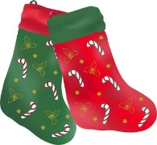  Christmas Holidays | 23  Christmas Holidays  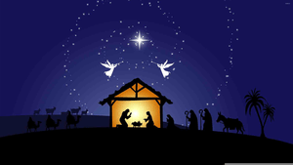
26  Christmas Holidays | 27  Christmas Holidays | 28  Christmas Holidays | 29  Christmas Holidays | 30  Christmas Holidays

