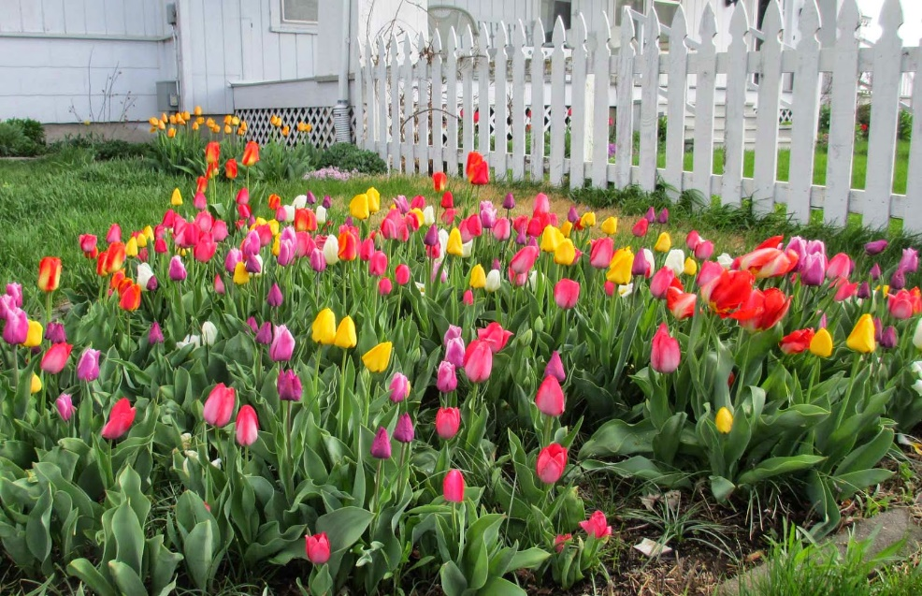
Class News
Mrs. Williams’ Second Grade
May 2, 2022

Reading Skills: contractions, syllable patterns, predict outcomes

Language: types of sentences

Spelling: vowel variant /oo/ oo, ou

Math: graphing

Science/Social Studies: wrap up habitats and adaptions

Upcoming events:
Friday, May 20 – D.A.R.E. Day
Tuesday, May 24 – Awards Assembly at 9 a.m.

