Please review the study guide. A reading test will be on Thursday.

Declarative/telling sentences- they will have to determine if the group of words is a telling sentience or not

We will test topic 4- subtraction facts to 20 on Thursday. A homework sheet was sent home today.

Pumpkins

MATH:

Week of Oct. 24

Red Ribbon Week- Oct. 24-28

Monday- wear red

Tuesday- wear pajamas

Wednesday- wear tie dye/neon

Thursday- wear favorite team shirt

Friday- wear costumes

High Freq. Words:

Down its red help six

Contact Information

Email: Pamela.luker@acboe.net

Website: prattvilleprimary.com/pamelaluker

LANG. ARTS:

SS/SCIENCE:

READING:

Our Learning





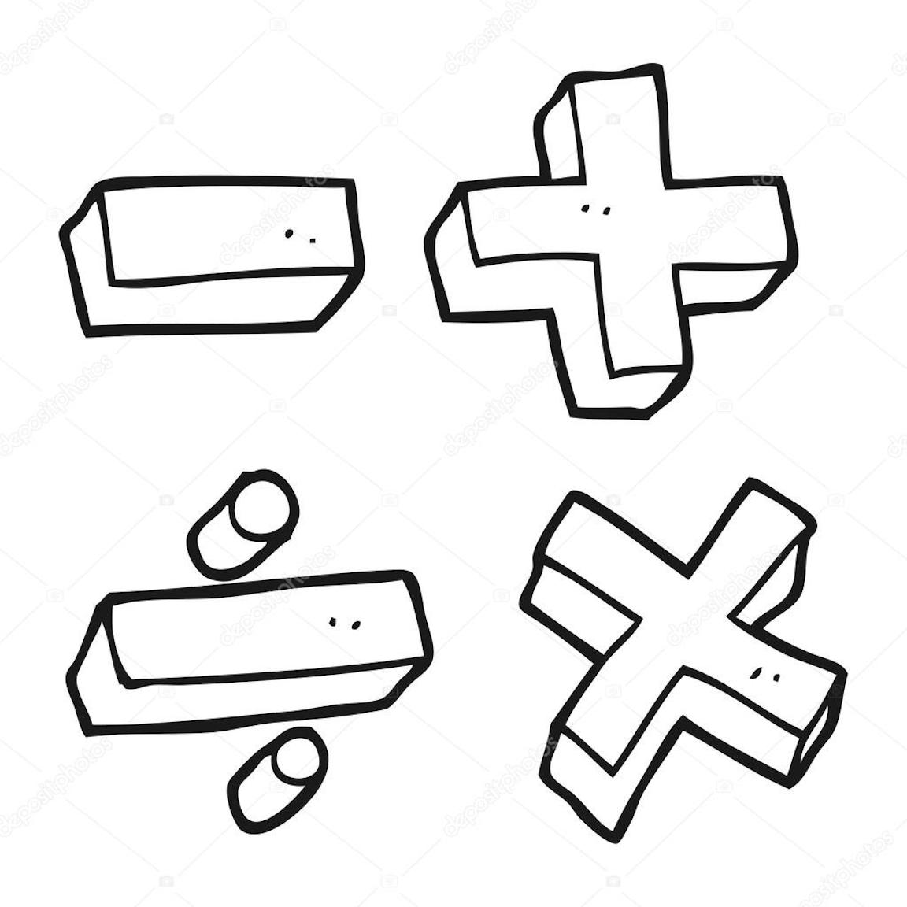

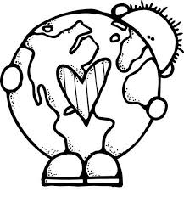

Upcoming Events

Oct. 28 Monster Mash @12:45-1:25 wear costumes

Oct. 31 no costumes at school

Nov. 1 picture retakes

Nov. 4 special snack- rice krispies

Nov. 11 Veteran’s day/no school

Reminders

\* Please remind your children to keep all toys (stuffed animals, balls, fancy pens, etc.) at home

\* An unit review sheet was placed in a sheet protector in your child’s bonder. This sheet will give you an overview of what skills will be tested. This week we are on unit 3 lesson 2.

Mrs. Luker’s Class