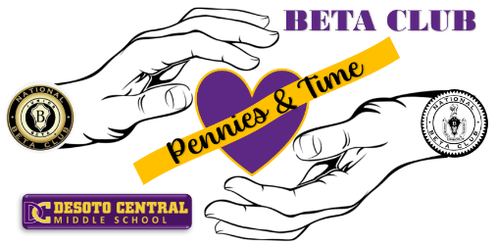
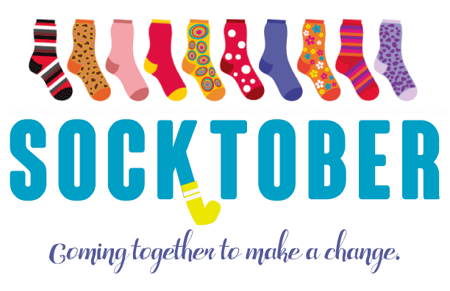
DCMS Beta Club will be providing Pennies & Time Service Opportunities throughout the year. We will be participating in Socktober. Each night in the United States, an estimated 600,000 people live on the streets. This October, we want 2 million people to show that even a small act of love, such as donating a pair of socks, can make a big difference in the lives of our neighbors who are homeless. If you would like to help out by providing new unopened packages of socks, then please bring those to the library by Friday, November 3rd. There will be a donation bin set up near the Beta table for you to place your items. Thank you.

