Clatskanie School District Student Success Act Community Engagement Summary

January 31, 2020
Prepared by Megan Irwin
Brave Ideas Consulting

Table of Contents

Page
Purpose …………………………………………………………………………….. 3
Methodology ……………………………………………………………............ 4
Stakeholder Engagement Themes …………………………………………. 6
Demographic Analysis ………………………………………………………… 14
Considerations …………………………………………………..……………….. 15

I. Overview

Passed in 2019, Oregon’s Student Success Act (SSA) marks a historic investment in Oregon’s public schools, focused on equity and improving outcomes for populations of students who experience disparities in educational outcomes as a result of historical oppression and marginalization by the public-school system. As part of the SSA, the Oregon Department of Education is dispersing $500 million dollars to school districts across the state as part of the Student Investment Account (SIA).

SIA funds serve two purposes: 1) Meeting students’ mental and behavioral health needs; 2) Increasing achievement and reducing academic disparities for students of color, students with disabilities, emerging bilingual students, and students navigating poverty, homelessness, and foster care. Per the requirements of the law, investments must focus entirely on these focal populations.

Districts may invest SSA funds in the following areas: 1) Behavioral and mental health supports; 2) Providing a well-rounded education; 3) Expanded learning time; 4) Class size reduction, and all investments must focus specifically on improving outcomes for the focal populations.

As part of SSA planning, school districts are required to conduct expanded community engagement to ensure the voices and perspectives of impacted populations are used to guide investments. Engagement must focus on soliciting input on strategies to:
- Reduce academic disparities
- Meet behavioral and mental health needs
- Provide access to academic courses
- Allow teachers and staff sufficient time to collaborate and develop strategies to help students stay on track to graduate
- Establish and strengthen partnerships
The Clatskanie School District (CSD) will receive an estimated $660,000 in SIA funds to invest in strategies to improve educational outcomes for students in the focal population. This report provides a summary of CSD’s community engagement efforts today including activities, findings, and emerging themes from community engagement efforts.

CSD academic achievement at a glance:

CSD is home to 704 students and is currently facing some academic challenges, falling below state averages on all key indicators tracked by ODE’s annual report card (ODE 2017-18 data). The following data were considered by the District’s School Improvement Team as part of the process to identify problems of practice that may be addressed by SIA investments.

ODE’s state issued district report cards do not provide academic achievement data disaggregated by race/ethnicity, poverty, special education status, or any other sub-groups defined by the SSA as priority populations. CSD is encouraged to obtain this information and provide a disaggregated look at achievement for its community for use in it’s SIA fund application

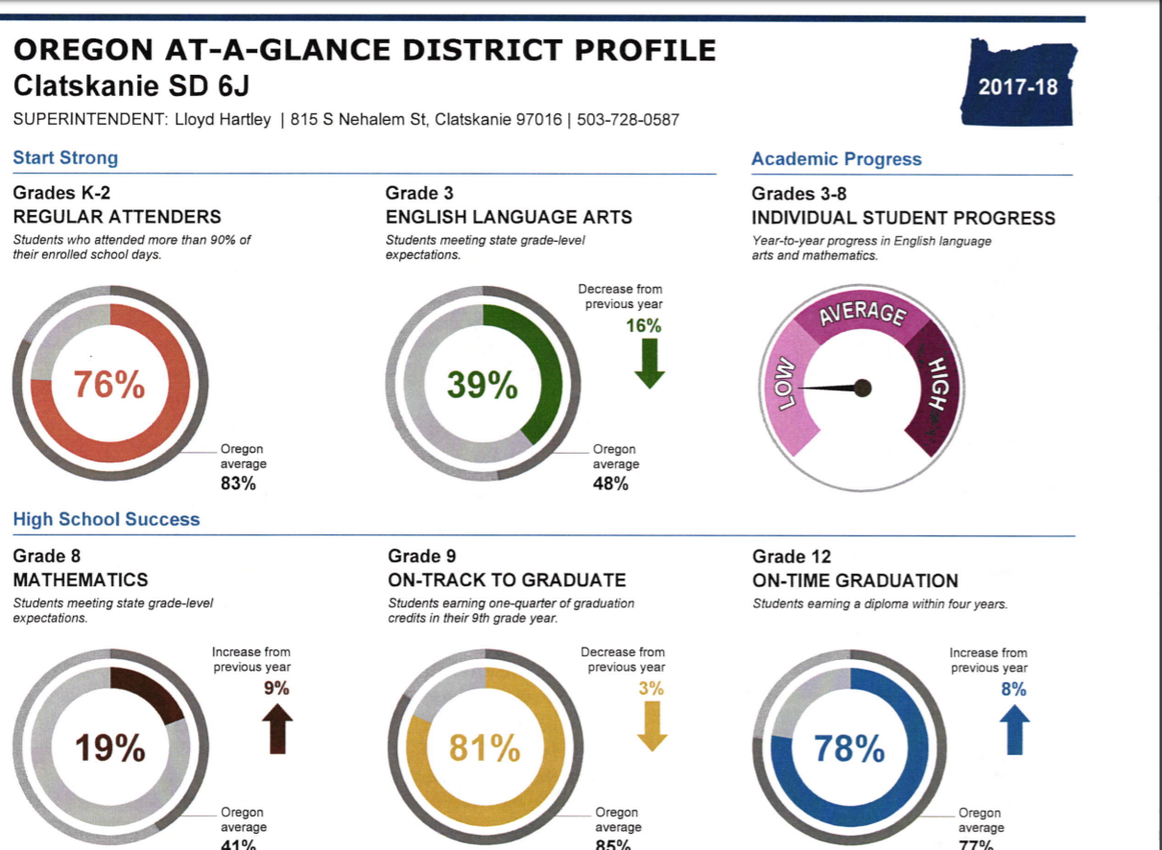

II. Methodology

Between November 2019 and January 2020 CSD conducted a perception survey to understand how students, teachers, community members and families perceive their school experience and conducted one focus group with parents of foster children and children in special education. Work to further engage students from impacted populations via empathy interviews is ongoing.

In December 2019, CSD convened a group of teachers, administrators, community members (including parents and the mayor of Clatskanie), and school board members to review and interpret perception survey data and identify problems of practice SIA funds could potentially address.

Perception survey methodology:
A total of 439 people responded to the perception survey, answering the following questions:
- How well do you feel the school is preparing you/your student for the next academic year? (Extremely well, quite well, slightly well, not well at all.)
- How much of a sense of belonging do you/your student feel at school? (Tremendous sense of belonging, quite a bit of belonging, a little bit of belonging, no belonging at all.)
- At school how well does the overall approach to discipline work? (Extremely well, quite well, slightly well, not well at all.)
- If you are a parent or guardian, to what extent do you know how your student is doing socially and emotionally at school? (A tremendous amount, quite a bit, a little bit, not at all.)
- If you are a parent or guardian, to what extent do you know how your student is doing socially and emotionally at school? (open-ended response).
- To what extent do you know how you/your student is doing academically? (A tremendous amount, quite a bit, a little bit, not at all.)
- Overall, how much respect do you think the teachers have for the students? (A tremendous amount of respect, quite a bit of respect, a little bit of respect, no respect.)
- How big of a problem are the following: (A very large problem, a large problem, a medium problem, not a problem at all.)
  - You feel unsure about how to communicate with the school.
  - The school provides little information about involvement opportunities.
  - The school is not welcoming.
  - You do not feel a sense of belonging in your school community.
  - Negative memories of your own school experience.
  - Your student does not want you to contact the school.
  - You worry that adults at the school will treat you/your student differently if you report a concern.
- If you or a student is bullied at your school, how difficult is it for him/her to get help from an adult? (Extremely difficult, quite difficult, somewhat difficult, not difficult.)
- Overall how safe do you or your student feel at school? (Extremely unsafe, quite unsafe, somewhat unsafe, not unsafe at all?)
- To what extent are drugs and tobacco/vaping a problem at school? (A tremendous problem, quite a problem, a bit of a problem, not a problem at all.)
- Overall, what grade would you give your school? (A through F.)
- Is there anything else you would like to share with us? (Open ended.)
Superintendent Cathy Horowitz conduced a quantitative analysis of findings, detailed in the next section of this report. Open-ended were not analyzed.

Participants were also asked to self-identify demographic information including: race/ethnicity, language, navigating poverty, English Language Learner, foster care, experiencing mental health difficulties, homeless/housing insecure, LGBTQIA, experiencing a disability, person of color.

Focus group methodology:
Five families participated in CSD’s SSA focus group.

Families were invited to participate in a focus group for foster families and families with students in special education. Invites went out to families in the mail and via social media. Social group participants responded to the following discussion questions on a continuum of “agree” to “disagree”
- My student has access to the courses and supports that he/she needs.
- My student talks positively about school
- I feel supported as a parent/guardian
Participants were also asked to indicate which SIA spending categories would most benefit their students:
- Smaller class sizes/more adults in the school.
- Mental and behavioral health supports.
- Extended learning time.
  - Before or after school programs.
  - Summer programs.
  - Longer school year
- Well rounded education.
  - More career/technical education.
  - Early childhood education.
  - More support for academics like literacy and math.

III. Stakeholder Engagement Themes

Perception survey data and focus group findings show that the Clatskanie student and family community are split on how well they feel the school district is preparing and supporting students academically.

Academic preparation:
A slight majority of survey respondents (54%) feel that their school is adequately preparing them for the next academic school year. Similarly, all focus group respondents felt for the most part their students have access to the kinds of supports they need to succeed academically. Focus group participants shared that they would like to see the district add summer learning opportunities to prevent “summer slide,” and that more one on one and specialized support is needed for students with special needs.

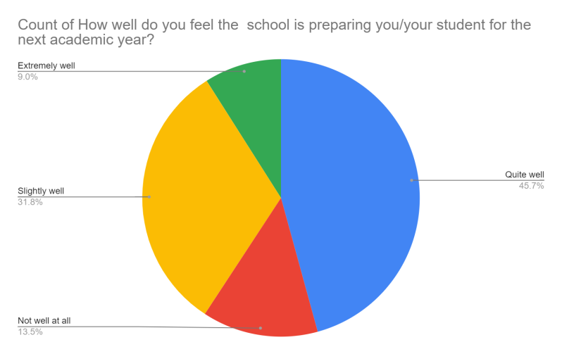

Perception survey data also indicate that the district is doing a good job ensuring that families know and understand how their child is doing academically.
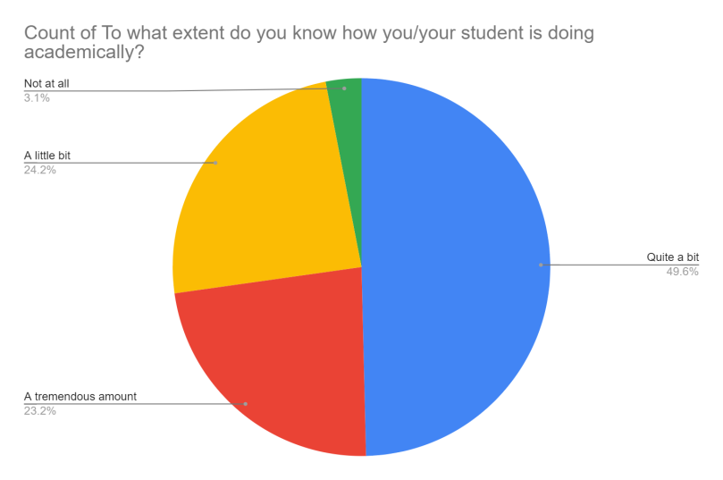

Social-emotional support:
Many survey respondents reported a sense of belonging at school, aligned with focus group participant’s perception that their students are having positive experiences at school, that discipline practices are effective, and that teachers treat students with respect.

“My student feels safe, cared about, and loved” – mother of special education student.

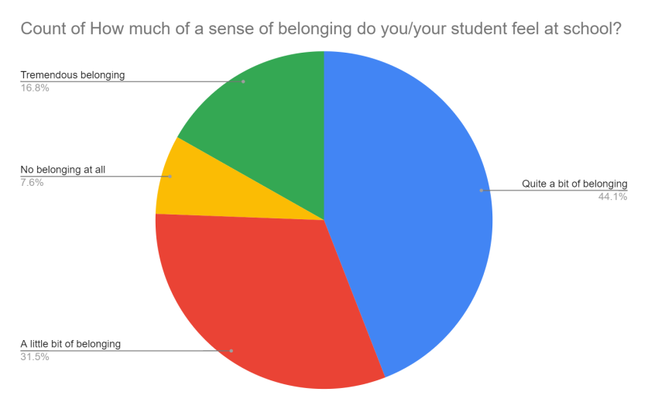

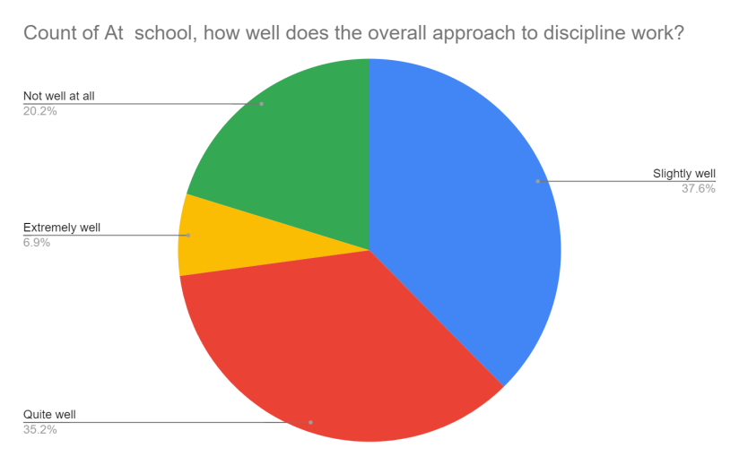

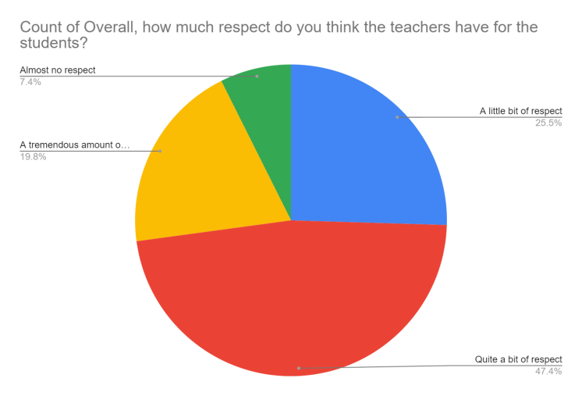
Despite these strengths, perception survey data do highlight challenges regarding student’s feelings of safety and belonging at school, and their ability to find support when they need it. Just over half (51.8%) of survey respondents reported that they feel unsafe at school, that it is difficult to get help when a student is being bullied, and they worry that if they raise a concern their student will be treated differently. A majority of respondents also reported that drugs, alcohol, and vaping are a problem at school.

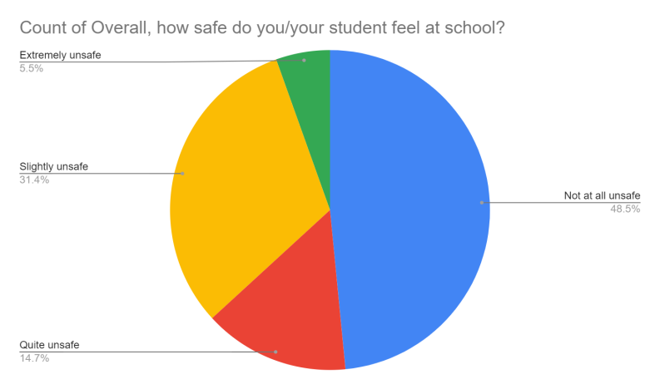

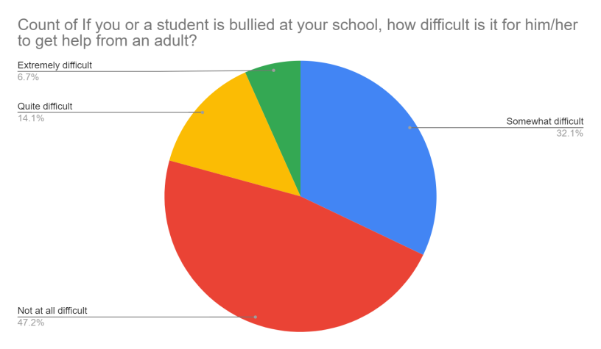

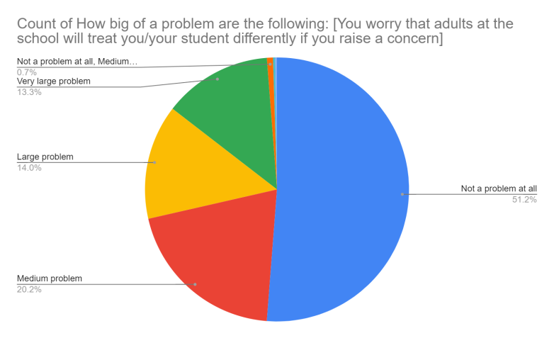

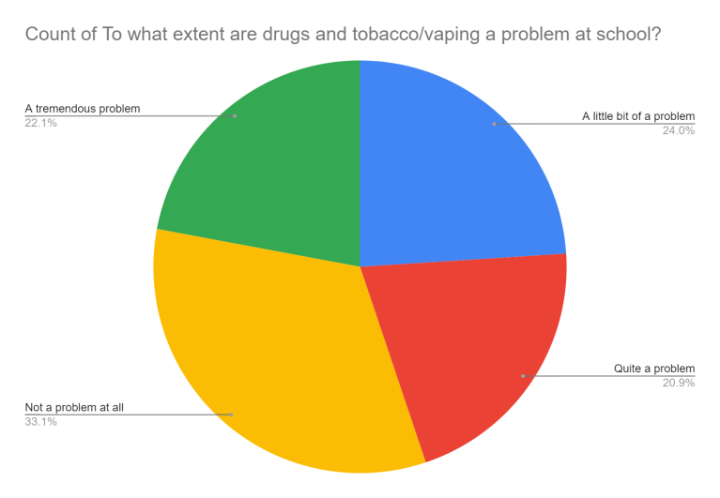
Responses related to feelings of safety, sense of belonging, parent knowledge of academic progress and student social emotional well-being, and concerns about the use of drugs, nicotine, and alcohol among students may be of particular significance for SIA investment planning. It is possible that these factors contribute to the districts high rate of chronic absenteeism and low academic achievement in reading and math. More information is needed to understand this connection. The district is currently working to understand root causes via empathy interviews with students, work expected to be completed in February 2020.

Perception Survey Data by SSA priority population:
Responses to the perception survey by people who self-identify as members of SIA population subgroups are provided below. These populations expressed slightly higher concerns about discipline, sense of belonging, teacher respect for students, and drugs and alcohol than the general population.

Potential areas of concern in bold for emphasis:

Identify as a person of color: Sixty-three people who responded to the survey identified as people of color.
- 54% say that CSD prepares their children for the next academic year extremely or quite well; 46% say the district prepares their children slightly or not well at all.
- 55% say their student feels a tremendous or quite a bit sense of belonging; 45% say their student feels only a little bit of belonging or no belonging at all.
- 33% say the district’s approaches discipline extremely or quite well; 66% say the district approaches discipline slightly well or not well at all.
- 30% say they know how well their student is doing socially and emotionally; 60% say they know a little or nothing at all about their student’s social emotional well-being.
- 59% say they know how well their student is doing academically; 41% say they know little or nothing at all.
- 48% say that teachers show tremendous or quite a bit of respect for students; 52% say teachers show a little or almost no respect for students.
- 51% say that communication is a very large, a large problem or a medium problem; 49% say it is not a problem at all.
- 63% report that receiving little information about involvement opportunities is a very large, large, or medium problem; 37% say it is not a problem at all.
- 40% say that the school is note welcoming and report that it is a very large, large or medium problem; 70% say it is not a problem at all.
- 33% say that worrying their student will be treated differently if they report a problem is a very large, large, or medium problem; 67% say it is not a problem at all.
- 52% report that it is extremely, quite, or somewhat difficult to get help when a student is bullied; 48% say it is not difficult at all.
- 55% report that they feel extremely, quite, or somewhat unsafe at school; 45% report they do not feel unsafe at all.
- 73% say they feel drugs are a tremendous, quite large, or little bit of a problem; 27% say they are not a problem at all.
- Grades to the district by respondents:
  - A: 13%
  - B: 30%
  - C: 37%
  - D: 11%
  - F or lower: 10%
Identify as ELL: Only two people responded to the survey that they identify as a student or parent of an English Language Learner. This sample size is not large enough to yield information regarding this population’s perspective. It is recommended that the district reach out to this community in a culturally responsive way in order to better understand their perceptions and needs.

Identify as a as experiencing poverty: Sixty-four people who responded to the survey say they are experiencing poverty.
- 49% % say that CSD prepares their children for the next academic year extremely or quite well; 51% say the district prepares their children slightly or not well at all.
- 51% say their student feels a tremendous or quite a bit sense of belonging; 49% say their student feels only a little bit of belonging or no belonging at all.
- 38% say the district’s approaches discipline extremely or quite well; 62% say the district approaches discipline slightly well or not well at all.
- 46% say they know how well their student is doing socially and emotionally; 54% say they know a little or nothing at all about their student’s social emotional well-being.
- 71% say they know how well their student is doing academically; 29% say they know little or nothing at all.
- 43% say that teachers show tremendous or quite a bit of respect for students; 57% say teachers show a little or almost no respect for students.
- 51% say that communication is a very large, a large problem or a medium problem; 49% say it is not a problem at all.
- 43% report that receiving little information about involvement opportunities is a very large, large, or medium problem; 57% say it is not a problem at all.
- 41% say that the school is note welcoming and report that it is a very large, large or medium problem; 59% say it is not a problem at all.
- 46% say a sense of belonging at school is a very large, large, or medium problem; 41% say it is not a problem at all.
- 50% say that worrying their student will be treated differently if they report a problem is a very large, large, or medium problem; 50% say it is not a problem at all.
- 61% report that it is extremely, quite, or somewhat difficult to get help when a student is bullied; 39% say it is not difficult at all.
- 60% report that they feel extremely, quite, or somewhat unsafe at school; 40% report they do not feel unsafe at all.
- 60% say they feel drugs are a tremendous, quite large, or little bit of a problem; 40% say they are not a problem at all.
- Grades to the district by respondents:
  - A: 20%
  - B: 40%
  - C: 28%
  - D: 13%
  - F or lower: 8%
Identify as homeless or housing insecure: Only seven people responded that they identify as homeless or housing insecure. This sample size is not large enough to yield information regarding this population’s perspective. It is recommended that the district reach out to this community in a culturally responsive way in order to better understand their perceptions and needs.

Identify as a part of the foster care system: Eleven respondents reported they are involved with the foster care system.
- 60% % say that CSD prepares their children for the next academic year extremely or quite well; 50% say the district prepares their children slightly or not well at all.
- 91% say their student feels a tremendous or quite a bit sense of belonging; 9% say their student feels only a little bit of belonging or no belonging at all.
- 73% say the district’s approaches discipline extremely or quite well; 27% say the district approaches discipline slightly well or not well at all.
- 55% say they know how well their student is doing socially and emotionally; 45% say they know a little or nothing at all about their student’s social emotional well-being.
- 71% say they know how well their student is doing academically; 29% say they know little or nothing at all.
- 45% say that teachers show tremendous or quite a bit of respect for students; 55% say teachers show a little or almost no respect for students.
- 73% say that communication is a very large, a large problem or a medium problem; 27% say it is not a problem at all.
- 43% report that receiving little information about involvement opportunities is a very large, large, or medium problem; 57% say it is not a problem at all.
- 41% say that the school is note welcoming and report that it is a very large, large or medium problem; 59% say it is not a problem at all.
- 55% say a sense of belonging at school is a very large, large, or medium problem; 45% say it is not a problem at all.
- 55% say that worrying their student will be treated differently if they report a problem is a very large, large, or medium problem; 45% say it is not a problem at all.
- 61% report that it is extremely, quite, or somewhat difficult to get help when a student is bullied; 39% say it is not difficult at all.
- 66% report that they feel extremely, quite, or somewhat unsafe at school; 34% report they do not feel unsafe at all.
- 64% say they feel drugs are a tremendous, quite large, or little bit of a problem; 36% say they are not a problem at all.
- Grades to the district by respondents:
  - A: 10%
  - B: 18%
  - C: 45%
  - D: 10%
  - F or lower: 10%
Identify as experiencing a person with a disability: Fifty-eight respondents reported that they or their student are a person with a disability.
- 55% % say that CSD prepares their children for the next academic year extremely or quite well; 45% say the district prepares their children slightly or not well at all.
- 57% say their student feels a tremendous or quite a bit sense of belonging; 43% say their student feels only a little bit of belonging or no belonging at all.
- 38% say the district’s approaches discipline extremely or quite well; 62% say the district approaches discipline slightly well or not well at all.
- 41% say they know how well their student is doing socially and emotionally; 34% say they know a little or nothing at all about their student’s social emotional well-being.
- 60% say they know how well their student is doing academically; 40% say they know little or nothing at all.
- 22% say that teachers show tremendous or quite a bit of respect for students; 78% say teachers show a little or almost no respect for students.
- 43% say that communication is a very large, a large problem or a medium problem; 57% say it is not a problem at all.
- 48% report that receiving little information about involvement opportunities is a very large, large, or medium problem; 52% say it is not a problem at all.
- 31% say that the school is note welcoming and report that it is a very large, large or medium problem; 69% say it is not a problem at all.
- 38% say a sense of belonging at school is a very large, large, or medium problem; 62% say it is not a problem at all.
- 53% say that worrying their student will be treated differently if they report a problem is a very large, large, or medium problem; 47% say it is not a problem at all.
- 53% report that it is extremely, quite, or somewhat difficult to get help when a student is bullied; 47% say it is not difficult at all.
- 64% report that they feel extremely, quite, or somewhat unsafe at school; 47% report they do not feel unsafe at all.
- 79% say they feel drugs are a tremendous, quite large, or little bit of a problem; 21% say they are not a problem at all.
- Grades to the district by respondents:
  - A: 21%
  - B: 38%
  - C: 22%
  - D: 12%
  - F or lower: 3%

After analyzing CSD’s academic and perception survey data, CSD’s School Improvement Team identified eight problems of practice facing the district were identified, along with strategies to address each problem aligned with SIA spending priorities.

School Improvement Team Findings

Problem #1: Math achievement is low and falling
(Suggestion: Disaggregate by grade level to get more precise in aligning solutions)

Identified reasons
- Staff training
- Standards understanding/alignment across grades (priority standards - possible need for curriculum adoption?)
- Need common formative assessments
- Knowledge of instructional best practice (“focus on writing and discourse in math”) (multi-tiered systems) (training in differentiated learning and groups in one class)
- Need more prep time and weekly grade level collaboration
- Need teaming and consistency

Addressing math with SSA
SSA Area: Expanded learning time
- After school support opportunities

SSA Area: Health and safety
- None identified

SSA Area: Well rounded education
- Math intervention system
- Prioritizing math RTI
- Focus on writing and discourse in math
- Clear targets and criteria for success

Smaller class size/more staff
- Adults don’t have time for training and fidelity in best practices
- Time to monitor lessons
- Time for collaboration

Problem #2: ELA achievement is low
(Suggestion: Disaggregate by grade level to get more precise in aligning solutions)
Possible reasons:
- Need for PD
- Need for aligned, focused standards

Addressing ELA with SSA

SSA Area: Expanded learning time
- Offer after school help

SSA Area: Health and safety
- None identified clearly
- Possibly - implement multi-tiered systems of support

SSA Area: Well rounded education
- Offer pre-k (or align with Early Learning Hub plan for expansion) to build early literacy skills.
- Offer art, music, and PE to utilize electives to build engagement
- Focus on writing
- Focus on systems
- Identify priority standards for authentic literacy

SSA Area: Smaller class size/more staff
- Target students - rigor, writing, reading
- Time for PD in fundamental reading
- Time to monitor lessons
- Time for grading quarterly writing benchmarks K-12 graded as a district

Problem #3: We are not meeting the needs of Hispanic (Latinx) students
Possible reasons:
- Need for all school correspondence to be sent home in native language
- Need to utilize translator rather than relying on kids to communicate in home language [to parents?]
- Need for an ELA curriculum

Addressing the needs of Latinx students with SSA

SSA Area: Expanded learning time
- After school support for families

SSA Area: Health and safety
- Provide a district liaison to increase parent access to schools in a safe way/culturally responsive way
- Suggestion: May want to explore whether families experience fear or uncertainty in engaging with district due to a cultural disconnect/need for cultural responsiveness

SSA Area: Well-rounded education
- Adopt an ELL curriculum

SSA Area: Smaller class size/more staff
- Time to monitor data and create/review progress reports
- Time to create an aligned system for support and instruction
- Time for PD on teaching level 1, 2, and 3 assessment
- Time to monitor ELLs and do a CORE review

Problem #4: We do not have a system wide, common, definition of student success at the school, district, and community level.

More information needed:
- Dig deeper with parents: “My child’s time at CSD will be successful if…”
- Dig deeper with students
- Strategies for more communication and discussion about rigor district wide
- Suggestion: Use focused/expanded community engagement strategies (empathy interviews and focus groups) to engage people in creating the vision.

Addressing a vision of success with SSA

SSA Area: Expanded learning time
- None

SSA Area: Health and safety
- None identified

SSA Area: Well-rounded education:
- None identified

SSA Area: Class size/more staff
- None identified

Not SSA aligned, but important possible strategies
- Backward planning [as a district]
- Create a standards based/common reporting system
- Bridge gaps between grade levels and curriculum
- Define rigor by grade level
- District team to collaborate and decide the definition (suggestion: use expanded community engagement information to create the definition).

Problem #5: Students do not feel safe at school

Addressing safety with SSA

SSA Area: Expanded learning time
- Need time to implement restorative practices and CPS

SSA Area: Health and safety
- More mental health services
- Cougar pens
- Strategies to build communities in schools/classrooms
- Attention to addressing the environment at school blow outs
- Response team
- Improve teacher/student relationships
- Create safety infrastructure

SSA Area: Well-rounded education
- None identified

SSA Area: Class size/more staff
- More monitoring in the halls
- More skilled teaching

Problem #6: We are not addressing behavioral health needs
More information needed:
- Needs assessment to understand root causes.
- Research to select a program and provide training to implement

Addressing behavioral health with SSA

SSA Area: Expanded learning time
- None identified

SSA Area: Health and safety
- Implementation of SEL
- Cougar dens
- Equitable distribution of mental health services that meet the level of need
- Building coping strategies
- Small support groups for peer/skill building
- Skill building
- Relationships with families
- Behavior rating/data collected to inform intervention needs for students

SSA Area: Well rounded education
- Develop early learning programs to impact students sooner.
- PE

SSA Area: Class size/more staff
- Time for training
- Behavior coaches

Problem #7: We are not meeting the academic needs of girls

More information needed:
- More data on why - engage students to find out - what do they feel is getting in theri way
- What grade level does this start?

Addressing achievement for girls with SSA

SSA Area: Expanded learning time
- None identified

SSA Area: Health and safety
- Cougar dens
- District campaign for female empowerment - show it’s ok to be strong (“CRAB in the building) (*not sure what this means -making a guess it goes here)
- Building classroom/school communities
- Daily affirmations
- Explicitly team media messages about social media
- Have opportunities for exposure to professional women in schools

SSA Area: Well-rounded education
- SAFE
- STEAM

SSA Area: Class size
- No specific strategy identified

Problem #8: Chronic absenteeism is increasing
More information needed:
- Empathy interviews to understand why as part of needs assessment
- Expanded community engagement
- Further examine the connection between mental health and feeling safe to chronic absenteeism

Addressing chronic absenteeism with SSA
SSA Area: Expanded learning time
- None identified

SSA Area: Health and safety
- Stop suspending kids
- Student recognition and incentives
- Involve students in the solution
- Cougar Dens

SSA Area: Well-rounded education
- PE
- Art
- Music

SSA Area: Class size/more adults
- Boots on the ground person in the community for both schools

Finally, in an effort to better understand potential root causes of the district’s challenges, and to identify parent priorities for SIA investments, the district hosted two focus groups with foster families, families with children in special education, and low-income families. Five families attended the focus group for special education and foster families. The focus group for low-income families did not have any attendees despite outreach efforts by the superintendent and it is recommended that a follow up attempt is made in partnership with community members or organizations with personal relationships with this population.

Focus Group Findings

Families who participated in CSD’s focus group reported that their experience in the district is generally positive, agreeing that their students speak positively about school and that they feel supported as parents or guardians. They also generally agreed that their students have access to courses and supports they need to succeed at school, however, they noted that there are not enough resources for students who need extra support. Specifically, they expressed concern about the need for more one-on-one support and/or extra adults in the classroom for children with special needs or mental health challenges. The group also identified the need for additional services and supports such as counselors for children navigating challenging life circumstances like involvement with the child welfare system.

When asked about the best way to spend SIA funds parents showed the strongest support for decreasing class sizes or adding teaching assistants to classrooms to reduce ratios, and for adding more electives and job training opportunities to the course offerings available to students.

When asked how lowering class sizes or adult/child ratios would help their students, participants reported that they see a strong connection between the need to lower class sizes and strategies to support students who struggle because of delays/disabilities, social-emotional needs, and behavioral health challenges.

“If there were more adults in the classroom to support my son, he could spend more time fully included in class.” – parent of a special education student.

The group reported that they would also like to see more non-academic electives that focus on soft skills, life skills, and job training opportunities for students.

Parents ranked extended learning time and well-rounded education as their second highest priorities, asking for more after school programs and summer programs, as well as expanded academic support in literacy and math. The group noted that if the district provides extended learning time programs there is a need to make sure that they are accessible to students and identified transportation as a significant barrier.

While they ranked it as the third most important priority, parents acknowledged the need for more mental health supports for students, and indicated they would like to see more training for teachers in how to support students with behavioral health needs, as well as specialized programs such as Advanced Behavioral Therapy, aimed at supporting these students.

The group ranked early childhood education and extending the school year as their lowest priorities.

IV. Demographic Analysis

The SSA requires engagement efforts focus on receiving feedback from students and families from the law’s focal population. A demographic analysis of survey respondents is provided below.

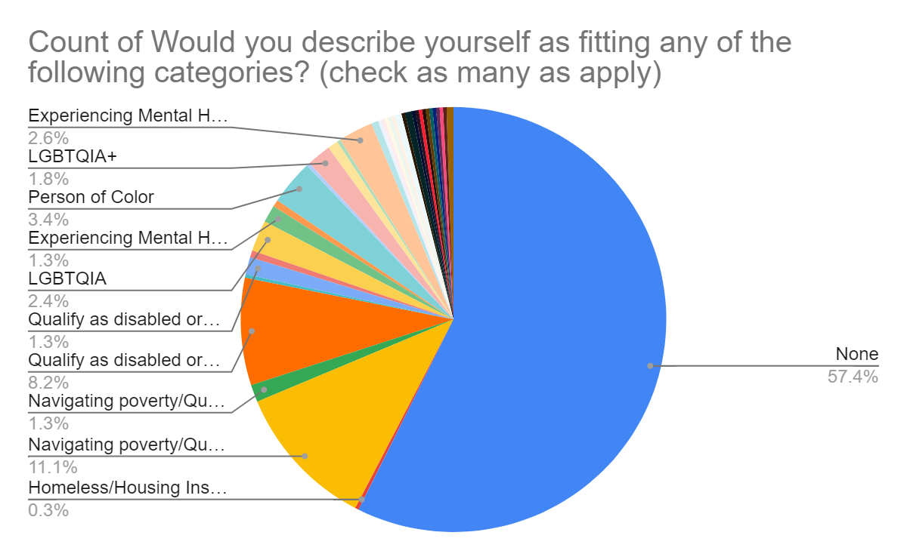

According to the Oregon Department of Education (ODE) the district’s student population is as follows:

Race/ethnicity | Percent of student population
American Indian/Alaska Native | 1%
Asian | 1%
Black/African American | M1%
Hispanic/Latinx | 9%
Multiracial | 9%
Native Hawaiian/Pacific Islander | <1%
White | 79%

ODE reports that <5% of BSD students were ever English learners, 54% are on free and reduced lunch (a proxy for navigating poverty), and 19% are in special education. Based on the data above, students in special education, students navigating poverty, and Latinx students are under-represented in survey responses. It is recommended that the district make additional efforts to reach these families to understand their perception of the district and their needs.

V. Considerations and Next Steps

As CSD develops its SIA plan, it is crucial that the district continue to solicit input from parents, students, and community members, with a focus on better understanding the root causes of the district’s most persistent challenges and the problems of practice identified in this report: chronic absenteeism, students who do not feel safe at school, low academic achievement for girls, and overall low academic achievement in math.
Recommendations for further engagement and SIA planning are as follows:
  - Continue to make efforts to contact parents and students from the SSA focal populations. Work through community organizations, teachers, providers, and community members who have existing, trusting, relationships with these populations in order to increase turnout and participation.
  - Continue to convene the District Improvement Team and build on the work they began in December 2019. The group was highly engaged at this meeting, and appeared to want more opportunities to engage and guide district planning and investments.
  - Develop a strategy for reporting ideas about SIA investments back to the community before finalizing and submitting the plan, especially teachers and the families who participated in providing feedback, the team that identified problems of practice, teachers, and survey participants.
  - Develop an ongoing strategy for meaningful community engagement while rolling out, implementing, and evaluating SIA plans.

