**YORK WEST END  
READING FAIR**

**CONTEST**

# STUDENT GUIDELINES

**PRE-KINDERGARTEN – FOURTH GRADE**

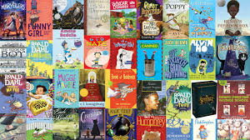 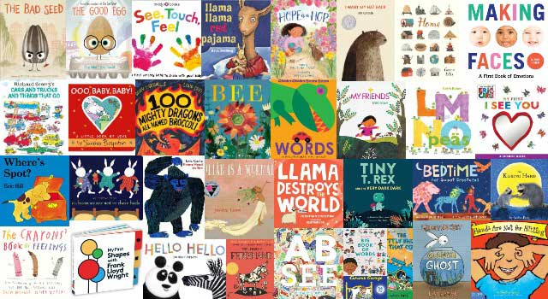

**What: April Reading Fair Contest**

**Why: To motivate learners and build more**

**excitement about the importance of READING.**

**When: April 25, 2025 @ 2:00 PM**

**Who: YWE Students**

**Where: York West End Jr High School’s Gym**

**Examples of student Reading Fair boards**

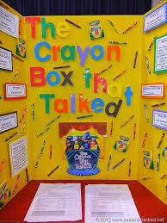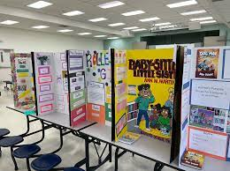

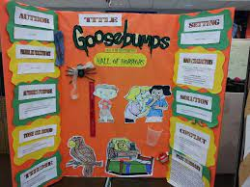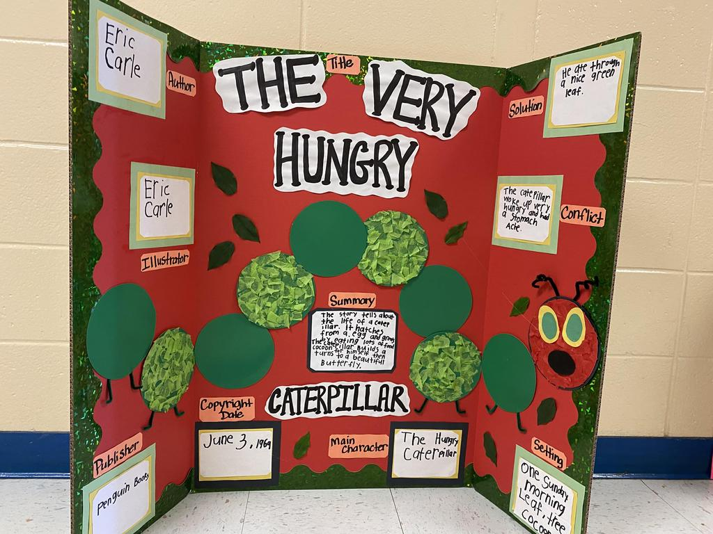

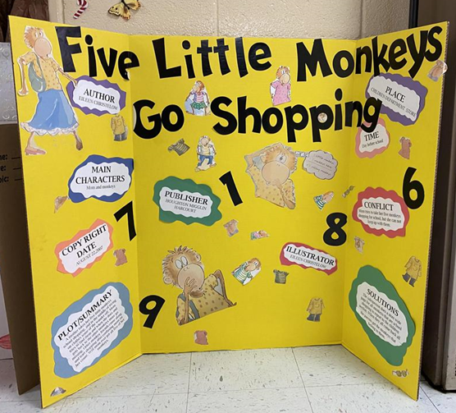 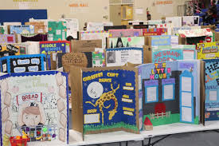

**Reference: www.googleimages.com**

YWE Reading Fair Contest Guidelines

* Sign up in order to participate in the York West End (YWE) Reading Fair Contest.
* Participants should choose a book on their reading level. This means the participant will need to read the book.
* Only two story boards of the same title are allowed, so please turn in your entry form early.
* All entries should represent a fictional book.
* Participants must design and make a story board using the attached checklist. All items must be included on the storyboard.
* Storyboards must be original. Ideas can be found by using online searches.

❖ Storyboard will need to be displayed on a standard tri-fold project board that measures

36” H x 48” W.

* Identifying information will need to be written on the **BACK** of the storyboard. This will include student name, teacher name, and grade level.
* Storyboards should be colorful and interesting. All display items should fit on the tri-fold or in the middle of the display. Nothing should hang off the display table or on the floor.

❖ Writing can be handwritten or typed.

Please Note: Storyboard content should match the age, grade level, and the ability of the student presenting the display.

* Electrical cords will not be available or allowed for presentation of material.
* Participant must have storyboard set up before judging begins in order to compete.
* Student must be present to win!

# YWE Reading Fair Contest Checklist

**The storyboard should creatively display the following:**

_____Title**\***

_____Author**\***

_____Publisher and Publication Date**\***

_____Main Characters-only those important to the story line**\***

_____Setting-place and time of the story**\***

_____Plot Summary-a brief summary (not a retelling) of what the story is about in your own

words

_____Conflict-the problem of the story, in your own words**\***

_____Resolution-how the conflict is resolved, tell in your own words**\***

_____Author’s Purpose-explain why the author wrote the story (to entertain, to persuade, to

inform)**\***

_____Theme and Lesson-describes what the author wants the reader to learn, not main idea

**Pre-Kindergarten through 1st grade students may complete only the starred* items above…**

**Your librarian will be more than ecstatic to help with any questions, concerns, or issues. Thanks for participating in our Reading Fair Contest!**

**Library Media Contact Info:**

**Dr. Compton**

**Email:** [**ccompton@sumter.k12.al.us**](mailto:ccompton@sumter.k12.al.us)

**Phone: 205.392.5901 ext:2304**

**What are the judges looking for?**

**Writing:**

* Writing is neat and inviting.
* Writing is easily understood.

**Creativity:**

* Project is original.
* Project demonstrates imagination.
* Unique materials are used to express ideas.

**Quality of Project:**

* Storyboard should match the age, grade level and the ability of the student presenting ▪ Project is durable and can stand up through judging.

**Thoroughness of Written Information:**

* Project captures the most important information.
* Project captures the concept/point the author made in the book.

**Interest Evoked:**

* Project demonstrates student’s ability. Project encourages others to read the book Project attracts others and makes them interested in the work.

# YWE Reading Fair Contest Rubric

# 

Project #___________(committee will provide you with a number)

**(All Grades)**

**All of the following must be present on the board:**

* Title

o Author

o Main Characters-only those important to the storyline

o Setting-place and time of the story

o Conflict-the problem of the story

o Solution or Resolution-how the problem is resolved

o Plot Summary-brief summary (not a retelling) of what the story is about and what takes place **(All Grades)**

**(3rd and 4th grade only)**

* Author’s Purpose-why the author wrote the story (to entertain, inform, and/or persuade)

o Tone or Mood-describes how the author wants the reader to feel while reading the story **(3rd and 4th grade only)**

**Deduct 10 points if any of the above story elements are not present on the board. ____**

**Subtract 10 points if student involvement is not evident on the display. _____**

|  |  |  |
| --- | --- | --- |
| **Category** | **Scoring** | **Point Total** |
| **Clarity of Writing**   * Captures attention * Easily understood | **Lowest**  **Highest**  1 2 3 4 5  1 2 3 4 5 | **10 points**  _______ |
| **Creativity**   * Has originality of subject or idea * Demonstrates imagination in manner of production/presentation * Has clever, inventive, and effective use of materials to express ideas | **Lowest**  **Highest**  1 2 3 4 5 6 7 8 9 10  1 2 3 4 5 6 7 8 9 10    1 2 3 4 5 6 7 8 9 10 | **30 points**    ________ |
| **Quality of Product**   * Follows directions * Demonstrates skill and craftsmanship | **Lowest**  **Highest**  1 2 3 4 5 6 7 8 9 10  1 2 3 4 5 6 7 8 9 10 | **20 points**    ________ |
| **Thoroughness of written information**   * Proper emphasis is placed on important items * Completely portrayed the concept of the book | **Lowest**  **Highest**  1 2 3 4 5 6 7 8 9 10    1 2 3 4 5 6 7 8 9 10 | **20 points**    ________ |
| Interest Evoked   * Represents real study and effort * Exhibit is appropriate to age level * Encourages viewer to read this book * Project is visually appealing | **Lowest**  **Highest**  1 2 3 4 5  1 2 3 4 5  1 2 3 4 5  1 2 3 4 5 | **20 points**    ________ |

Judge Badge ________ **TOTAL________**

**YWE Reading Fair Contest Sign Up Form**

**Date _________________**

**Project #___________**(committee will provide you with a number)

Student Name __________________________________________

Teacher Name ______________________

Grade ___________

Reading Fair Book _____________________________________

Book Author ____________________________________

**TO BE COMPLETED BY SCHOOL OFFICIALS**

**Student Entry ________________________________**

**Name _______________________________________**

**Date ________________**

**Book Title _____________________________ Author ______________________**

**Completed by: ________________________________**