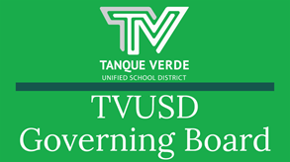
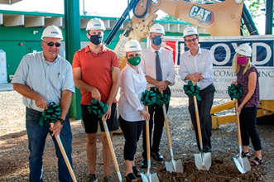

Governiing Board Meetiing Summary September 7, 2021
Septtember 10,, 2021At the September 7, 2021 Governing Board Meeting, he Board was presented with updates regarding summer construction projects and the groundbreaking celebration held the same day. Action and discussion items included a revision to the Safe Return to In-Person Learning Plan, School Funding and SY2022-23 Calendar Options.Please continue reading for more detailed information about these topics and more!Sttudentt Board Member ReporttStudent Board Member, Lilyana Brummitt reported on school events for Emily Gray Jr. High and Tanque Verde High School. Her presentation may be viewed here: Student Board Report
Superiinttendentt ReporttDr. Scott Hagerman provided the Governing Board with district updates on the completion of summer construction projects at Tanque Verde High School and Agua Caliente Elementary School, as well as new construction projects beginning at Emily Gray Jr. High and Tanque Verde Elementary School.

The presentation and photos may be viewedhere.

A Groundbreaking Ceremony was held at Tanque Verde High School earlier in the day. Members from the community and school leadership were in attendance. Distinguished speakers included Dr. Scott Hagerman, TVUSD Superintendent; Susan Fry, TVUSD Governing Board President; Phil Swaim of Swaim Associates, LTD; Alan Levin of Estimating Plus, LLC; and Nick Loper from the Arizona Department of Administration.

Please see the full article on the website for more detailed information.

Reviisiion off Saffe Retturn tto IIn-Person Learniing Pllan

Dr. Hagerman presented information regarding revisions to the Safe Return to In-Person Learning Plan.

The CDC and Federal Department of Education have updated their requirements related to COVID-19. The new order states: "CDC issued an order requiring wearing masks on all public conveyances, including on school buses. Accordingly, regardless of the mask policy at school, passengers and drivers must wear a mask on school buses, including on buses operated by public and private school systems, regardless of vaccination status, subject to the exclusions and exemptions in CDC’s order."

See U.S. Department of Education,Ed COVID-19 Handbook(masking practices p9)

The district proposed to adjust the Safe Return to In-Person Learning Plan to be in compliance with new CDC requirements. Citing a change to the legal advice received since the initial plan was published, Dr. Hagerman recommended the addition of the CDC mandated mask-while-on-school-buses requirement. The Governing Board voted in favor of following the CDC requirement and approved a mask mandate on all district buses.

The district proposal as approved:
“Face coverings will not be required when in any educational space except for school buses. The district will follow CDC requirements. Wearing a mask is required on all public conveyances, including on school buses.”

Please see the full presentationhere.

The Safe Return to In-Person Learning Plan, Revised 09/07/21 has been updated on the website here.

2022-23 Callendar Opttiions
Dr. Hagerman presented information about the development of the 2022-23 School Year Calendar.
The calendar is influenced by the holidays, and the Arizona Dept. of Education restriction that the Winter Break may not extend more than two weeks. In addition, the question of the placement of grading days and professional learning days for teachers is being considered. The options will be reviewed by the school site councils for their input before it goes to the Governing Board for approval.
Option 1 Option 2

The full presentation may be reviewedhere. The Board will vote on the calendar options at the October 6, 2021 board meeting.

IInvesttiing iin Sttudentt Learniing

Dr. Hagerman presented information about funding related to the district, and the process




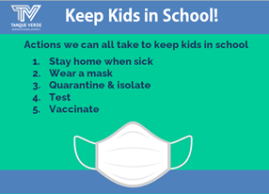
of how funding determinations are made in the district.Assessment of Needs for Gap Funding Districts have two years to spend funds.Districts must have a plan to increase state scores in math and reading.TVUSD Need Areas include: Curriculum Technology 1:1 student devicesComplete Interactive Screen Implementation Indoor and Outdoor Learning SpacesEducational Equipment - For example: Art, music, athletics, science.Next Steps for Ed Plus Up awards (Gap Funding)State has extended the deadline until September 24, 2021. They have added additional requirements for funding. District must have a remediation plan.The full presentation may be viewedhere.
IImporttantt Dattes & IInfformattiionSeptember Events Calendar - UpdatedThe September Events have been updated to include the upcoming Site Council Meeting dates at each site.TVHS - September 16, 2021 EGJH - September 21, 2021 ACES - September 13, 2021 TVES - September 13, 2021The Tanque Verrde Foundattiion is hosting the Tinker Verde Nerdy Derby on November 20, 2021 at the Forty Niner Country Club. This family oriented eventreplaces the Tech Trek and our TVUSD schools will benefit from technology investment.For more information click on the event logo, or visit: https://tanqueverde.org/2021/08/30/2nd-annual-tinker-verde-nerdy-derby/The 21-22 SCHOOL YEAR CALENDAR may be found here: TVUSD School Year Calendar 2021-22 K-12th.
Substtiittutte Teacher Pay IIncrease - Hellp needed!!



Tanque Verde Unified School District will be increasing the substitute teacher pay effective September 8, 2021. The new rates will be as follows:Regular substitute teachers: $140.00 per day Tanque Verde retirees: $150.00 per dayLong-term substitute teachers: $165.00 per dayIf you have a Arizona substitute teaching certificate and would like to join our team, please complete the Substitute Teacher Application at:https://www.tanqueverdeschools.org/EmploymentOpportunities.aspx If you are interested in how to become a substitute teacher, please contact Keith Wick at (520) 749-5751.
Keepiing Schoolls Saffe and OpenIf your child/children exhibit any symptoms of illness, please keep them home and contact the school nurse. If, during the school day, any symptoms of illness appear, your child/children will be separated from the class and you will be called to pick up your child/children within one hour.IItt iis sttronglly recommended by tthe CDC and Piima Countty Healltth Departtmentt tthatt sttudentts and sttaffff wear masks when on campus iin K-12 schoolls,, regardlless off ttheiir vacciinattiion sttattus..
Sttay Home When Siick!!All attendance policies have been put on hold for the 2021-22 school year. Please continue to report your child’s absences so they receive the support needed.Symptoms may appear 2-14 days after exposure to the virus. People with these symptoms may haveCOVID-19: Symptoms of COVID-19 CDC | Launch tthe CDC Sympttom Sellff Checker Here::

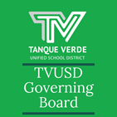

Quaranttiine NottiiffiicattiionsDirect notifications are made to families of students who are identified as having been in close contact with an individual diagnosed with a positive case of COVID-19. An initial phone call is made, and a follow up letter from the Pima County Health Department is sent via email to the families of students who are identified as having been in close contact with a positive individual - student or staff member.Close contact is defined by the CDC and PCHD as:Within 6 feet for a cumulative 15 minutes or more over a 24 hour period.A school-wide notification is then sent via Constant Contact to notify the whole school community that there was a case on the school campus. If you receive a school-wide notification but did not receive an individual notification in advance, then your student was not identified as being in close contact.
You May Qualliify!Free & Reduced Mealls and Other Benefiits InformatiionDear TVUSD Parent/Guardian:Children need healthy meals to learn. TVUSD will be offering healthy meals toall students at no cost every school day in School Year 2021-2022. Your child(ren) will receive free breakfast and lunch meals every school day regardless of your household income.You may qualify for additional reduced fees and other resources!Families are still encouraged to submit a school meal application for free or reduced-price meal benefits because this information may be used for other programs, including:Pandemic-Electronic Benefit Transfer (P-EBT), Federal and State funding for your school, Reduced registration fees for academic tests, Discounted rates for internet service, and Other community resourcesFor more detailed information on eligibility, please visit our website at: TVUSD Food ServicesPlease help us qualify for more Federal and State funding for students! Our school is participating in programs that your child may benefit from if your child qualifies for free or reduced-price meals. The Free & Reduced Meals Application is the key to unlocking those benefits.THE APPLICATION MAY NOW BE COMPLETED ONLINE!!

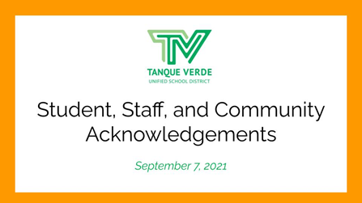
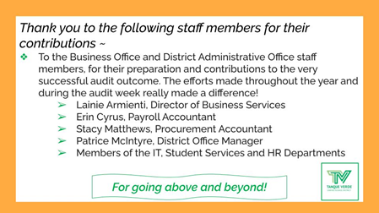
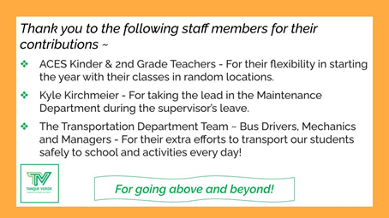
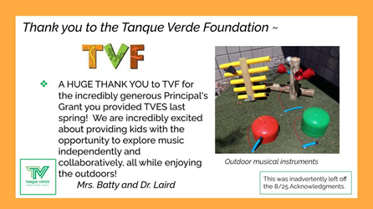
CLICK ON THE MY SCHOOL APPS BUTTON BELOW!Apply Now (English) Apply Now (Spanish)
Nextt Governiing Board Meettiing Datte::The next Regular Governing Board Meetingwill be held on Wednesday, September 22, 2021, at 6:00 p.m. at the Tanque Verde Elementary School Library. Seating is limited. The meeting will be livestreamed.Board Meeting Agendas and MinutesTVUSD Board Meeting Livestream Link
Board Acknowlledgementts - Septtember 7,, 2021

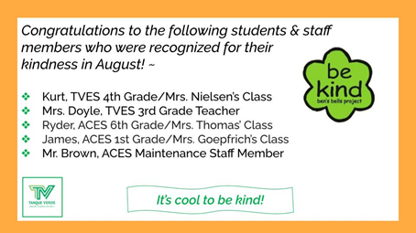
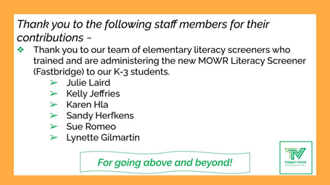
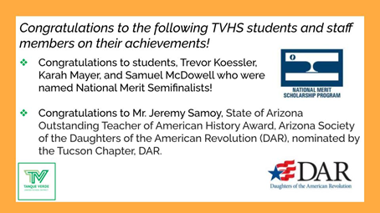
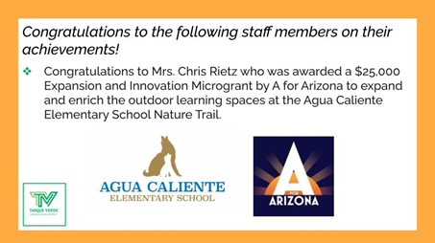

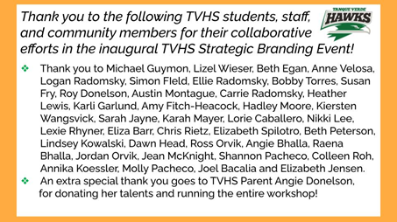
Connect wiith us
Visit our website

