……

Mrs. Janes Newsletter
September 30-October 4, 2024

New

Reading:

- Long i: (ie I y igh i_e)
- Character/Setting/Plot/Main Idea/Details/Context Clues
- Story: Great Girls Contest
- Unit 2 Test- 10/3-10/4

Word Study
pie tie child kind sky dry high lime light bright

High Freuency Words
good many near off people right that two under very

Math
- Topic 9 Test (skip counting and greater than/less than) Tuesday-Oct 1st
- County Test-Oct. 2-3
- Practice addition speed drill at home

Language:

- Plural Nouns-**Test Oct. 2nd
- Handwriting

Social Science:
- Scholastic News

this week’s focus

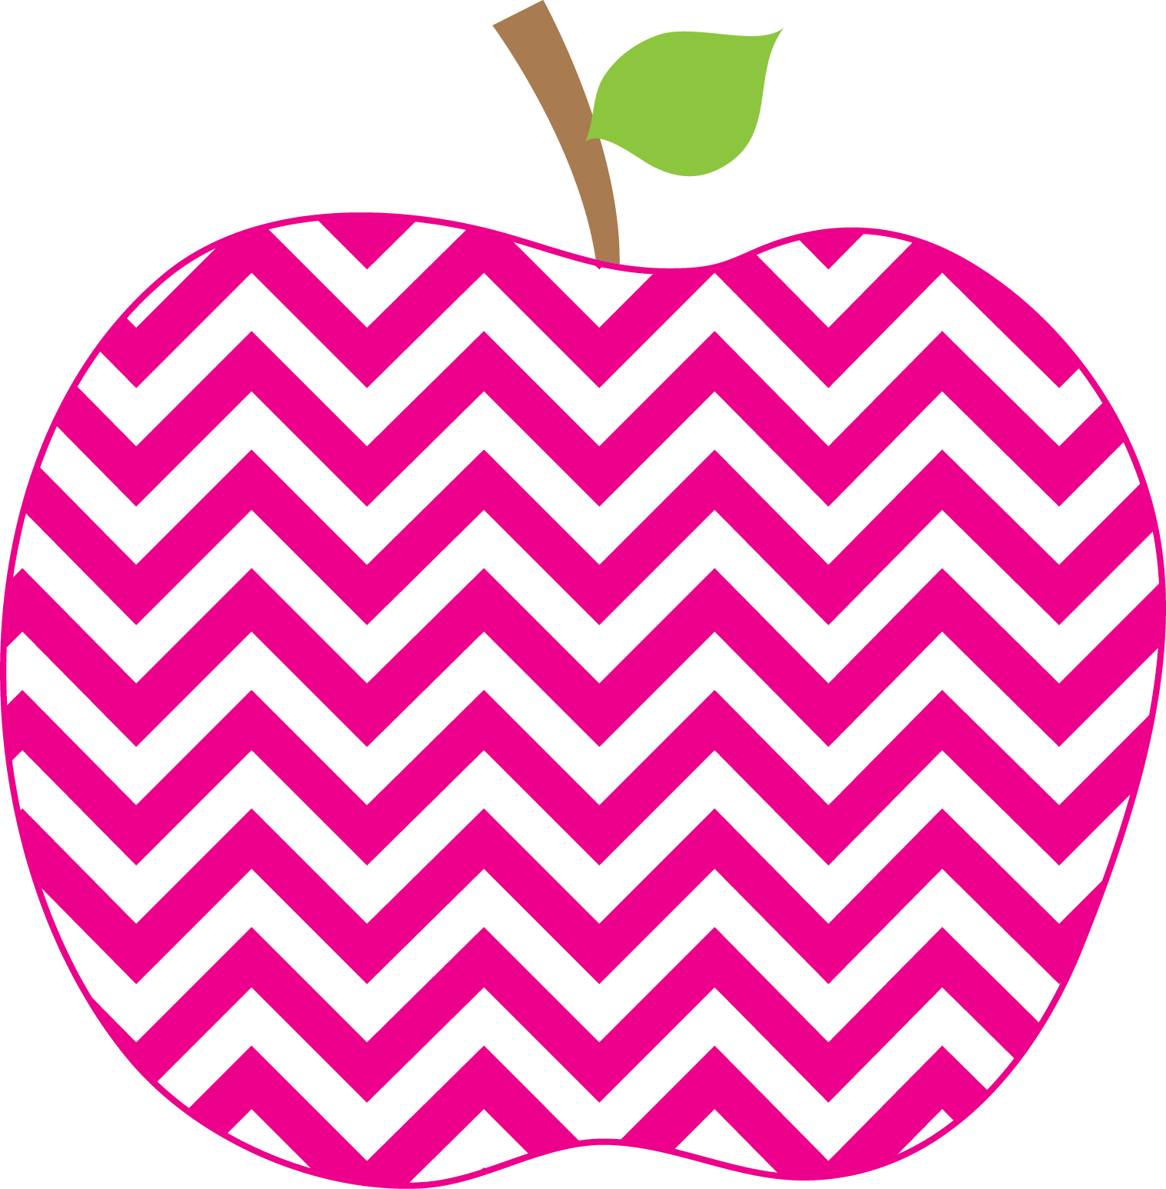


: (

Student of the Week
Josie

Zoe W
If you would like to send in student of the week treats for your child’s week, please send them in on Friday.
- PLEASE SEND EXACT CHANGE FOR SNACK. ($0.75 or $1.50) I do not have change to give back.
- PE 11:20-1205
- Lunch: 12:29-12:56
- Please label any money sent in (ex. Snack, field trip, etc.)
- Your child must wear tennis shoes or closed toe shoes to PE EVERYDAY!

Upcoming Events and Important Info

- 9/30-Fall makeup pictures
- 9/30-10/4-Book Fair
- 10/7-10/8 Fall Break (No school)
- Please initial behavior calendar NIGHTLY!!!
- Please clean out your child’s folder nightly!

Reminders

Every Student Empowered, Every Student Succeeds

